Veteran Authorization and Preferences Enhancements (VAPE)

User Guide

VAP 2.7.0



Version 2.0

April 2017

Department of Veterans Affairs

Office of Information and Technology (OI&T)

Revision History

| Date | Revision | Description | Author |
| --- | --- | --- | --- |
| 04/14/2017 | 2.0 | This document contains updates from the eHealth Exchange Work stream 2 team Release 2.6.4. It incorporates updates to Section 4.6.9 Data Quality Export report. | Booz Allen Hamilton |
| 03/22/2017 | 1.9 | Updated Version Number, Revision History, ToC, ToT, ToF. | Pro-Sphere Tek, Inc. |
| 03/03/2017 | 1.8 | This document contains all of the updates associated to the VAP 2.7.0 Release. This includes the following:   * All screenshots are updated with the new user interface updates to modernize the look and field * Content was added around the new report Document Size (Summary) and admin features (facility management)   Minor Build 4 updates to include Partner Description field | Booz Allen Hamilton |
| 01/27/2017 | 1.7 | Updated Section 3.1 with the new Logging On instructions and PIV authorization | Booz Allen Hamilton |
| 12/09/2016 | 1.6 | Updated Version Number, Revision History, ToC, ToT, ToF. | Pro-Sphere Tek, Inc. |
| 12/08/2016 | 1.5 | Updated document to add VAP 2.6.0 functionality. This included:   * Updated with VAP 2.6.0 screenshots containing page layout revisions * Updated records per page * Adding Section 4.1 (Reporting Dashboard) * Addition of Scheduled Exports * Addition of Monthly Received Documents Report | Booz Allen Hamilton |
| 09/20/2016 | 1.4 | Updated Version Number, Revision History, TOC, TOT, TOF. | Pro-Sphere Tek, Inc. |
| 09/14/2016 | 1.3 | Updated Section 3 to include a note about Compatibility Mode  Updated the document with the latest screenshots referring to VAP 2.5.0 functionality (Build 2) to include changes from User Acceptance Testing. These included:   * Screenshots * Addition of OID to exported reports * Facility Station IDs * Close “tabs” upon exiting pop-up reminder | Booz Allen Hamilton |
| 09/07/2016 | 1.2 | Converted to VIP template. Updated Version Number, Revision History, Artifact Rational, and ToC. | Pro-Sphere Tek, Inc. |
| 07/15/2016 | 1.1 | Update document to add VAP 2.5.0 functionality. This included:   * Delayed Consent Reports (Summary and Detailed) * Adding/Approving/Canceling/Printing Delayed Status authorizations * Mailed letters and dates * Facility parent/child multi-selection   Updated screenshots | Booz Allen Hamilton |
| 05/24/2016 | 1.0 | Tech Writer Review:  Removed Section 1.2.4. | Pro-Sphere Tek, Inc. |
| 05/23/2016 | .08 | Tech Writer Review:  Removed embedded cross-references. | Pro-Sphere Tek, Inc. |
| 05/09/2015 | .07 | Tech Writer Review:  Reviewed updates requested by the HMPS Admin Team. | Pro-Sphere Tek, Inc. |
| 05/09/2015 | 0.06 | Update to incorporate feedback to User Guide updates for Version 2.4. Changes include the following:   * Clarify VAP is only accessible on VA network * Noted VAP links in which access may need to be requested   Grammatical Updates | Booz Allen Hamilton |
| 04/18/2016 | .05 | Tech Writer Review:  Incorporated User Guide content into the latest PMAS template. | Pro-Sphere Tek, Inc. |
| 03/18/2016 | .04 | Updated for VAPE Version 2.4 Build 1 to include the interfacing with kiosks and electronic management of consent directives. | Booz Allen Hamilton |
| 10/20/2015 | .03 | Updated for Veterans Authorization and Preferences Enhancements Version 2.4 Build 1. | Booz Allen Hamilton |
| 8/17/2015 | .02 | Updated for Veterans Authorizations and Preferences (VAP) Enhancements Version 2.3 Builds 6/8. | Booz Allen Hamilton |
| 02/13/2015 | .01 | Updated for Veterans Authorization Preference (VAP) Enhancements Version 2.2 Build 3. | Booz Allen Hamilton |

Artifact Rationale

Per the Veteran-focused Integrated Process (VIP) Guide, the User’s Guide is required to be completed prior to Critical Decision Point #2 (CD2), with the expectation that it will be updated as needed. A User Guide is a technical communication document intended to give assistance to people using a particular system, such as VistA end users. It is usually written by a technical writer, although it can also be written by programmers, product or project managers, or other technical staff. Most user guides contain both a written guide and the associated images. In the case of computer applications, it is usual to include screenshots of the human-machine interfaces, and hardware manuals often include clear, simplified diagrams. The language used is matched to the intended audience, with jargon kept to a minimum or explained thoroughly. The User Guide is a mandatory, build-level document, and should be updated to reflect the contents of the most recently deployed build. The sections documented herein are required if applicable to your product.

Table of Contents

1. Introduction 1

1.1 Purpose 1

1.2 Document Orientation 1

1.2.1 Organization of the Manual 2

1.2.2 Assumptions 2

1.2.3 Disclaimers 2

1.2.3.1 Software Disclaimer 2

1.2.3.2 Documentation Disclaimer 3

1.3 National Service Desk and Organizational Contacts 3

2 System Summary 3

2.1 Data Flows 3

2.2 User Access Levels 4

2.3 Continuity of Operation 5

3 Getting Started 5

3.1 Logging On 5

3.2 Understanding the User Interface Navigation 7

3.3 Understanding the Workflow 9

3.4 Exit System 10

4 Using the Software 11

4.1 Searching for a Patient 11

4.2 Patient Details Screen 14

4.2.1 Patient Summary Tab 14

4.2.1.1 Patient Information 14

4.2.1.2 Manage Access to Veteran Health Records 15

4.2.1.3 Announce 17

4.2.1.4 Status History Table 18

4.2.1.5 eHealth Exchange Correlations Table 20

4.2.2 Health Summary (C32) Tab 21

4.3 Patient Consent Directive 25

4.3.1 eHealth Exchange Record Sharing 26

4.3.2 Restricting eHealth Exchange Record Sharing 42

4.4 Admin 54

4.4.1 Batch Announce Patients 54

4.4.2 Manage Batches 59

4.4.3 Service Audit 61

4.4.4 Partner Organization 62

4.4.5 Monthly Received Documents 64

4.4.6 Facilities 65

4.5 Generating Summary Reports 68

4.5.1 Dashboard 68

4.5.2 Disclosures Summary 70

4.5.3 Received eHealth Exchange Documents Summary 73

4.5.4 Document Size 76

4.5.5 Consent Directive Summary 78

4.5.6 Opt-In Summary 82

4.5.7 Delayed Consent Summary 84

4.5.8 Patient Discovery Audit Summary 88

4.6 Generating Detailed Reports 90

4.6.1 Disclosures Detailed 90

4.6.2 Received eHealth Exchange Documents Detailed 97

4.6.3 Consent Directive Detailed 101

4.6.4 Opt-In Detailed 106

4.6.5 Expiring Consent 109

4.6.6 Delayed Consent Detailed 113

4.6.7 Patient Discovery Audit Detailed 117

4.6.8 Scheduled Exports 121

4.6.9 Data Quality Report 122

4.7 Viewing the User Guide 125

4.8 Expiring Consent Notification 125

4.9 Setting a Default Facility 126

4.9.1 Setting a Default Facility When No Default is in Place 126

4.9.2 Changing the Automatic Default Facility 127

4.10 Viewing Build Information 128

5 Troubleshooting 130

5.1 Special Instructions for Error Correction 130

6 Acronyms and Abbreviations 136

7 Appendix 137

7.1 Definitions 137

7.2 Appendix A 139

7.3 Appendix B 140

7.4 Appendix C 145

Table of Tables

Table 1: Target Audience for VAP User Guide 1

Table 2: Tier Support Contact Information 3

Table 3: Consent Directive Status 19

Table 4: VAP 2.7 Error Messages with Causes and Resolutions 127

Table 5: Acronyms 133

Table 6: Definitions 134

**Table of Figures**

Figure 1: VAP High Level Application Design 4

Figure 2: VAP Access Control System High-Level Design 4

Figure 3: Compatibility View Settings 5

Figure 4: Login Screen 6

Figure 5: Home Page for ROI Administrator or ROI Operator 6

Figure 6: Using the Application 7

Figure 7: Patient Search Screen Showing Logout Confirmation 10

Figure 8: Logout Screen 11

Figure 9: Patient Search Screen 12

Figure 10: Patient Search Results Screen with No Results 13

Figure 11: Patient Search Results Screen with Multiple Results 13

Figure 12: Patient Details Screen / Comments Section 14

Figure 13: Add Comment Box 15

Figure 14: Add Comment 15

Figure 15: Patient Details Screen / Manage Access to Veteran Health Records 16

Figure 16: Patient Details Screen / Announce 17

Figure 17: Patient Details Screen / Re-Announce 17

Figure 18: Announce Alert 18

Figure 19: Patient Details Screen / Status History Table 19

Figure 20: Status History / Authorization Expired 20

Figure 21: Patient Details Screen / eHealth Exchange Correlations Table 21

Figure 22: Patient Details Screen / Health Summary (C32) Tab – Top 22

Figure 23: Patient Details Screen / Health Summary / Medical History, Part 1 23

Figure 24: Patient Details Screen / Health Summary / Medical History, Part 2 24

Figure 25: Patient Details Screen / Health Summary / Medical History, Part 3 25

Figure 26: Patient Details Screen – Patient Has Not Authorized eHealth Exchange Record Sharing 26

Figure 27: Patient Details Authorize eHealth Exchange Dialog Box 27

Figure 28: Patient Details Authorize eHealth Exchange Dialog Box – Ready to Authorize 28

Figure 29: Patient Details – Patient Has Authorized Health Record Sharing 29

Figure 30: Patient Details Revoke eHealth Exchange Dialog Box – No Reason Selected 30

Figure 31: Patient Details with Revoke eHealth Exchange Dialog Box – Entered in Error 31

Figure 32: Patient Details Revoke eHealth Exchange Dialog Box – Revoked 32

Figure 33: Patient Details Revoke eHealth Exchange Dialog Box – Patient Deceased 33

Figure 34: Patient Details Revoke eHealth Exchange Dialog Box – New Authorization 33

Figure 35: Patient Details Revoke eHealth Exchange Dialog Box – Ready to Revoke and Create New Authorization 34

Figure 36: Patient Details – Patient Has Revoked Health Record Sharing with eHealth Exchange 35

Figure 37: Patient Details Screen – Patient Has Created a New eHealth Exchange Authorization 35

Figure 38: Delay Authorization with Reason(s) for Delay 36

Figure 39: Delayed Status Shown in Manage Access to Veteran Health Records 37

Figure 40: Delayed Status Shown in Status History 37

Figure 41: Notification Letter of Authorization Delay 38

Figure 42: Approve Pending eHealth Exchange Authorization 39

Figure 43: Cancel Pending eHealth Exchange Authorization 40

Figure 44: Generate Notification Letter of Authorization Delay 40

Figure 45: Status History – Click Edit Icon to Edit/Add/Delete Mailed Dates 41

Figure 46: Mailed Date(s) – Edit Current Date 41

Figure 47: Mailed Date(s) – Red Trash Icon to Delete Mailed Date(s) 41

Figure 48: Mailed Date(s) – Add another Mailed Date(s) 42

Figure 49: Patient Details Screen – Patient Has Not Restricted Health Record Sharing 42

Figure 50: Patient Details eHealth Exchange Restrictions Dialog Box – Top 43

Figure 51: Patient Details Screen with eHealth Exchange Restrictions Dialog Box – Bottom 44

Figure 52: eHealth Exchange Restrictions Dialog Box – Ready to Restrict 45

Figure 53: Patient Details Screen after Successful Restrictions Authorization 46

Figure 54: Patient Details Screen – Restrictions View/Modify Option 46

Figure 55: Patient Details Screen with View/Modify eHealth Exchange Organization Restrictions Dialog Box – Top 47

Figure 56: Patient Details Screen with View/Modify eHealth Exchange Organization Restrictions Dialog Box – Bottom 48

Figure 57: View/Modify eHealth Exchange Organization Restrictions Dialog Box – Ready to Modify 49

Figure 58: Patient Details Screen after Successful Restrictions Modification 50

Figure 59: Patient Details Screen – Restrictions Revocation Option 50

Figure 60: Patient Details Screen with Revoke Restrictions Dialog Box – No Reason Selected 51

Figure 61: Patient Details Screen with Revoke Restrictions Dialog Box – Entered in Error 51

Figure 62: Patient Details Screen with Revoke Restrictions Dialog Box – Revoked 52

Figure 63: Patient Details Screen with Revoke Restrictions Dialog Box – Patient Deceased 53

Figure 64: Patient Details Screen after Successful Restrictions Revocation 53

Figure 65: Batch Announcement Patients Screen – No Selections 54

Figure 66: Batch Announcement Patients Screen – Organizations Selected 56

Figure 67: Batch Announce Patients Screen - Announcement Review 57

Figure 68: Batch Announce Patients Results Screen - No Patients Found 57

Figure 69: Batch Announce Patients Listed in an Excel or CVS File 58

Figure 70: Batch Announce Patients from Listed in an Excel or CVS File 58

Figure 71: Manage Batches Query Screen 59

Figure 72: Batch Announcements Search Results Screen 60

Figure 73: Batch Announce Detail Pop-Up 61

Figure 74: Service Audit Report 61

Figure 75: Partner Organizations Report 62

Figure 76: Editing an Existing Partner Organization 63

Figure 77: Monthly Received Documents Report 64

Figure 78: Facilities Report 65

Figure 79: Editing an Existing Facility 66

Figure 80: Add New Facility 67

Figure 81: Reporting Dashboard 69

Figure 82: Disclosures Summary Report Query Screen (eHealth Exchange) 70

Figure 83: Disclosures Summary Report Query Screen (Direct) 70

Figure 84: Disclosure Summary Report Screen - No Results Found 72

Figure 85: Disclosures Summary Report Screen (eHealth Exchange) 72

Figure 86: Disclosures Summary Report Screen (Direct) 73

Figure 87: Received eHealth Exchange Documents Summary Report Query Screen 74

Figure 88: Received eHealth Exchange Documents Summary Report Screen 75

Figure 89: Document Size Report Query Screen 76

Figure 90: Document Size Report Screen 77

Figure 91: Consent Directive Summary Report Query Screen 78

Figure 92: Select Facilities Pop-Up Windows 80

Figure 93: Consent Directive Summary Report Screen (Top) 81

Figure 94: Consent Directive Summary Report Screen (Bottom) 81

Figure 95: Opt-In Summary Report Results (top) 82

Figure 96: Opt-In Summary Report Results (bottom) 82

Figure 97: Select Facilities Pop-Up Windows 83

Figure 98: Delayed Consent Summary Report 84

Figure 99: Select Facilities Pop-Up Windows 86

Figure 100: Delayed Consent Summary Report 87

Figure 101: Patient Discovery Audit Summary Report 88

Figure 102: Patient Discovery Audit Summary Report Results 89

Figure 103: Accounting of Disclosures Report Query Screen (Exchange) 91

Figure 104: Accounting of Disclosures Report Screen (Exchange) 93

Figure 105: Accounting of Disclosures Report Screen (Direct) 93

Figure 106: Document View Screen for Summarization of Episode Note 94

Figure 107: Document View Screen for Discharge Summarization Note 95

Figure 108: Print Dialog Box 96

Figure 109: Export Warning Message and Exported Excel 97

Figure 110: Received eHealth Exchange Documents Report Query Screen 98

Figure 111: Received eHealth Exchange Documents Report Screen 100

Figure 112: Export Warning Message 101

Figure 113: Exported Received eHealth Exchange Documents Report Displaying OID (Excel) 101

Figure 114: Consent Directive Report Query Screen 102

Figure 115: Select Facilities Pop-Up Windows 103

Figure 116: Restriction Details (Restricted Organizations) 104

Figure 117: Consent Directive Detailed Report Screen 105

Figure 118: Consent Directive Detailed Report Screen (Showing View) 105

Figure 119: Export Warning Message 106

Figure 120: Opt-In Detailed Report Query Screen 106

Figure 121: Select Facilities Pop-Up Windows 108

Figure 122: Opt-In Patients Detailed Report Screen 109

Figure 123: Export Warning Message 109

Figure 124: Expiring Consent Report Query Screen 110

Figure 125: Select Facilities Pop-Up Windows 111

Figure 126: Expiring Consent Report Screen 112

Figure 127: Export Warning Message 113

Figure 128: Delayed Consent Detail Report 113

Figure 129: Select Facilities Pop-Up Windows 115

Figure 130: Delayed Consent Detail Report 116

Figure 131: Export Warning Message 117

Figure 132: Patient Discovery Audit Report Query Screen 118

Figure 133: Patient Discovery Audit Report Screen (Top) 119

Figure 134: Patient Discovery Audit Report Screen (Bottom) without Test Patients 119

Figure 135: Patient Discovery Audit Report Screen (Bottom) with Test Patients 119

Figure 136: Export Warning Message 121

Figure 137: Exported Patient Discovery Audit Report Displaying OID (Excel) 121

Figure 138: Export Warning Message (Reports Exceeding 1000 Rows) 122

Figure 139: Scheduled Exports Report 122

Figure 140: File Open Dialog Box 123

Figure 141: Generated Archive Folder/s 123

Figure 142: Generated XML Files 123

Figure 143: User Guide Option under Welcome Menu 125

Figure 144: Expiring Consent Notification Query Screen 126

Figure 144: VAP Expiring Consent Report Email 126

Figure 145: Set Default Facility Screen 127

Figure 146: Set Default Facility – Manually Set 127

Figure 147: Changing the Automatic Default Facility 127

Figure 148: Default Facility Changed 128

Figure 149: The About VAP Option Under the Welcome Menu 128

Figure 150: About VAP Screen 129

Figure 151: Error Messages with Causes and Resolutions 139

Figure 152: File Types 139

Figure 153: Open With Dialog Box 140

Figure 153: Batch Announce Use Case Diagram 143

Figure 154: Example of a Consent Directive Summary Report Search Criteria Screen 144

Figure 155: Example of a Consent Directive Summary Report Screen 145

Figure 155: Tooltip (hover over) - Start/End Date 146

Figure 156: Tooltip (hover over) – Patient Preferred Facility 146

Figure 157: Tooltip (hover over) – Total 146

Figure 158: Tooltip (hover over) – SSN 147

Figure 159: Error Message 147

# Introduction

The Veterans Authorizations and Preferences (VAP) project in the Virtual Lifetime Electronic Record (VLER) Initiative is responsible for authorizing Health Information Exchange (HIE) to trusted external partners and managing Veteran electronic Consent Directives. The VAP project creates an enterprise-wide electronic solution capable of supporting Veteran Authorization Preferences/Consent Directives, and organizational policies on privacy and security relative to ROI, the disclosure of individually-identifiable health information to carry out treatment, payment, or healthcare operations. The VAP application is comprised of both user and machine interfaces to set patient preferences for how patient data can be shared.

The VAP 2.7.0 application is a Department of Veterans Affairs (VA) Web application. This tool is designed to be used by ROI personnel and other authorized users to create Consent Directives, thereby facilitating the sharing of Veteran health information with non-VA healthcare provider organizations and the Social Security Administration (SSA) through the eHealth Exchange. It also allows the user to make announcements and view reports.

The VAP application resides on the VA Intranet. The application can be accessed by way of the VAP User Interface (UI) using any standard Web browser (e.g., Chrome, Firefox, or Internet Explorer) on a computer that is connected to the VA network.

## Purpose

The purpose of the VAP 2.7 User Guide (UG) is to provide detailed information to the ROI personnel and other authorized users about using the VAP 2.7 application.

## Document Orientation

The UG is targeted to ROI personnel, including ROI Administrators, ROI Operators, ROI Reporters, and ROI Testers, and other authorized users. These authorized users use the VAP system to create Consent Directives to enforce constraints on sharing Veteran health data with the network of partners and communities participating in the eHealth Exchange, including the SSA. VAP 2.7 users are tasked with the following responsibilities.

Table 1: Target Audience for VAP User Guide

| User | Description of User |
| --- | --- |
| ROI Reporters | The Reporters run the detailed and summary reports. These users see the Consent Directive Summary Report screen when they log into the application. |
| ROI Operators | In addition to all tasks supported by the Reporter role, the Operators search for patients and authorize, restrict, or revoke record sharing with the network of eHealth Exchange partners and communities and/or authorize or revoke record sharing with the SSA. These users see the Patient Search screen when they log into the application. This is the role typically assigned to ROI personnel and other authorized users. |
| ROI Administrators | The Administrators initiate Batch Announcements in addition to all tasks supported by the ROI Operator and ROI Reporter roles. These users see the Patient Search screen when they log into the application. These users are also able to see the Service Audit report, which shows system transactions made to VAP from VA systems (e.g., eBenefits, Exchange). As part of Release 2.6.0, these users will be able to access a report that shows the count of received documents from each partner by user. |
| ROI Testers | The Testers can view the Extensible Markup Language (XML) code and perform other functions required for testing addition to all tasks supported by the ROI Administrator, ROI Operator, and ROI Reporter roles. This role is only available to the developers and select VA personnel who do testing. These users see the Patient Search screen when they log into the application. |

For the purposes of the User Guide, all four categories of user roles are referred to as VAP 2.7 system users.

### Organization of the Manual

The UG covers all VAP system functionality, including logging into the application, performing patient searches, making batch announcements, managing batches, managing facilities and partner organizations, preparing summary and detailed reports, reviewing the UG, setting the expiring consent notification and default facility, viewing the current build and logging out of the application.

### Assumptions

This guide was written with the following assumed experience/skills of the audience:

* User has basic knowledge of the operating system (such as the use of commands, menu options, and navigation tools).
* User has been provided the appropriate active roles, menus, and security keys required for the VAP 2.7 system.
* User is using the VAP 2.7 system to create Consent Directives to enforce constraints on sharing Veteran health data with the network of partners and communities participating in the eHealth Exchange, including the SSA.
* User has validated access to VAP 2.7.
* User has completed any prerequisite training.

### Disclaimers

#### Software Disclaimer

*This software was developed at the Department of Veterans Affairs (VA) by employees of the Federal Government in the course of their official duties. Pursuant to title 17 Section 105 of the United States Code this software is not subject to copyright protection and is in the public domain. VA assumes no responsibility whatsoever for its use by other parties, and makes no guarantees, expressed or implied, about its quality, reliability, or any other characteristic. We would appreciate acknowledgement if the software is used. This software can be redistributed and/or modified freely provided that any derivative works bear some notice that they are derived from it, and any modified versions bear some notice that they have been modified.*

#### Documentation Disclaimer

*The appearance of external hyperlink references in this manual does not constitute endorsement by the Department of Veterans Affairs (VA) of this Web site or the information, products, or services contained therein. The VA does not exercise any editorial control over the information you may find at these locations. Such links are provided and are consistent with the stated purpose of the VA.*

## National Service Desk and Organizational Contacts

Table 2 lists organizational contacts needed by site users for troubleshooting purposes. Support contacts are listed by name of service responsible to fix the problem, description of the incident escalation, associated tier level, and contact information (email and phone number).

Table 2: Tier Support Contact Information

| Name | Role | Org | Contact Info |
| --- | --- | --- | --- |
| Clinical Application Coordinator | Tier 0 Support | VHA | Local Clinical App Coordinator |
| OI&T National Service Desk | Tier 1 Support | OI&T | [Nationalservicedeskanr@va.gov](mailto:Nationalservicedeskanr@va.gov)  1-855-673-4357 |
| OI&T Local Support | Tier 2 Support | OI&T | OI&T Local Helpdesk |
| Health Product Support | Tier 2 Support | VHA | [Nationalservicedeskanr@va.gov](mailto:Nationalservicedeskanr@va.gov)  1-855-673-4357 |
| OI&T System Admin/Field Operation Support | Tier 2 & 3 support | OI&T | [Nationalservicedeskanr@va.gov](mailto:Nationalservicedeskanr@va.gov)  1-855-673-4357 |
| VistA Patch Maintenance | Tier 3 Application Support | OI&T | [Nationalservicedeskanr@va.gov](mailto:Nationalservicedeskanr@va.gov)  1-855-673-4357 |
| Enterprise Operations | Tier 3 & 4 Support | OI&T | OI&T Enterprise Operations Helpdesk |

# System Summary

## Data Flows

The VAP application is hosted at the Austin Information Technology Center (AITC). The system is only accessible within the VA intranet to authorized users. VAP interfaces with numerous other VA applications such as eHealth Exchange, eBenefits, Master Patient Index (MPI)/Master Veteran Index (MVI), and SAC. Figures 1 and 2 below break the VAP application down into the high-level components of the system.

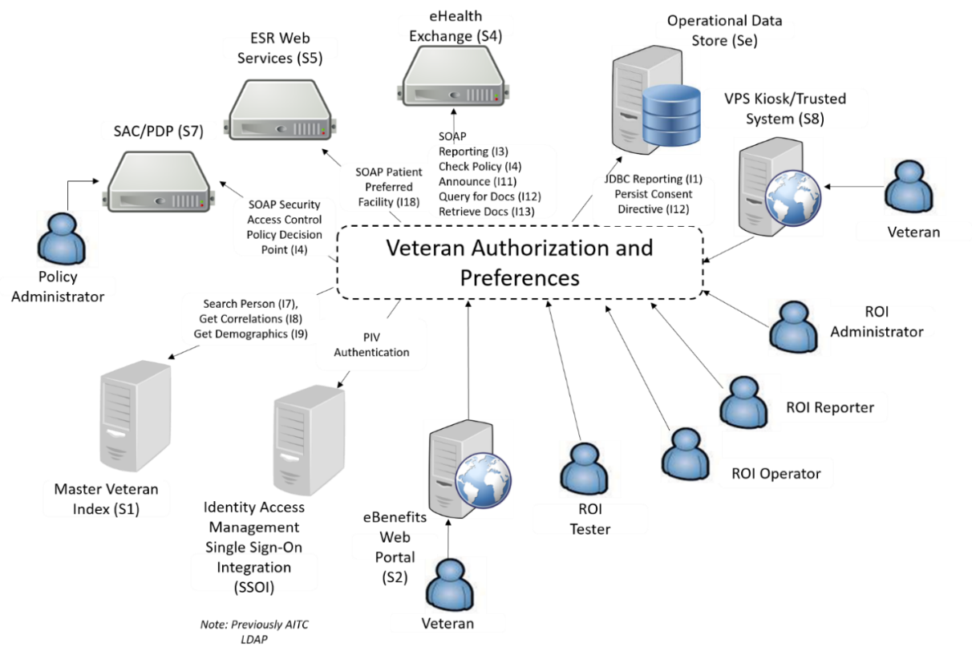

Figure : VAP High Level Application Design

## User Access Levels

System to User authentication and authorization is performed with a combination of validating a user's VA credentials through the Identity Access Management (IAM) Single-Sign-On Integration (SSOI) service and validation within VAP. Once a user has authenticated, the headers are passed to VAP which are then mapped to the user roles. As a result of the PIV integration, VAP no longer reaches to the AITC LDAP to determine if a user is authorized to access VAP. Instead, the users and roles are stored within the VAP system database. The VAP systems ROI web user interface uses these role mappings to constrain what capabilities of the application are exposed to the user.

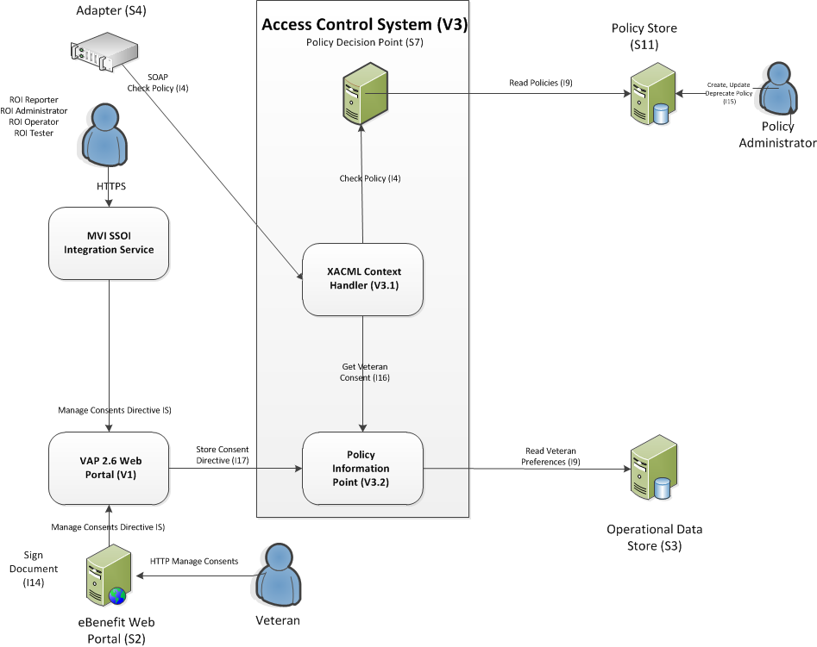

Figure : VAP Access Control System High-Level Design

## Continuity of Operation

Standby systems are in place at AITC. In the event of system failure, systems can be migrated to other host servers via VMotion tool of the VMWare Server Farm. In the event of a database failure, a redundant database server has been allocated for this purpose.

# Getting Started

This section explains the VAP 2.7 application screen layout and workflow.

**Note**: The UG displays test data on the screens and uses test data in the text. There is no Personal Identifiable Information (PII) included in this guide.

Additionally, it is important to note that certain features within the VAP application cannot be used with Compatibility Mode turned on, in Internet Explorer (IE). Please ensure that this option is turned off prior to accessing. To turn this feature off, click on “Compatibility View Settings.” A pop-up should appear, as shown below, that provides the option to “check/un-check” display intranet in Compatibility. This feature should be unchecked, as shown in Figure 3.

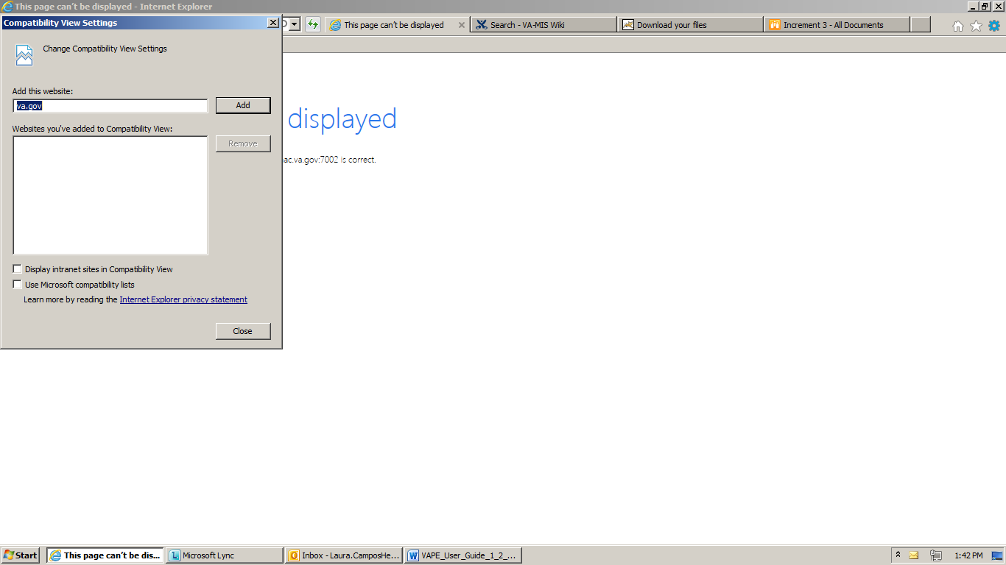

Figure : Compatibility View Settings

## Logging On

After logging into the VA network using your VHA user identification (ID) and password or PIV credentials, open an Internet browser and enter the following Uniform Resource Locator (URL) to be routed to the Veterans Authorization and Preferences application shown in Figure 4: <https://nvpapp-prd.va.gov/nvap-web/Login.do>. It is important to note that the VA is migrating systems to enforce two-factor authentication. As part of this effort to ensure VA applications are securely accessed, the authentication aspect of VAP will be completed by Identity Access Management (IAM) Single-Sign-On System (SSOI). Upon navigating to the VAP application, the user will be automatically routed to the SSOI user login for PIV authentication. Once the user has entered his or her PIV credentials and been validated, SSOI will re-route to the VAP application.

In order to access this link, access to the VAP application is needed. Please work with your local site Point of Contact (POC) to submit a request for VAP access.

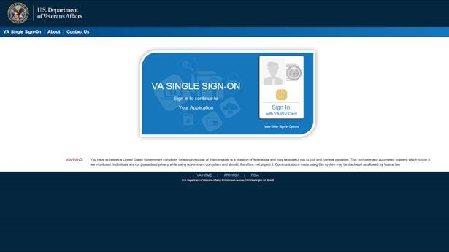

Figure 4: Login Screen

To Login to the Application

1. Enter your PIV card into the card reader and click Login. Enter your PIN when prompted.
2. Once authorized, you will be routed to VAP 2.7 application (Figure 5) and your user name is displayed after the “Welcome” message in the top right corner of the screen.
3. The menu at the top of the screen is based on your role when you logged into the application. It allows you to select other options available to your role.

The Patient Search screen is displayed automatically when you successfully log into the VAP 2.7 system as a ROI Administrator or ROI Operator. ROI Reporters see the Consent Directive Summary Report screen at login.

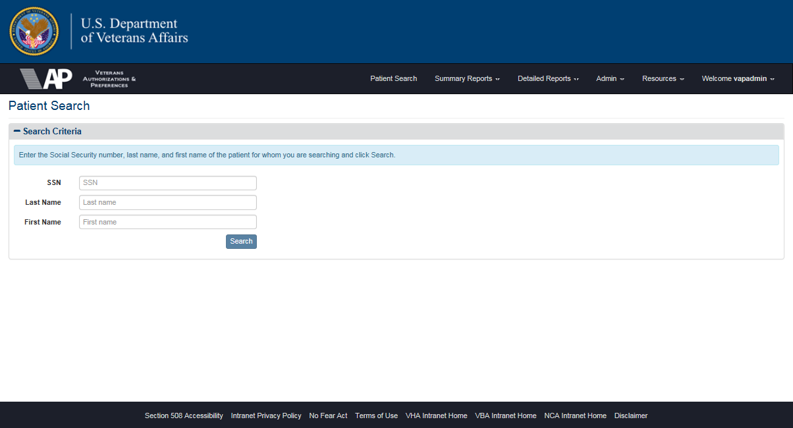

Figure : Home Page for ROI Administrator or ROI Operator

If you are not an authorized user, the [Login] Not Authorized screen is displayed. Click the **Login** button to try again, or click the **Close** button to exit the application. Contact your supervisor or the Helpdesk number at the bottom of the Login screen (to determine what needs to be done to get access.)

## Understanding the User Interface Navigation

The VAP 2.7 application runs as a web application on the VA Intranet. The application is divided into three distinct components on the browser screen as shown in Figure 6.



Figure : Using the Application

* A frame at the top displays a horizontal application menu after you have logged into the application. This menu only displays the items available to your role. The menu in the illustrations reflects the options available to ROI Administrators (i.e., the users with the highest level of production access) to allow all options to be discussed in the UG. **Note**: VAP Administrators are able to see Admin reports and additional functionality for managing the application. VA information is also displayed allowing access to the VA Intranet through the Resources menu.
* The central part of the screen displays the active VAP 2.7 system component.
* The bottom of the screen contains a list of standard links that provide access to Section 508 Accessibility information, the Intranet Privacy Policy, the No Fear Act, Terms of Use, links to related Intranet sites, and a Disclaimer.

The menu displays these primary options.

* Patient Search
* Summary Reports
* Detailed Reports
* Admin
* Resources
* Welcome “UserName”

The **Summary Reports** menu item has eight (8) options that link you to the query screens used to generate three summary reports.

* Dashboard
* Disclosures
* Received eHealth Exchange Documents
* Document Size
* Consent Directives
* Opt-In Patients
* Delayed Consent
* Patient Discovery Audit

The **Detailed Reports** menu option contains options that link you to the query screens used to generate eight (8) reports.

* Disclosures
* Received eHealth Exchange Documents
* Consent Directives
* Opt-In Patients
* Expiring Consent
* Delayed Consent
* Patient Discovery Audit
* Scheduled Exports

There are six (6) submenu options under the **Admin** menu heading.

* Batch Announce Patients
* Manage Batches
* Service Audit
* Partner Organizations
* Monthly Received Documents
* Facilities

There are five (5) submenu options under the **Resources** menu heading.

* VA Intranet Home
* About VA
* Organizations
* Find a Facility
* Employee Resources

There are five (5) submenu options under the **Welcome** “UserName” menu heading.

* User Guide
* Expiring Consent Notification
* Set Default Facility
* About
* Logout

The Set Default Facility menu item contains options to change the facility associated with a user ID. The preferred facility for the Veteran is the facility that will appear in the VAP reports. There is no menus associated with the Patient Search. It is important to note each of these options is discussed in more detail in the following sections.

## Understanding the Workflow

The VAP 2.7 system event flow (workflow) describes the work that is accomplished by using the application.

* Log into the application (All Users)
* Manage Consent (Administrators, Operators, and Testers)
* Patient Search
* Authorize/Revoke/Delay Record Sharing
* Restrict Record Sharing
* Generate Batch Announcements (Administrators)
* View Manage Batches (Administrators)
* Access Service Audit Report (Administrators)
* View/Edit Partner Organizations (Administrators)
* View/Edit/Add Facilities (Administrators)
* View Monthly Received Documents Report (Administrators)
* Generate and View Reports (All Users)
* Generate and View Summary Reports
* Generate and View Detailed Reports
* View User Guide (All Users)
* Edit Expiring Consent Notification
* Set Default Facility
* Review Build Information (All Users)
* Log out of the application (All Users)

The VAP system event flow (workflow) will interface with kiosks to provide additional functionality, outside the application, at a future date.

* External to the system, the VAP Subsystem 2.7 provides the functionality to receive a request or query from kiosks to include a Veteran’s current active status, a list of active partners, and a restriction list. VAP will prepare and return a response. This functionality will be available upon VPS Kiosk functionality deployment.

## Exit System

Logout of the VAP 2.7 system by selecting the Logout option under the **Welcome** menu at the top of the screen.

***To Log Out of the VAP 2.7 Application***

1. Click the Logout menu item under the Welcome menu at the top of any screen to log out of the VAP system application. (Figure 7 shows the Patient Search screen, but ROI Reporters will not see this screen. They see one of the summary or detailed report screens).

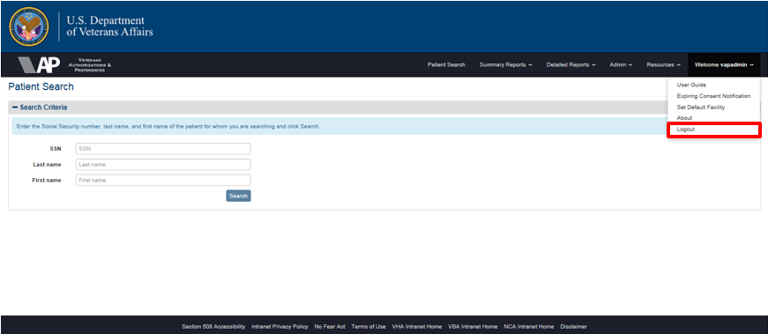

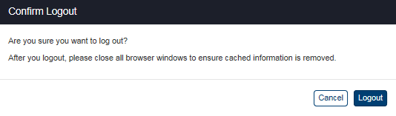

Figure : Patient Search Screen Showing Logout Confirmation

***Logout Option under Welcome Menu***

1. A pop-up message appears with the following message: “Are you sure you want to log out” and “After you logout, please close all browser windows to ensure cached information is removed.” Click Logout to proceed.
2. The Logout screen (Figure 8) appears with no application menu and displays the message, “You have successfully logged out of VAP.” This confirms that you are logged out. (The “Welcome” message also disappears from the top right corner of the screen.)
3. The Log Out button appears below the message. Click the button to log out of the VA SSOI session, shown in Figure 9.

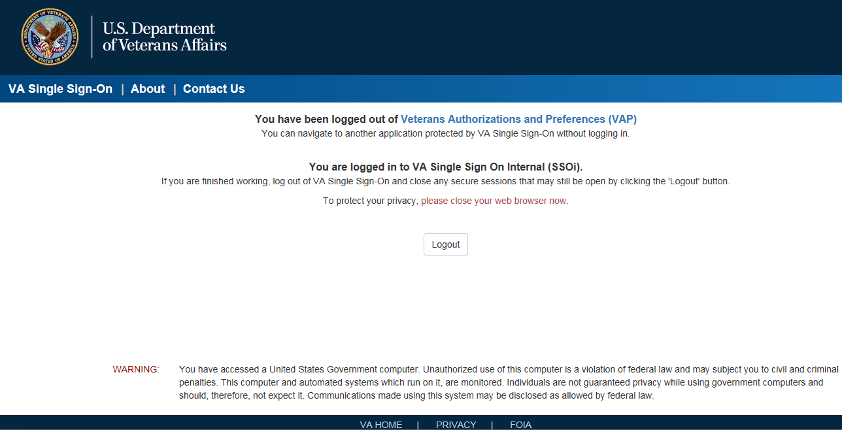

Figure : Logout Screen

# Using the Software

The VAP 2.7 application allows the ROI Administrator and Operator roles to search for a patient and then authorize, restrict, or revoke record sharing for the patient. ROI Administrators can generate batch announcements, and view/edit facility and partner information. All users can generate and view detailed and summary reports.

This section describes how to use the application. (The ROI Tester role has the same privileges as the ROI Administrator role in this guide. The additional functions available to Testers will be documented separately.)

You cannot access the VAP 2.7 application unless you meet three (3) requirements:

* You must have a Veterans Health Administration (VHA) user name and password.
* You must have access to the VA network.
* The Austin Information Technology Center (AITC) must have associated your user name with a ROI role.

Consult your supervisor or the VA Help Desk if you need help meeting any of these conditions.

## Searching for a Patient

The Patient Search screen, Figure 9, is automatically displayed when you successfully log into the VAP 2.7 system as a ROI Administrator or ROI Operator. (ROI Reporters see the Consent Directive Summary Report screen at login). You can navigate back to this screen from within the application by selecting the Patient Search option on the menu at the top of the screen.

**Note**: The UG displays test data on the screens and uses test data in the text. There is no Personally Identifiable Information (PII) included in this guide.

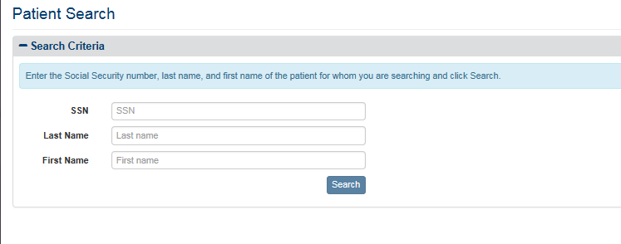

Figure : Patient Search Screen

*To Search for a Patient*

All three (3) fields must be filled with valid data to search for a patient.

1. Enter a complete Social Security Number (SSN) – nine (9) numbers with no hyphens – in the SSN field (required).
2. Enter the last name (not case-sensitive) of the person that matches the SSN entry in the Last Name field (required).
3. Enter the first name (not case-sensitive) of the person that matches the SSN entry in the First Name field (required).
4. Click the Search button. This displays Patient Summary tab information on the Patient Details screen (Figure 12). Use the scroll bar at the right of the screen to view the information at the bottom of the screen.
5. Typically, the search results in only one match, because you must enter the patient’s SSN, last name, and first name. Searches that yield a unique entry display the patient information on the Patient Summary tab of the Patient Details screen (Figure 12) for the person found by the search.
6. If the search does not find any matches, the Patient Search Results screen, Figure 10, indicates no patients were found. This either means that the information you entered was not correct or the patient you are seeking is not in the system. Reenter the data on the Patient Search screen and try again. If the data you entered is correct, the patient is not in the system.

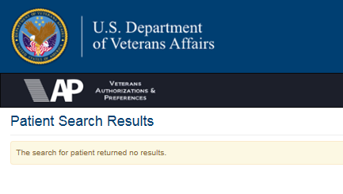

Figure : Patient Search Results Screen with No Results

1. If the search results in more than one match, Figure 11, it displays a list of matches and allows the user to select the correct person from the list as shown below. The search targets the Master Veteran Index (MVI). The MVI uses probabilistic, instead of exact, matching based on different weights associated with demographic traits. If the MVI finds two records that are almost the same and its matching algorithm cannot determine which record is a unique match, it displays both results as shown below and lets the user decide which listing indicates the correct patient. **Note**: This screen can only appear in the Production application and is not seen by the Development teams. The screen print is from an older version (build) of the application and does not show the correct menu at the top of the screen (Figure 11).
2. If the system fails to connect to MVI, it will retry the MVI call. If the connection keeps failing past the configuration defined number of attempts (five attempts), then failure via timeout from MVI is tracked and logged within the VAP system administrator logs. An error message noting the page is unavailable will be displayed to the user.
3. Click the radio button next to the record that is the best match and click the View Details button. This displays Patient Summary tab information on the Patient Details screen for the selected patient.

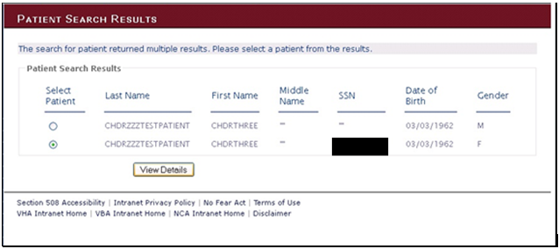

Figure : Patient Search Results Screen with Multiple Results

## Patient Details Screen

The Patient Details screen displays the patient information on the Patient Summary tab found by the search. A second tab on this screen, Health Summary (C32), displays the health information stored in the Veteran’s C32 Health Summary.

### Patient Summary Tab

There are six (6) parts to the Patient Summary tab on the Patient Details screen:

* Patient Information
* Comments
* Manage Access to Veteran Health Records
* Announce
* Status History
* eHealth Exchange Correlations

#### Patient Information

The Patient Summary Information includes the Veteran’s name (first name and last name), address (street address, city, state, and ZIP code), gender (Male or Female), Veterans Health Information Systems and Technology Architecture (VistA) Integration Control Number (ICN), multiple birth status (YES or NO), date of birth (mm/dd/yyyy), telephone number, marital status (Married, Divorced, Widowed, or Single) and SSN as shown in Figure 12. The data displayed within this section is not stored within the VAP system, instead, this information is pulled from the Master Veterans Index (MVI) upon selection of patient through the Patient Search.

Within each Patient Detail view, there are two locations in which users can leave comments, *Comments* and *Status History* sections.

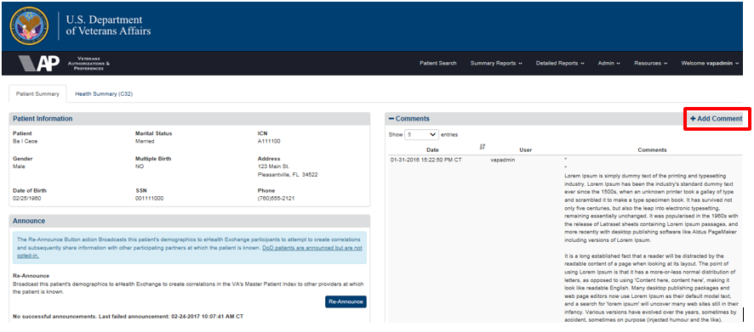

Figure : Patient Details Screen / Comments Section

In the *Comments* sections, when a user selects “Add Comment,” a pop-up text input form (Figure 13) is opened in the center of the screen, and can be used to write and save a comment.

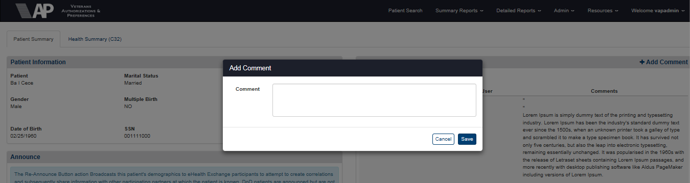

Figure : Add Comment Box

In the *Status History* section, users can leave comments which pertain to a specific Consent Directive that a patient has completed, Figure 14. In the same process as above, users are able to select, “Add Comment,” and write remarks in a popup window. A comment cannot be deleted. In addition, the user is able to see the timestamp and username of the individual who entered the comment.



Figure : Add Comment

#### Manage Access to Veteran Health Records

The Patient Summary tab also indicates the patient’s current authorization, restrictions, and revocation settings and allows ROI Administrators and ROI Operators to authorize, restrict, or revoke the disclosure of protected health information to eHealth Exchange providers and organizations and the SSA. Users can change the authorization, restrictions, and revocation settings on behalf of and upon explicit request from the Veterans. See Section 4.3 Patient Consent Directive for instructions on changing authorization, restrictions, and revocation settings.

Figure 15 illustrates the options on this tab if eHealth Exchange sharing and restrictions and SSA sharing have not been authorized. These options allow you to perform the following actions if you have a signed Consent Directive from a Veteran:

* The Share Veteran electronic health information (eHealth Exchange) option allows ROI Administrators and Operators to authorize sharing records with non-VA provider organizations for treatment purposes using eHealth Exchange. See “To Authorize Patient Health Record Sharing with eHealth Exchange” in Section 4.3.1 eHealth Exchange Record Sharing.
* The Manage Veteran restrictions option allows ROI Administrators and Operators to restrict sharing records with non-VA provider organizations for treatment purposes using eHealth Exchange. See “To Create Patient Health Record Sharing Restrictions with eHealth Exchange” in Section 4.3.2 Restricting eHealth Exchange Record Sharing*.*

**Note**: In VAP 2.6.0, the option to manually enter Social Security Administration authorizations has been removed. SSA authorizations can only be submitted electronically through system interfaces.

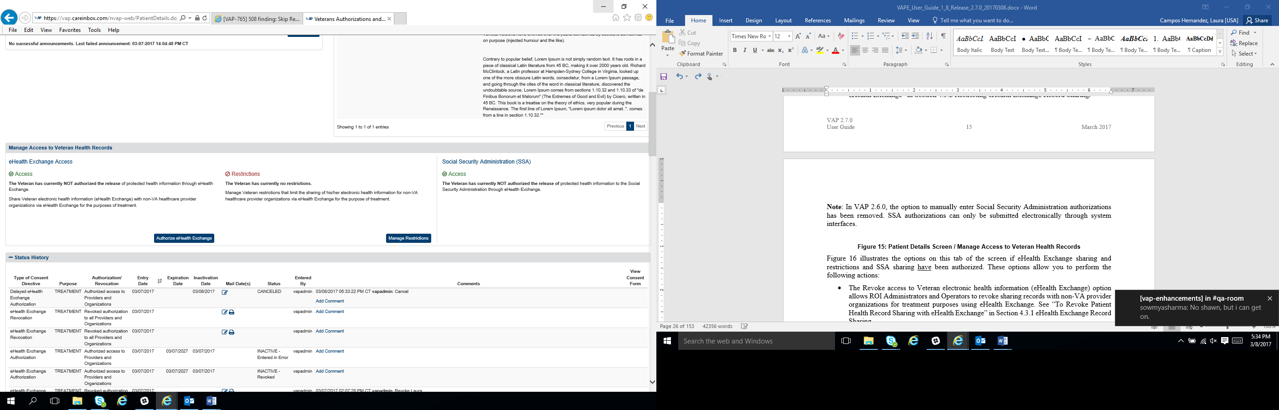

Figure : Patient Details Screen / Manage Access to Veteran Health Records

The figure below illustrates the options on this tab of the screen if eHealth Exchange sharing and restrictions and SSA sharing have been authorized. These options allow you to perform the following actions:

* The Revoke access to Veteran electronic health information (eHealth Exchange) option allows ROI Administrators and Operators to revoke sharing records with non-VA provider organizations for treatment purposes using eHealth Exchange. See “To Revoke Patient Health Record Sharing with eHealth Exchange” in Section 4.3.1 eHealth Exchange Record Sharing.
* The View/Modify Veteran’s existing restrictions option allows ROI Administrators and Operators to view and/or modify restrictions on sharing records with non-VA provider organizations for treatment purposes using eHealth Exchange. See “To View and Modify Patient Health Record Sharing Restrictions with eHealth Exchange” in Section 4.3.2 Restricting eHealth Exchange Record Sharing.
* The Revoke or terminate Veteran’s existing restrictions option allows ROI Administrators and Operators to revoke any or all restrictions on sharing records with non-VA provider organizations for treatment purposes using eHealth Exchange. See “To Revoke Patient Health Record Sharing Restrictions with eHealth Exchange” in Section 4.3.2 Restricting eHealth Exchange Record Sharing.

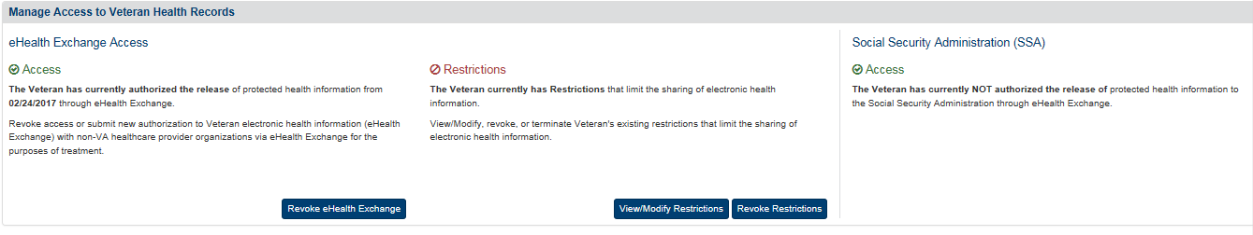

**Note**: In VAP 2.6.0, the option to manually enter restrictions/authorizations to revoke Social Security Administration consents has been removed. SSA consent forms can only be submitted electronically through system interfaces.

#### Announce

Regardless of whether a patient has an eHealth Exchange Authorization, the **Announce** button initiates announcements to all eHealth Exchange Partners, except to the SSA, and defers to the eHealth Exchange Adapter to carry out the announcements. The Adapter sends (broadcasts) these announcements (patient discovery messages) containing the patient’s demographics to the targeted eHealth Exchange partners in an attempt to establish a patient correlation. The eHealth Exchange partners reply with messages indicating whether or not the patient is known to them. If they know the patient, they send the correlated patient identifier, which could get registered under the VA MVI. It is important to note that if the individual has a restriction for a particular organization, an announce can still be made.

eHealth Exchange correlations for a patient can subsequently be displayed in the Correlations table of the Patient Details page as shown in Figure 16. The authorize button notifies the user that the announcement has been requested and that it will process in the background and that they can move on to other activities.

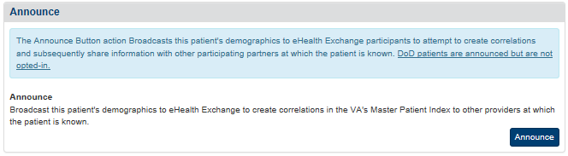

Figure : Patient Details Screen / Announce

If patient has already been announced, the language of the Announce button changes to Re-Announce as shown in Figure 17.

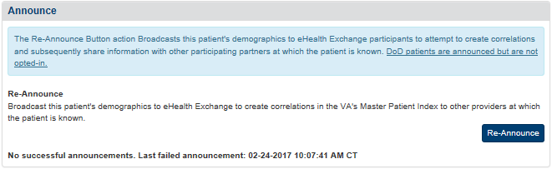

Figure : Patient Details Screen / Re-Announce

The alert function is updated to provide user the ability to announce patient and be directed to the search screen without having to click on a confirm dialog as following steps:

1. User will click on the Announce/Re-announce button (Figure 16 [Announce] and Figure 17 [Re-announce]).
2. User will be directed to the patient search screen (Figure 18). The system will provide notification that an announcement has been kicked off but it will not require input from the user.

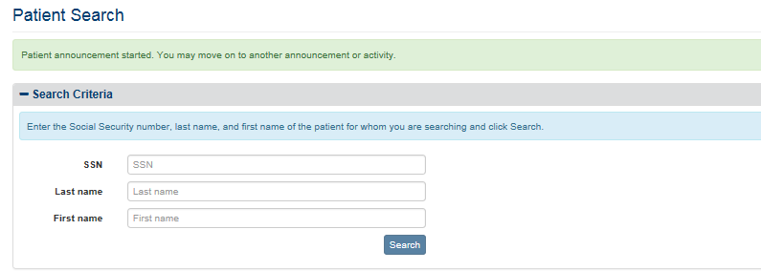

Figure : Announce Alert

#### Status History Table

The Patient Details page contains sections called Status History and eHealth Exchange Correlations. Both of these sections are able to be expanded to see their information, as well as minimized through the plus and minus options. The Consent Directive Status table at the bottom of the Patient Details screen provides a record of the authorization, restrictions, delays, and revocation actions performed by the VAP 2.7 system users. Figure 19 displays the Status History Table screen and Table 3 describes its column headings. Consent can be managed internally within the Patient Details page or submitted by external systems such an eBenefits or the VPS Kiosk. SSA can also create an authorization entry by providing an electronic authorization document during the patient discovery process.

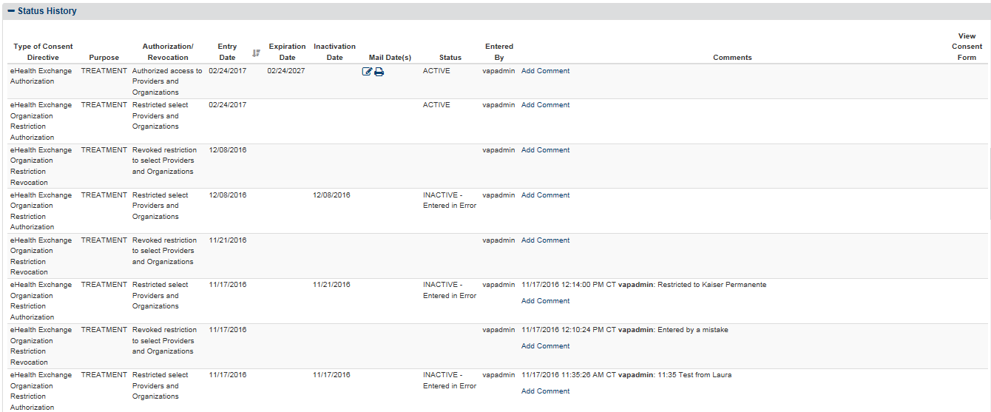

Figure : Patient Details Screen / Status History Table

Table 3: Consent Directive Status

| Column Heading | Description |
| --- | --- |
| **Status History** | |
| Type of Consent Directive | * eHealth Exchange Organization Authorization or Revocation * eHealth Exchange Organization Restriction Authorization or Revocation, * SSA Authorization or Revocation * Kiosk Authorization or Revocation |
| Purpose | eHealth Exchange Treatment or SSA Coverage |
| Authorization/Revocation | A message indicating an Authorization, Restriction, or Revocation for :   * eHealth Exchange providers and organizations * Social Security Administration |
| Entry Date | Date when the authorization, restriction or revocation was entered into the system through the VAP system portal, eBenefits, SSA, or Kiosk. |
| Expiration Date | The expiration date for the authorization (i.e., patient signature date plus five years for eHealth Exchange or two years for SSA). |
| Inactivation Date | The inactivation date for the revocation or restriction (i.e., date when the patient revoked or restricted consent through the VAP system portal, eBenefits or Kiosk). |
| Status | The Status of the Consent Directive: ACTIVE or INACTIVE. If the entry is INACTIVE (i.e., a restriction with no prior authorization or revocation), a message appears explaining the reason for the status. The following five (5) entries can appear: Authorization Expired, Entered in Error, New Authorization, Patient Deceased, and Revoked as shown in Figure 19 and Figure 20. |
| View Consent Form | If the entry is an authorization added by eBenefits, the Social Security Administration, or the VPS Kiosk, a **View/Print** link appears in the View Consent Form column in the table. For an eBenefits authorization, clicking the link will open a standard Windows File Download dialog box that you can use to print, save, or view a Portable Document Format (PDF) copy of the consent form generated by eBenefits. For a SSA authorization or the Kiosk authorization, clicking the link will allow you to view the PDF embedded in the page and will give you the option of downloading and saving that authorization. |
| Entered By | Displays the username of the individual who entered the consent directive. Consent Directive entered online through external system such as eBenefits will get recorded in the “Entered By” column as “eBenefits’ or the system for which the call is entered by. |
| Mail Date(s) | User can Add/Edit/Delete letter Mailed Date(s) from Status History Table. The Mail date feature is applicable only for Delayed eHealth/SSA Authorizations, eHealth Revocation, or expiring eHealth authorizations. |
| **eHealth Exchange Correlations** | |
| Facility Number |  |
| eHealth Exchange Organization Name |  |
| eHealth Exchange Organization Assigning Authority |  |
| Patient ID |  |

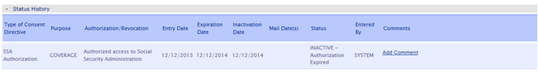

Figure : Status History / Authorization Expired

This view-only Status History table cannot be modified or deleted. The order of records is based on the date when the authorization, restrictions, and revocation actions occurred. The action with the most recent date is displayed first. (A system-generated date is captured when each record is created.)

#### eHealth Exchange Correlations Table

The eHealth Exchange Correlations table at the bottom of the Patient Summary tab (on the Patient Details screen) shows with which organizations the patient has been “correlated” (i.e., patient identity is known and patient has received services), so exchange of data can happen with those organizations. It appears immediately after the table that shows the Status History. Figure 21 displays the following information:

* Facility Number
* eHealth Exchange Organization Name
* eHealth Exchange Organization Assigning Authority
* Patient ID

**Note**: If a correlation needs to be removed, contact your local Master Veteran’s Index (MVI) point of contact (POC). The POC can work with the national Healthcare Identity Management (HC IdM) Team to remove the correlation.

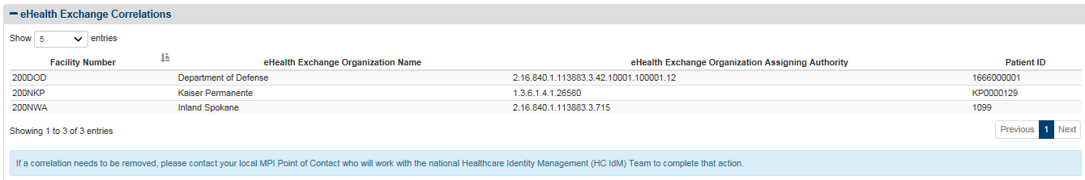

Figure 21: Patient Details Screen / eHealth Exchange Correlations Table

This view-only eHealth Exchange Correlations table cannot be modified or deleted.

### Health Summary (C32) Tab

The Healthcare Information Technology Standards Panel (HITSP) C32 record summarizes a Veteran’s medical status for the purpose of information exchange. It may include administrative (e.g., registration, demographics, insurance, etc.) and clinical (problem list, medication list, allergies, test results, etc.) information. VAP 2.7 system incorporates the latest C32 stylesheets from VistA Web for proper display of the received data elements for the Health Summary (C32) page.

*To View a Health Summary*

1. Click the Health Summary (C32) tab at the top of the Patient Details screen to display the Patient Health Summary screen for the patient found by the search (Figure 22- Figure 25). Use the scroll bar at the right of the screen to view the information at the bottom of the screen.
2. The Printer icon at the top left of the screen allows you to print the document. Click the icon to open a standard Windows Print dialog box that you can use to print or view a copy of the C32 information. Step 14 of Section 4.6.1 Disclosures Detailed Report, and Figures 106 and 107 detail this process.

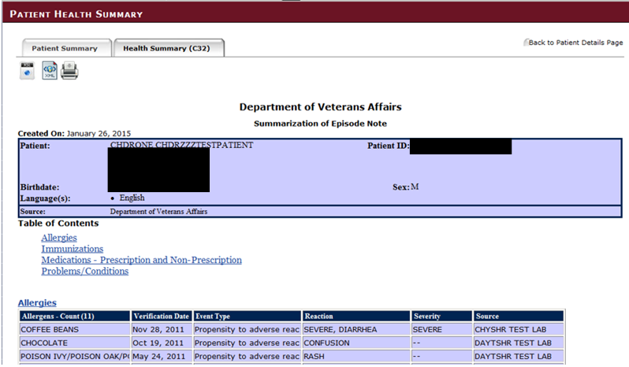

Figure 22: Patient Details Screen / Health Summary (C32) Tab – Top

The Health Summary information includes the date the record was created (month, dd, yyyy), the patient’s name (first name and last name), the patient’s Veterans Health Information Systems and Technology Architecture (VistA) Integration Control Numbers (ICNs), contact information (street address, city, state, ZIP Code, and home phone number) for the patient, date of birth (month, dd, yyyy), sex (Male or Female), language or languages, and the source of this information.

This screen (shown in Figure 22 to Figure 25) contains a large amount of information, more information than can be displayed in a standard window. Use the scroll bar at the right of the screen to scroll down to reveal any information not displayed when you first select the tab.

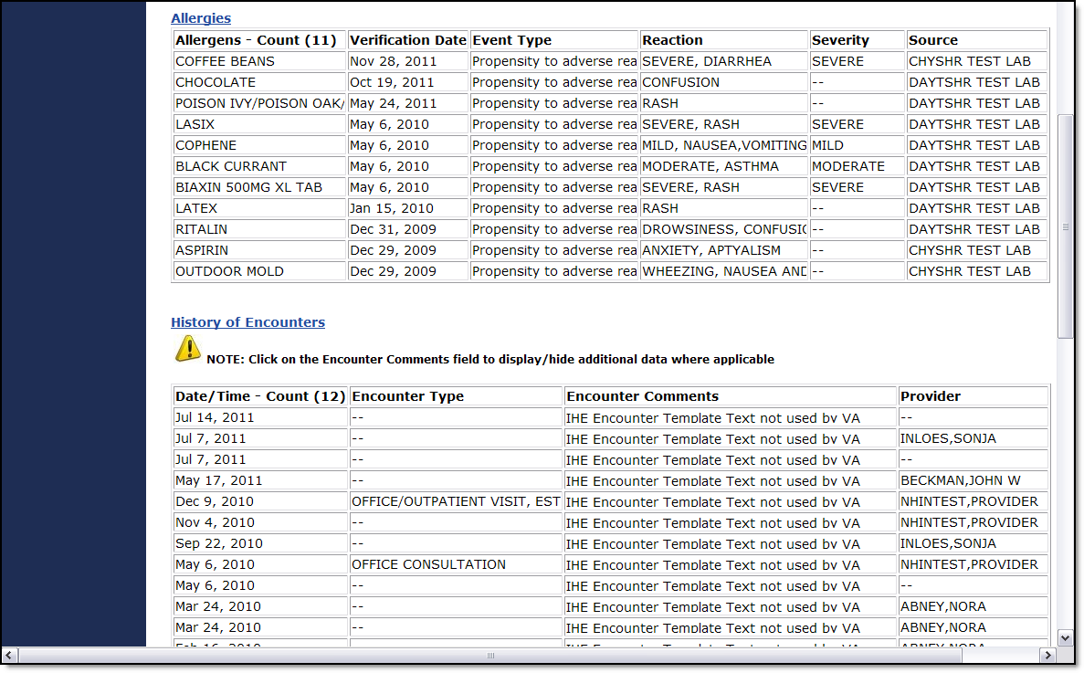

Figure 23: Patient Details Screen / Health Summary / Medical History, Part 1

The following patient medical history information can appear at the bottom of the screen as shown in Figure 23 to Figure 25. (Not all categories appear for every patient.) A dynamic internal Table of Contents before this section contains links that provides direct access to each category of patient information. This information cannot be deleted or modified.

* The Allergies category (Figure 23) displays the following information for each entry: Allergens, Count (##), Verification Date, Event Type, Reaction, Severity, and Source (## indicates the number of allergens listed).
* The History of Encounters category (Figure 23) Date / Time, Count (##), Encounter Type, Encounter Comments, and Provider (## indicates the number of encounters listed).
* The History of Procedures category (Figure 24) Date / Time, Count (##), Procedure Type, Procedure Comments, and Provider (## indicates the number of procedures listed).
* The Immunizations category (Figure 24) displays the following information for each entry: Immunizations, Count (##), Series, Date Issued, Reaction, and Comments (## indicates the number of immunizations listed).

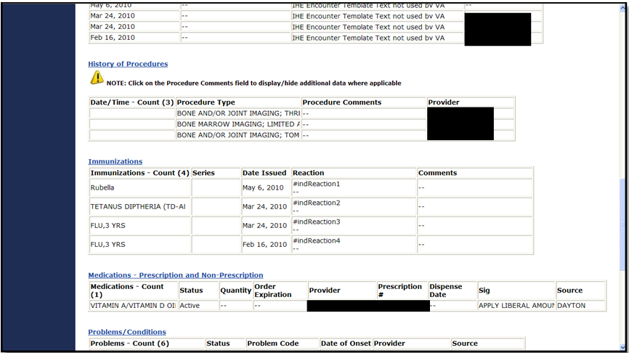

Figure 24: Patient Details Screen / Health Summary / Medical History, Part 2

* The Medications – Prescription and Non-Prescription category (Figure 24) displays the following information for each entry: Medications, Count (##), Status, Quantity, Order Expiration, Provider, Prescription #, Dispense Date, Sig, and Source (## indicates the number of medications listed).
* The Problems/Conditions category (Figure 25) displays the following information for each entry: Problems, Count (##), Status, Problem Code, Date of Onset, Provider, and Source (## indicates the number of problems listed).
* The Results category (not pictured in this example and may no longer be available) displays the following information for each entry: Date / Time, Count (##), Result Type, Source, Result Unit, Interpretation, Reference Range, Status, and Comment (## indicates the number of results listed).
* The Vital Signs category (Figure 25) displays the following information for each entry: Date, Count (##), TEMP (temperature), PULSE, RESP (respiration), BP (blood pressure), Ht (height), Ht (height) – Lying, Wt (weight), POx, OCF, and Source (## indicates the number of vital signs listed).
* The following Emergency Contact information (Figure 25) may be displayed at the end of the Medical Record: Name, address, home telephone number, and relationship to the patient.

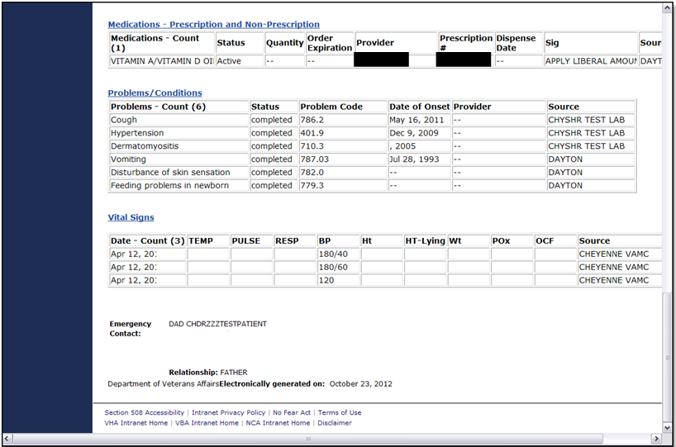

Figure 25: Patient Details Screen / Health Summary / Medical History, Part 3

## Patient Consent Directive

ROI Administrators and ROI Operators can authorize, restrict, or revoke health information record-sharing for patients who have agreed in writing to share or not share their data. By default, no electronic health information is shared across the eHealth Exchange until a valid, signed authorization form has been received. After a patient chooses to share health data with eHealth Exchange partners, the shared data is used only for treatment purposes. After a patient chooses to share health data with the SSA, the shared data is used only to determine the eligibility for benefits (coverage).

If a patient has previously authorized sharing, he or she can submit a form that lets the ROI personnel and other authorized users revoke the authorization decision.

Two items related to authorizing sharing of health information are especially noteworthy.

* If a patient has an active authorization for sharing with eHealth Exchange organizations and a new organization is added to the list of eHealth Exchange providers and organizations, the patient’s data is automatically shared with the new partner.

In most cases, a paper form is received and validated before a patient’s authorized, restricted, and revoked status can be changed. A ROI Administrator or ROI Operator enters the requested information from the form into the appropriate fields in the VAP 2.7 system application software. The form is then scanned into VistA Imaging by appropriate personnel.

### eHealth Exchange Record Sharing

This section describes how to authorize, revoke, and delay record sharing with non-VA healthcare provider organizations using eHealth Exchange, Figure 26.

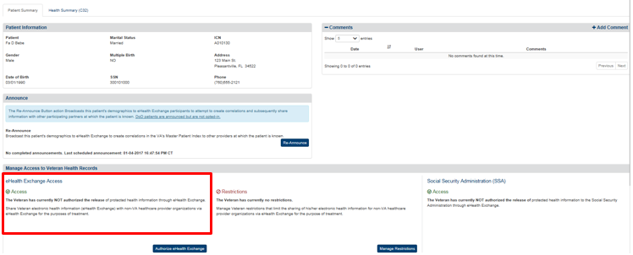

Figure 26: Patient Details Screen – Patient Has Not Authorized eHealth Exchange Record Sharing

***To Authorize Patient Health Record Sharing with eHealth Exchange***

The Manage Access to Veteran Health Records section (immediately below the Patient Information section of the Patient Summary tab) informs the user of the patient’s eHealth Exchange access status. The default option is that the health records are not shared. Health record sharing that previously has been authorized can also is revoked (see below). The message in this section describes the status of health record sharing for the individual Veteran. In this case the message reads as follows: The Veteran has currently NOT authorized the releaseof protected health information through the eHealth Exchange. The patient must authorize health record sharing before the ROI personnel and other authorized users can change the status from not authorized to authorized. VA Form 10-0485 is used to obtain patient authorization for the eHealth Exchange data sharing.

1. Click the **Authorize eHealth Button** as shown in Figure 26. This opens the Authorize eHealth Exchange dialog box as shown in Figure 27.

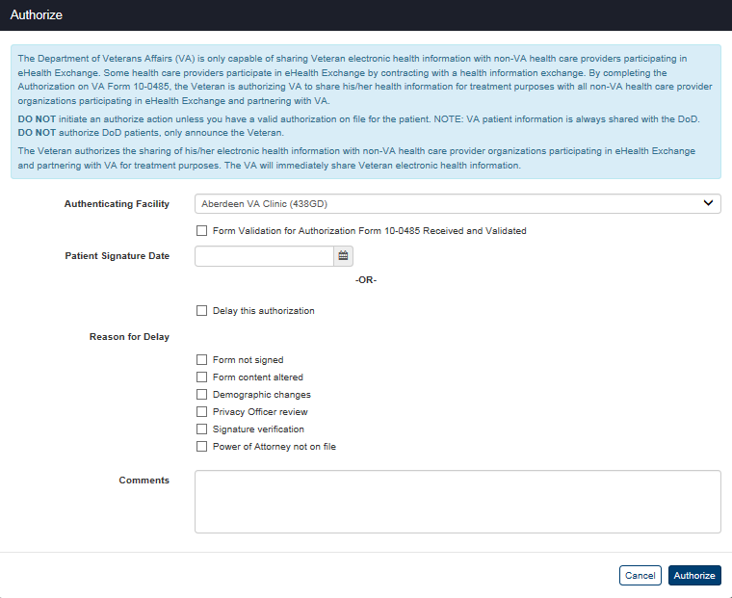

Figure 27: Patient Details Authorize eHealth Exchange Dialog Box

1. Read the information in the dialog box. “The Veteran authorizes the sharing of his/her electronic health information with non-VA health care provider organizations participating in the eHealth Exchange and partnering with VA for treatment purposes.” Do not initiate an authorize action unless you have a valid VA Form 10-0485 on file for the patient. You only announce them from the bottom of the Patient Details screen (Figure 16).
2. Select the facility that authenticated the patient’s request for authorization from the list in the Authenticating Facility list box (required). The default authenticating facility is selected based on the Location Code (characters four through six) used in the ROI user’s VA User ID. (A complete list of all approved Location Codes is available at <http://vaww4.va.gov/NamingConventions/ApprovedLOCATIONCodes.asp>. Not all codes correspond to VistA facilities.)
3. Check the 10-0485 Form Validation checkbox to verify that an Authorization Form was received and validated (required).
4. Enter the date (format: mm/dd/yyyy) of the patient’s signature from the Authorization Form in the Patient Signature Date field (required). The date of the signature for eHealth Exchange authorizations must be between the current date and a date no more than five (5) years prior to the current date. You can also select the date from the date range picker dropdown.

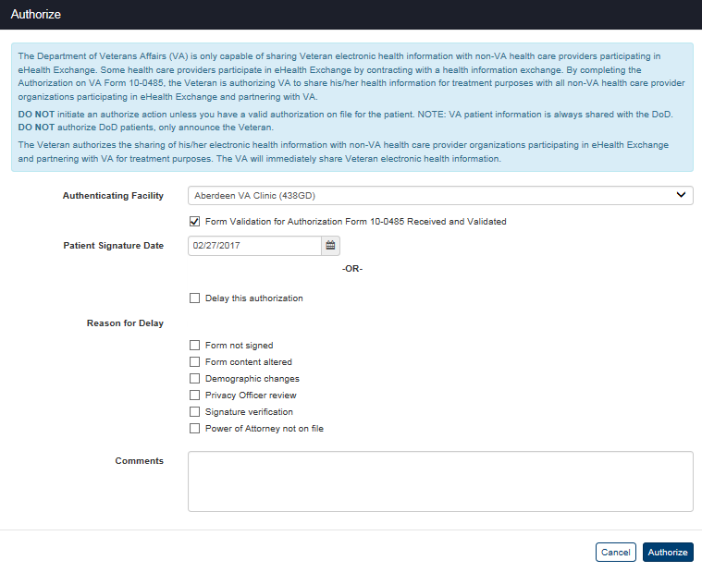

Figure 28: Patient Details Authorize eHealth Exchange Dialog Box – Ready to Authorize

1. Click the **Authorize** button to authorize record sharing for the patient. (The Authorize transaction will not be completed until all required fields are filled out.). The VAP 2.7 system creates the authorization and displays the Patient Details screen with the Status History and eHealth Exchange Correlations (Figure 21) sections (if they exist).
2. The message in the Manage Access to Veteran Health Records section on the screen changes to read as follows: The Veteran has currently authorized the release of protected health information from mm/dd/yyyy [authorization date] through the eHealth Exchange, Figure 29. The authorization expires ten (10) years from the date it was signed, but it can be revoked at any time by an ROI Administrator or ROI Operator if a Veteran submits a new authorization form to request a change.
3. The menu at the top of the screen is based on your role when you logged into the application. It allows you to select other options available to your role.

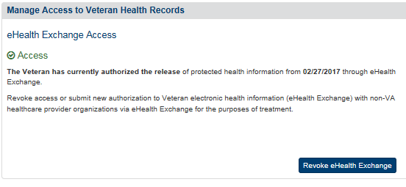

Figure 29: Patient Details – Patient Has Authorized Health Record Sharing

***To Authorize Patient Health Record Sharing using a Kiosk Device***

As a future update, the VAP project team is working with the VPS Kiosk team so the user can manage her/his consent through Kiosk devices. **Note**: Further details of how VA systems are able to use the VAP Application Programming Interface (API) web services are included within the VAP Interface Control Document. The functionality for the VPS Kiosks is not yet available until the kiosks development is completed.

***To Revoke Patient Health Record Sharing with eHealth Exchange***

The Manage Access to Veteran Health Records section (immediately below the Patient Information section of the Patient Summary tab) informs the user of the patient’s eHealth Exchange access status. The default option is that the health records are not shared. Health record sharing that previously has been authorized can be revoked. The message in this section describes the status of health record sharing for the individual Veteran. In this case the message reads as follows: The Veteran has currently authorized the releaseof protected health information through the eHealth Exchange. The patient must revoke health record sharing before the ROI personnel and other authorized users can change the status from authorized to not authorized.

1. Click the **Revoke eHealth Exchange** button as shown in Figure 29. This opens the Revoke eHealth Exchange dialog box as shown in Figure 30. **Note**: The fields on this screen change after you select an Inactivation Reason as shown in Figure 31 - Figure 34.
2. Read the information in the dialog box. Do not initiate a revocation action unless you have entered an authorization in error or have a valid VA Form10-0484 (for revocation of a previously signed authorization) or proof of death on file for the patient.
3. Select the facility that authenticated the patient’s request for revocation from the list in the Authenticating Facility list box (required). The default authenticating facility is selected based on the Location Code (characters four through six) used in the ROI user’s VA User ID. (A complete list of all approved Location Codes is available at <http://vaww4.va.gov/NamingConventions/ApprovedLOCATIONCodes.asp>. Not all codes correspond to VistA facilities).

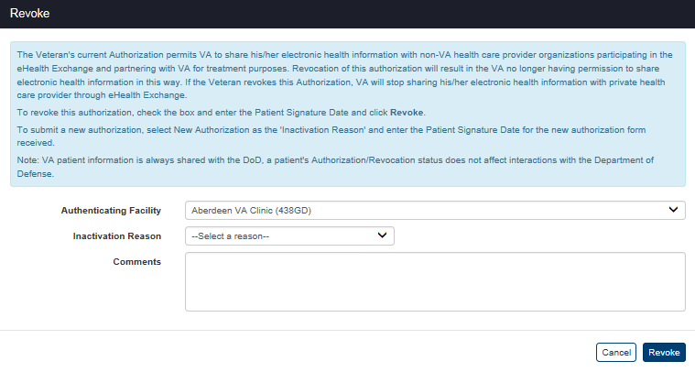

Figure 30: Patient Details Revoke eHealth Exchange Dialog Box – No Reason Selected

1. Select the reason the patient is revoking sharing from the list of reasons in the Inactivation Reason list box (required). There are four (4) available options: Entered in Error, Patient Deceased, Revoked, and New Authorization.
2. The “Entered in Error” list option activates the Revoke button without entering any additional data as shown in Figure 31. Click the Revoke button to stop sharing data after you have verified that sharing was not authorized.

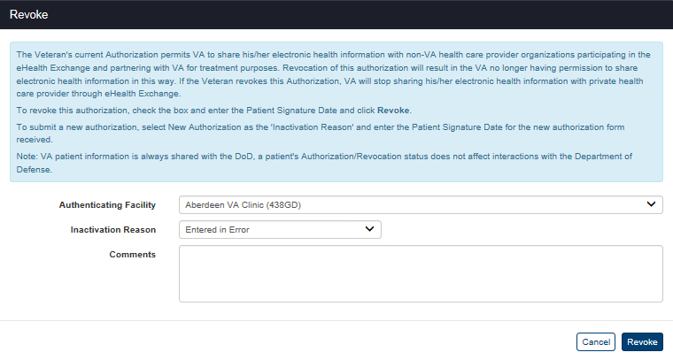

Figure 31: Patient Details with Revoke eHealth Exchange Dialog Box – Entered in Error

1. The “Revoked” list option adds the 10-0484 Form Validation check box and Patient Signature Date fields as shown in Figure 32.
2. Click the 10-0484 Form Validation checkbox to acknowledge that the patient’s revocation form was received and validated.
3. Enter the date on which the patient signed the revocation form in the Patient Signature Date field in the format mm/dd/yyyy (e.g., 12/26/2014). You can also select the date from the date range picker dropdown.
4. The date of signature for an eHealth Exchange revocation must be between the date the eHealth Exchange authorization form was signed and the current date.
5. The effective date for a manually-entered revocation is the date entered by ROI personnel and other authorized users as date- and time-stamped by the system instead of the actual date of the signature on the revocation form.
6. Click the **Revoke** button to stop sharing data after you have certified that you have a valid revocation form and entered the date on which it was signed. (The Revoke transaction will not be completed until all required fields are filled out.)

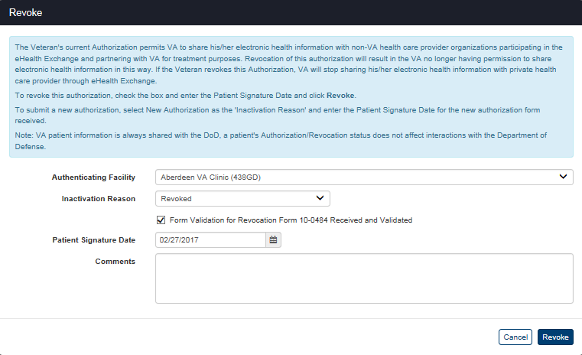

Figure 32: Patient Details Revoke eHealth Exchange Dialog Box – Revoked

1. The “Patient Deceased” list option adds the Patient Deceased Date field as shown in Figure 33.
2. Enter the date on which the patient died in the Patient Deceased Date field in the format mm/dd/yyyy (e.g., 12/26/2014). Dates of death must not be entered unless they have been verified by an official source in accordance with VHA Directive 2006-036, Guidelines for Data Entry and Maintenance Related to Identity Management. You can also select the date from the date range picker dropdown.
3. Click the **Revoke** button to stop sharing data after you have entered the date on which the patient died. (The **Revoke** transaction will not be completed until all required fields are filled out).

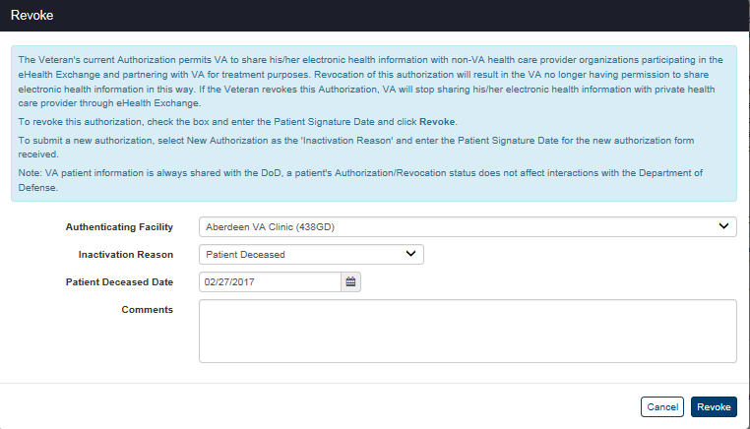

Figure 33: Patient Details Revoke eHealth Exchange Dialog Box – Patient Deceased

1. The “New Authorization” list option adds the 10-0485 Form Validation check box and Patient Signature Date fields as shown in Figure 34. “Expired Authorizations” and “Authorizations Ready to Expire” reports are available as comma-separated values (CSV) files by submitting a Remedy ticket.

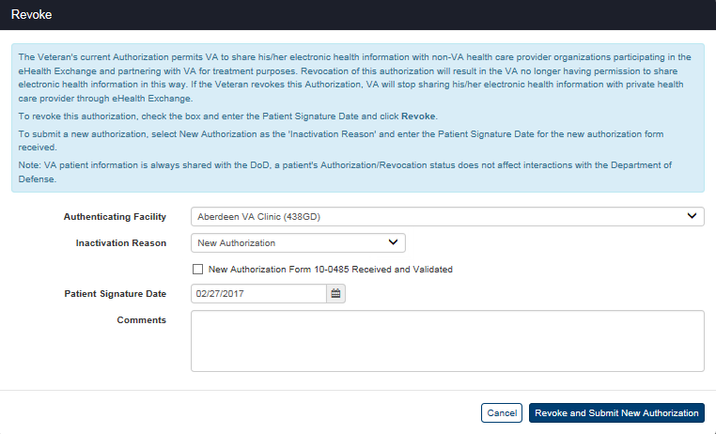

Figure 34: Patient Details Revoke eHealth Exchange Dialog Box – New Authorization

1. Click the 10-0485 Form Validation checkbox to acknowledge that the patient’s new authorization form was received and validated.
2. Enter the date on which the patient signed the new authorization form in the **Patient Signature Date** field in the format mm/dd/yyyy (e.g., 12/26/2014) (required). The date of the signature for the new authorization must be between the current date and a date no more than ten (10) years prior to the current date. You can also select the date from the date range picker dropdown.

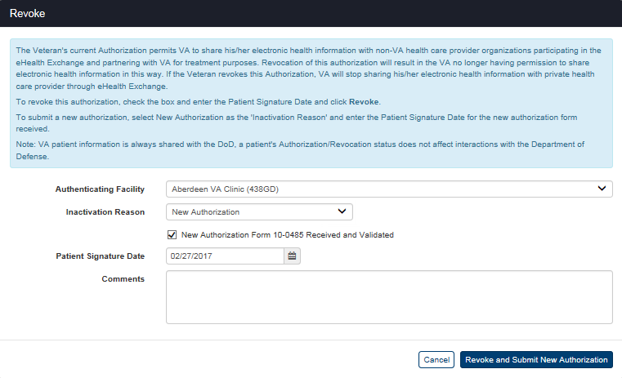

Figure 35: Patient Details Revoke eHealth Exchange Dialog Box – Ready to Revoke and Create New Authorization

1. Click the **Revoke and Submit New Authorization** button (Figure 35) to revoke the existing authorization and create a new authorization after you have certified that you have a valid new authorization form and entered the date on which it was signed. Submission of a new authorization even if it is outside of the 180 days window from the expiration date will automatically revoke the existing authorization and reset the expiration date to ten (10) years from the date the new authorization was signed. (The Revoke and Submit New Authorization transaction will not be completed until all required fields are filled out)
2. If sharing has been revoked with reasons of Revoked, Patient Deceased, New Authorization, or Entered in Error as described above, the message in the Manage Access to Veteran Health Records section on the screen changes to read as follows: “The Veteran has currently NOT authorized the release of protected health information through the eHealth Exchange,” Figure 36. The revocation remains in place until the Veteran reauthorizes sharing.

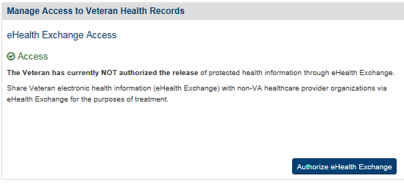

Figure 36: Patient Details – Patient Has Revoked Health Record Sharing with eHealth Exchange

1. If the current authorization is revoked and a new authorization is created, the message in the Manage Access to Veteran Health Records section on the screen changes to read as follows: “The Veteran has currently authorized the release of protected health information from {authorization date} that expires on {authorization date plus five years}, through eHealth Exchange” as shown in Figure 37. The new authorization remains in place until it expires, it is revoked, or it is revoked and another new authorization is created.



Figure 37: Patient Details Screen – Patient Has Created a New eHealth Exchange Authorization

***To Delay an Authorization due to missing or invalid information***

The Manage Access to Veteran Health Records section (immediately below the Patient Information and Announce sections of the Patient Summary tab) informs the user of the patient’s eHealth Exchange access status. The default option is that the health records are not shared. However, there are times when a form is received with missing or invalid information. In this case, consent directives may be entered as delayed by the ROI user.

1. Click the **Authorize eHealth Exchange** button as shown in Figure 36.
2. Read the information in the dialog box. Do not initiate a delayed authorize action unless you have a VA Form 10-0485 on file for the patient.
3. In certain cases, a VA Form 10-0485 is received with either missing or invalid information. In those cases, an individual’s authorization can be entered into a “delayed status” so that it can be tracked within the system.

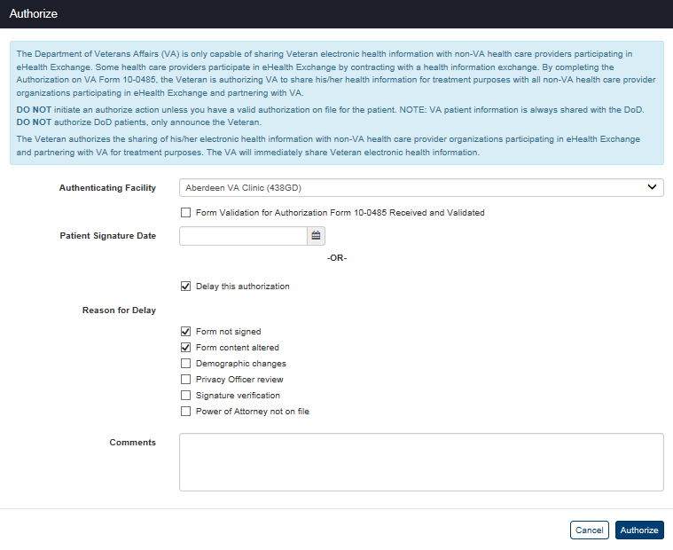

Figure 38: Delay Authorization with Reason(s) for Delay

1. Click the Delay this Authorization checkbox, shown in Figure 38, to delay authorization.
2. Multiple reasons for delay appear on screen as seen in Figure 38. These include form not signed, form content altered, demographic changes, privacy office review, signature verification, and power of attorney not on file. Check one or multiple reason(s) listed. A reason for delay must be selected in order to enter a delayed authorization into the VAP system, otherwise, the system will not allow the delay to be entered and the “Delay Authorization” button will not complete the transaction.
3. Additional space is provided to include any comments. It is not mandatory to enter a comment. As a note, all comments that are entered can be viewed on the Patient Details screen in the Status History in the row associated to the delay transaction. There is no functionality in place to delete comments; all entered comments will be stored in the system.
4. Select Authorize to save changes and delay authorization.

Once delayed, you will be able to see the status of the authorization on the Patient Details page under “Manage Access to Veterans Health Records” and “Status History” sections as seen in Figures 39 and 40. A delayed status report is in place to view both summary and detailed information on individuals in a delay.

Within the Manage Access to Veteran Health Records section, the reason for delay and delayed status is shown, in Figure 39. This section also allows the user to approve an authorization (which removes the delayed status and creates a valid authorization), cancel a delayed authorizations (which removes the delayed status but does not create a valid authorization), and print a delayed status letter. A delayed status letter is used to notify the user via print, that “one or more items are needed to provide VA with permissions to share your health information.” A preview of this letter is seen in Figure 41. You will find further steps on how to approve/cancel/print delayed statuses on the following pages.

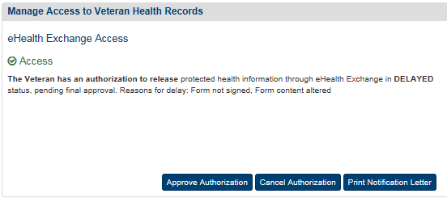

Figure 39: Delayed Status Shown in Manage Access to Veteran Health Records



Figure 40: Delayed Status Shown in Status History

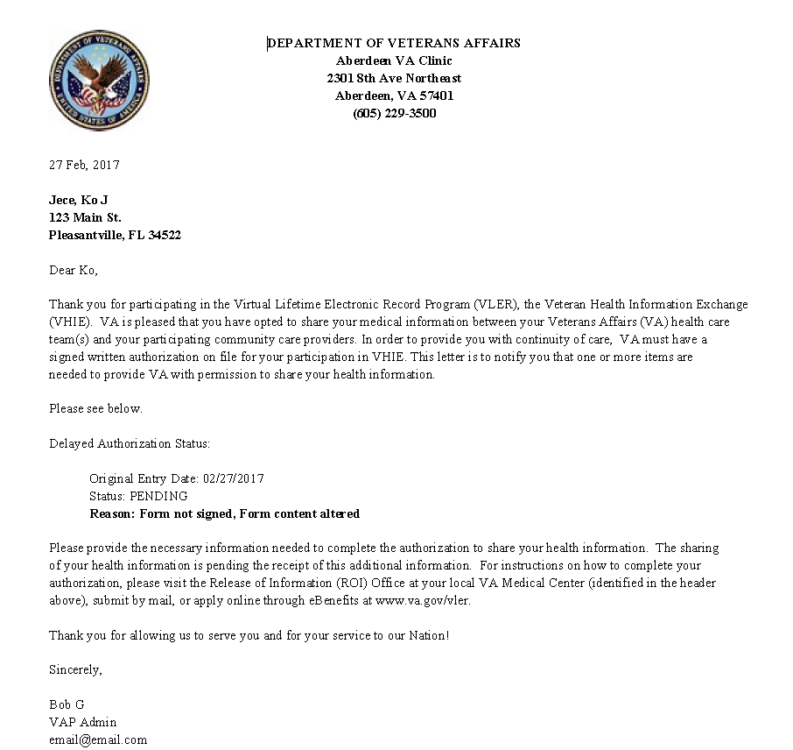

Figure 41: Notification Letter of Authorization Delay

Within the Status History table, a row is entered to show the delayed authorization event associated to the patient. In the first column, “Type of Consent Directive” the event is populated to note “Delayed eHealth Authorization.” The entry date column indicates the date the delayed consent is entered. Additionally, the “print” icon allows to generate a letter. The new entry icon allows for accessing the mailed dates functionality and adding/editing mailed dates.

***To Approve, Cancel, or Print a Delayed Authorization***

1. To remove the consent from a delayed status, click the **Approve Authorization** button seen in Figure 39 which will then direct you to the approval pop-up windows shown in Figure 42.
2. Select the facility that authenticated the patient’s request from the list in the **Authenticating Facility** list box (required). The default authenticating facility is selected based on the Location Code (characters four through six) used in the ROI user’s VA User ID. (A complete list of all approved Location Codes is available at <http://vaww4.va.gov/NamingConventions/ApprovedLOCATIONCodes.asp>. Not all codes correspond to VistA facilities).

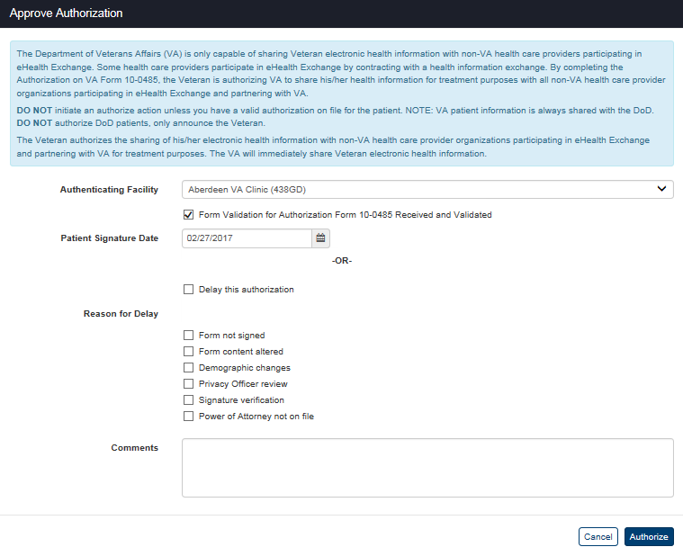

Figure 42: Approve Pending eHealth Exchange Authorization

1. Click the 10-0485 Form Validation checkbox to acknowledge that the patient’s approval authorization form was received and validated.
2. Enter the date on which the patient signed the approval authorization form in the **Patient Signature Date** field in the format mm/dd/yyyy (e.g., 12/26/2014) (required). The date of the signature for the new authorization must be between the current date and a date no more than ten (10) years prior to the current date. You can also select the date from the date range picker dropdown.
3. Click the **Authorize** button to approve record sharing for the patient. (The **Authorize** transaction will not be completed until all required fields are filled out.). This chance can now be seen in Status History under Patient Details page.
4. To cancel the delayed authorization, click the **Cancel Authorization** button seen in Figure 39 which will then direct you to the cancelation pop-up windows shown in Figure 43.

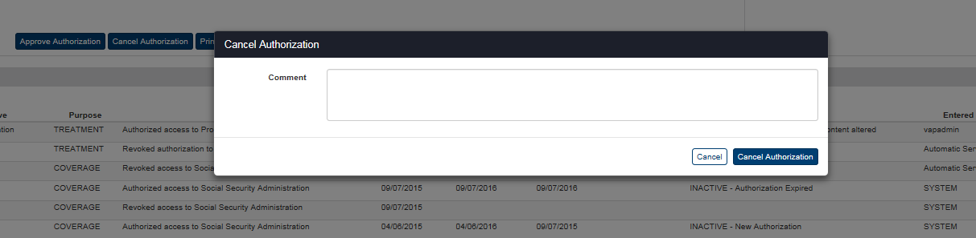

Figure 43: Cancel Pending eHealth Exchange Authorization

1. Enter a new comment in the box explaining the reasoning behind the cancellation decision. This field is required.
2. The **Cancel Authorization** transaction will not be completed until a comment is entered.
3. To print the delay notification letter, click the **Print Notification Letter** button under Manage Access to Veteran Health Records, Figure 39.

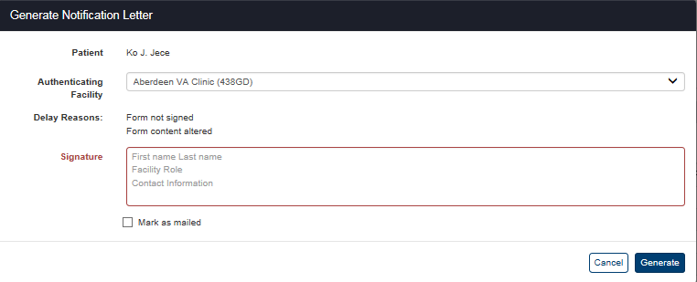

Figure 44: Generate Notification Letter of Authorization Delay

* 1. Click the arrow at the right of Authenticating Facility list box to select the patient’s authenticating facility (Figure 44).
  2. Enter a signature in the “signature” field box with your Name (First and Last), Facility Role, and Contact Information. (The **Generate** transaction will not be completed until all required fields are filled out.)
  3. Click the checkbox to mark the letter as mailed.
  4. Click the **Generate** button to generate the notification letter of authorization delay. An example of this letter can be seen from Figure 41.
  5. Once generated, the letter then appears in Status History Report. To Edit, Add, or Delete the Mailed Date, click the icon under “Mailed Dated” as show in Figure 45.

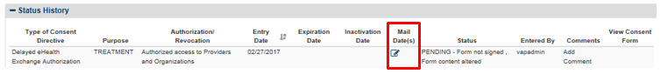

Figure 45: Status History – Click Edit Icon to Edit/Add/Delete Mailed Dates

* 1. Once the pop-up window (Figure 46) appears, you can edit the date currently selected. To delete a date, click the red trash icon shown to the right of the Date box, also shown in Figure 47. Then, to add another date, click the “Add another” link below the Date box, this can be seen in Figure 48. Click on the date field for the calendar to pop-up to select the date. The system will not allow the user to enter duplicate dates.

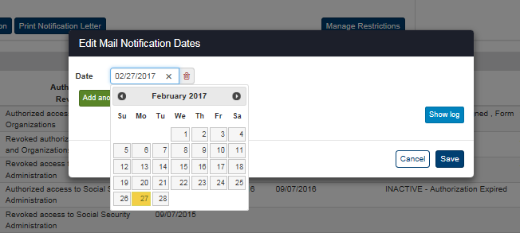

Figure 46: Mailed Date(s) – Edit Current Date

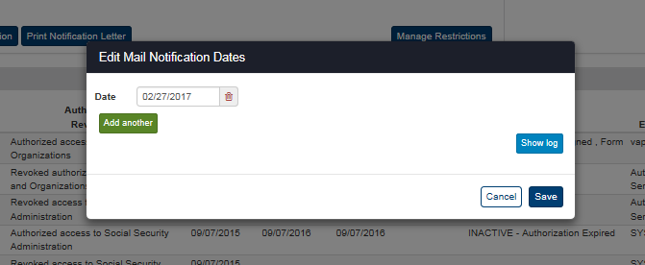

Figure 47: Mailed Date(s) – Red Trash Icon to Delete Mailed Date(s)

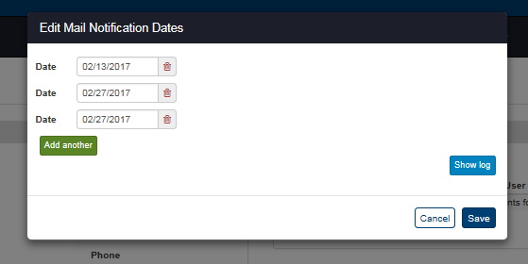

Figure 48: Mailed Date(s) – Add another Mailed Date(s)

**Note**: By selecting the “Show Log” feature, additional details can be seen of when a mailed date was added/modified/or deleted, as well as the user whom initiated the change.

### Restricting eHealth Exchange Record Sharing

This section describes how to create, view, modify, and revoke restrictions to record sharing with eHealth Exchange.

To Create Patient Health Record Sharing Restrictions with eHealth Exchange

ROI personnel and other authorized users can create eHealth Exchange record sharing restrictions for only one (1) provider and/or organization as requested by a Veteran. Restrictions should not be created unless the ROI personnel and other authorized users entering the restriction has a valid signed and dated VA Form 10-0525a completed by the Veteran requesting the restriction or restrictions.

1. Click the **Manage Restrictions** button under the Restrictions subheading of the Manage Access to Veteran Health Records section of the Patient Summary tab on the Patient Details screen (Figure 49). This opens the eHealth Exchange Restrictions dialog box as shown in Figure 50 and Figure 51.

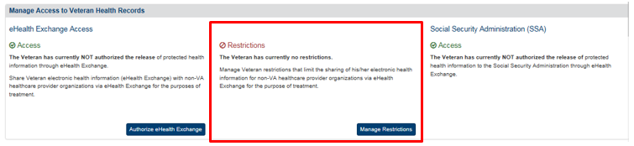

Figure 49: Patient Details Screen – Patient Has Not Restricted Health Record Sharing

1. Read the information in the dialog box. Do not initiate a restriction action unless you have a valid VA Form 10-0525a on file for the patient.
2. Select organizations from the list of allowed organizations in the All Providers and Organizations box on the left of the screen shown in Figure 50 and Figure 51 and move them to the eHealth Exchange Providers and Organizations who will NOT have access to the records box on the right of the screen.
3. Click the **Move All >>** button to move all organizations from the All Providers and Organizations box to the second box. This adds all of these providers and organizations to the list of providers and organizations that will not have access to the patient’s health records. You must move at least one of the providers or organizations back to the All Providers and Organizations box before the **Restrict** button can activate.
4. You can choose to add specific providers and/or organizations to the list of providers and organizations that will not have access to the patient’s health records. Select one or more providers and organizations from the list in the All Providers and Organizations box. Click a single name to select one provider or organization or hold the **Ctrl** key down while clicking more than one provider or organization name to select multiple (but not all) providers and/or organizations (Figure 51). Double-clicking on the name of a provider or organization in the list also moves that name to the eHealth Exchange Providers and Organizations who will NOT have access to the records box.

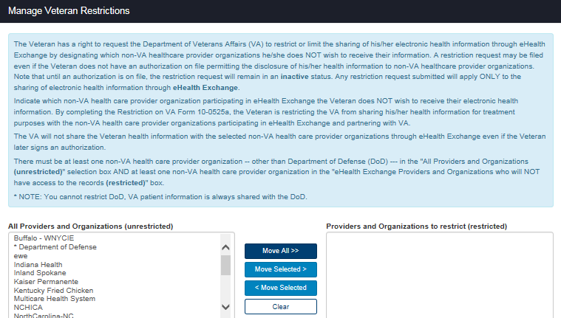

Figure 50: Patient Details eHealth Exchange Restrictions Dialog Box – Top

1. Click the **Move Selected >** button to move the selected providers and/or organizations to the eHealth Exchange Providers and Organizations who will NOT have access to the records box. The names of the selected providers and/or organizations disappear from the All Providers and Organizations box after they have been moved.
2. You can remove individual providers and organizations that were on the restricted list. Select one or more providers and/or organizations from the list on the right side in the eHealth Exchange Providers and Organizations who will NOT have access to the records box. Click a single name to select one provider or organization or hold the **Ctrl** key down while clicking more than one (but not all) provider and/or organization names to select multiple providers and/or organizations. Double-clicking on the name of a provider or organization in the list also moves that name back to the All Providers and Organizations box.
3. Click the **< Move Selected** button to move all selected providers and/or organizations to the All Providers and Organizations box. The names of the selected providers and/or organizations disappear from the eHealth Exchange Providers and Organizations who will NOT have access to the records box after they have been moved.
4. Click the **Clear** button to remove all of the previously selected providers and/or organizations from the eHealth Exchange Providers and Organizations who will NOT have access to the records box.

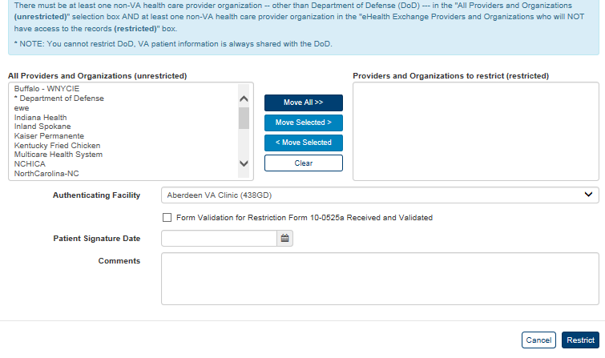

Figure 51: Patient Details Screen with eHealth Exchange Restrictions Dialog Box – Bottom

1. Select the facility that authenticated the patient’s request to restrict access from the list in the Authenticating Facility list box (required). The default authenticating facility is selected based on the Location Code (characters four through six) used in the ROI user’s VA User ID. (A complete list of all approved Location Codes is available at <http://vaww4.va.gov/NamingConventions/ApprovedLOCATIONCodes.asp>. Not all codes correspond to VistA facilities.)
2. Check the 10-0525a Form Validation check box to verify that a restriction form was received and validated (required). Checking this check box activates the Restrict button (Figure 52) as long as there is at least one other entry in the All Providers and Organizations.
3. Enter the date (format: mm/dd/yyyy) of the patient’s signature from the restriction form in the Patient Signature Date field (required). The date of the signature for eHealth Exchange restrictions must be less than or equal to the current date. You can also select the date from the date range picker dropdown.

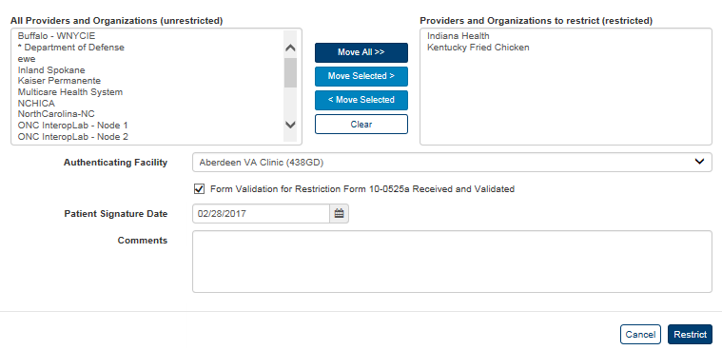

Figure 52: eHealth Exchange Restrictions Dialog Box – Ready to Restrict

1. Click the **Restrict** button. This displays the Patient Details screen. The Manage Access to Veteran Health Records Restrictions section shows two new links: View/Modify Veteran’s existing restrictions and Revoke or terminate Veteran’s existing restrictions. Restrictions remain in place until specifically revoked or replaced by the Veteran. If an active authorization is not on file permitting the disclosure of health information through the eHealth Exchange, the restriction remains in an “inactive” status until an active authorization is filed.
2. The menu at the top of the screen is based on your role when you logged into the application. It allows you to select other options available to your role.

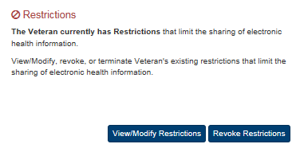

Figure 53: Patient Details Screen after Successful Restrictions Authorization

To View and Modify Patient Health Record Sharing Restrictions with eHealth Exchange

ROI personnel and other authorized users can view and modify (add or remove) eHealth Exchange record sharing restrictions for single or multiple providers and/or organizations as requested by a Veteran. Restrictions should not be modified unless the ROI personnel and other authorized users entering the restriction has a valid signed and dated VA Form 10-0525a completed by the Veteran requesting that the restriction or restrictions be modified. There must be at least one provider in the All Providers and Organizations (left) box in order to restrict sharing.

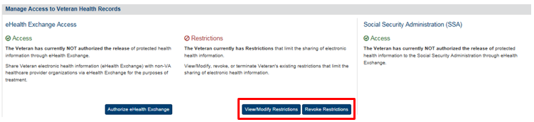

Figure 54: Patient Details Screen – Restrictions View/Modify Option

1. Click the **View/Modify Restrictions** button under the Restrictions subheading of the Manage Access to Veteran Health Records section of the Patient Summary tab on the Patient Details screen (Figure 54). This opens the View/Modify eHealth Exchange Organization Restrictions dialog box, shown in Figure 55 and Figure 56, which allows the ROI personnel and other authorized users to view any existing record sharing restrictions for the patient currently being reviewed.
2. Read the information in the dialog box. Do not initiate a modify action unless you have a valid VA Form 10-0525a on file for the patient. VA patient information is always shared with the DoD, so any action you can perform here does not stop sharing with the DoD.

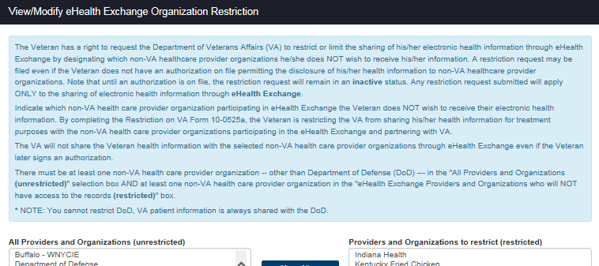

Figure 55: Patient Details Screen with View/Modify eHealth Exchange Organization Restrictions Dialog Box – Top

1. Select organizations from the list of allowed organizations in the All Providers and Organizations box on the left of the screen and move them to the eHealth Exchange Providers and Organizations who will NOT have access to the records box on the right of the screen or vice versa.
2. Click the **Move All >>** button to move all organizations from the All Providers and Organizations box to the second box. This adds all of these providers and organizations to the list of providers and organizations that will not have access to the patient’s health records. You must move at least one of the providers or organizations back to the All Providers and Organizations box before the **Restrict** button can activate.
3. You can choose to add specific providers and/or organizations to the list of providers and organizations that will not have access to the patient’s health records. Select one or more providers and organizations from the list in the All Providers and Organizations box. Click a single name to select one provider or organization or hold the **Ctrl** key down while clicking more than one provider or organization name to select multiple (but not all) providers and/or organizations (Figure 56). Double-clicking on the name of a provider or organization in the list also moves that name to the eHealth Exchange Providers and Organizations who will NOT have access to the records box.

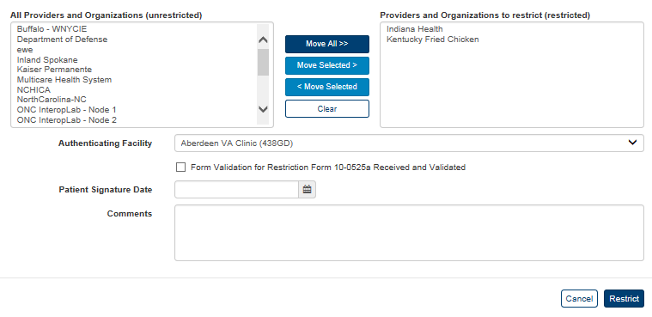

Figure 56: Patient Details Screen with View/Modify eHealth Exchange Organization Restrictions Dialog Box – Bottom

1. Click the **Move Selected** > button to move the selected providers and/or organizations to the eHealth Exchange Providers and Organizations who will NOT have access to the records box. The names of the selected providers and/or organizations disappear from the All Providers and Organizations box after they have been moved.
2. You can remove individual providers and organizations that were on the restricted list. Select one or more providers and/or organizations from the list on the right side in the eHealth Exchange Providers and Organizations who will NOT have access to the records box. Click a single name to select one provider or organization or hold the **Ctrl** key down while clicking more than one (but not all) provider and/or organization names to select multiple providers and/or organizations. Double-clicking on the name of a provider or organization in the list also moves that name back to the All Providers and Organizations box.
3. Click the < **Move Selected** button to move all selected providers and/or organizations to the All Providers and Organizations box. The names of the selected providers and/or organizations disappear from the eHealth Exchange Providers and Organizations who will NOT have access to the records box after they have been moved.
4. Click the **Clear** button to remove all of the previously selected providers and/or organizations from the eHealth Exchange Providers and Organizations who will NOT have access to the records box.

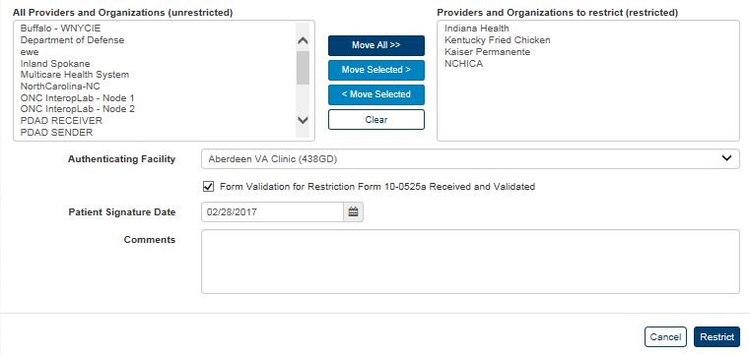

Figure 57: View/Modify eHealth Exchange Organization Restrictions Dialog Box – Ready to Modify

1. Select the facility that authenticated the patient’s request to restrict access from the list in the Authenticating Facility list box (required). The default authenticating facility is selected based on the Location Code (characters four through six) used in the ROI user’s VA User ID. (A complete list of all approved Location Codes is available at <http://vaww4.va.gov/NamingConventions/ApprovedLOCATIONCodes.asp>. Not all codes correspond to VistA facilities).
2. Check the 10-0525a Form Validation check box to verify that a restriction form was received and validated (required).
3. Enter the date (format: mm/dd/yyyy) of the patient’s signature from the restriction form in the Patient Signature Date field (required). The date of the signature for eHealth Exchange restrictions must be between the current date and a date no more than five years prior to the current date. You can also select the date from the date range picker dropdown.
4. Click the **Restrict** button. (The **Restrict** button is not activated until all required fields have been filled and there is at least one entry in each box on the screen, excluding the Comments box.) This displays the Patient Details screen. If at least one restriction remains, the Manage Access to Veteran Health Records Restrictions section shows the same two links (i.e., the options do not change): View/Modify Veteran’s existing restrictions and Revoke or terminate Veteran’s existing restrictions (Figure 58). Restrictions remain in place until specifically revoked or replaced by the Veteran. If an active authorization is not on file permitting the disclosure of health information through the eHealth Exchange, the restriction remains in an “inactive” status until an active authorization is filed.
5. You cannot remove all restrictions using this process. You must select the **Revoke** **Restrictions** button as shown in Figure 58 Patient Details Screen – Restrictions Revocation Option, and documented in the next section.
6. The menu at the top of the screen is based on your role when you logged into the application. It allows you to select other options available to your role.



Figure 58: Patient Details Screen after Successful Restrictions Modification

To Revoke Patient Health Record Sharing Restrictions with eHealth Exchange

ROI personnel and other authorized users can revoke (terminate) eHealth Exchange record sharing restrictions for all providers and/or organizations as requested by a Veteran. Restrictions should not be revoked unless the ROI personnel and other authorized users entering the revocation has a valid signed and dated VA Form10-0525 completed by the Veteran requesting that the restriction or restrictions be revoked.

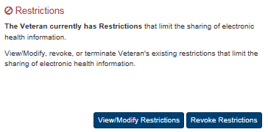

Figure 59: Patient Details Screen – Restrictions Revocation Option

1. Click the **Revoke Restrictions** button under the Restrictions subheading of the Manage Access to Veteran Health Records section of the Patient Summary tab on the Patient Details screen. This opens the Revoke or Terminate eHealth Exchange Organization Restriction dialog box shown below.
2. Read the information in the dialog box. Do not initiate a revocation action unless you have entered a restriction in error or have a valid VA Form 10-0525 or proof of death on file for the patient. VA patient information is always shared with the DoD, so any action you can perform here does not stop sharing with the DoD.
3. Select the facility that authenticated the patient’s request for revocation from the list in the **Authenticating** **Facility** list box (required). The default authenticating facility is selected based on the Location Code (characters four through six) used in the ROI user’s VA User ID. (A complete list of all approved Location Codes is available at <http://vaww4.va.gov/NamingConventions/ApprovedLOCATIONCodes.asp>. Not all codes correspond to VistA facilities).

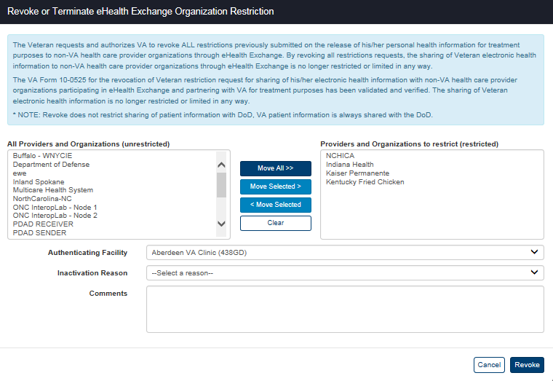

Figure 60: Patient Details Screen with Revoke Restrictions Dialog Box – No Reason Selected

1. Select the reason the patient is revoking restrictions from the list of reasons in the **Inactivation Reason** list box (required). There are three available options: Entered in Error, Patient Deceased, and Revoked.
2. The “Entered in Error” list option activates the **Revoke** button without entering any additional data as shown in Figure 61. Click the **Revoke** button to revoke the sharing restrictions.

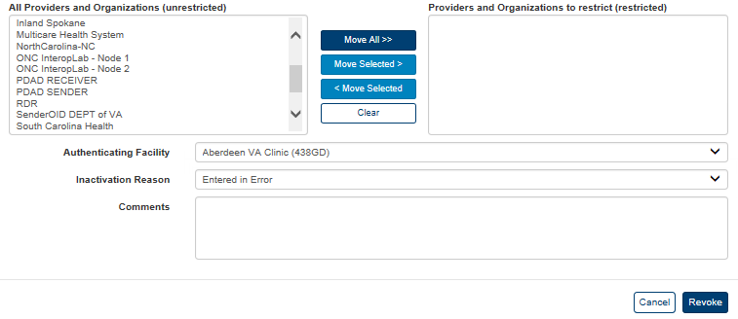

Figure 61: Patient Details Screen with Revoke Restrictions Dialog Box – Entered in Error

1. The “Revoked” list option adds the 10-0525 Form Validation check box and Patient Signature Date fields as shown in Figure 62.
2. Click the 10-0525 Form Validation checkbox to acknowledge that the patient’s restrictions revocation form was received and validated.
3. Enter the date on which the patient signed the revocation form in the **Patient Signature Date** field in the format mm/dd/yyyy. You can also select the date from the date range picker dropdown.
4. The date of signature for an eHealth Exchange restrictions revocation must be between the date the eHealth Exchange restrictions authorization form was signed and the current date.
5. The effective date for a manually-entered restriction revocation is the date entered by ROI personnel and other authorized users as date- and time-stamped by the system instead of the actual date of the signature on the restrictions revocation form.
6. The **Revoke** button is not activated until all required fields have been filled. Click the **Revoke** button to revoke the sharing restrictions after you have certified that you have a valid restrictions revocation form and entered the date on which it was signed.

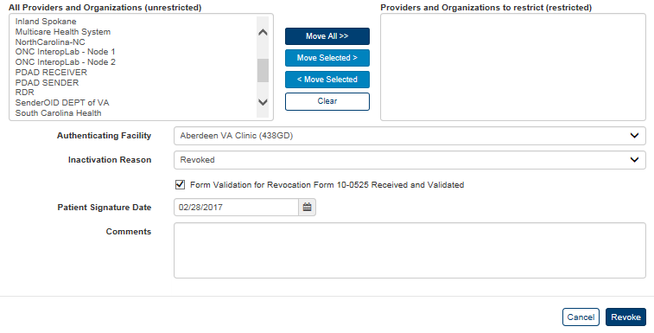

Figure 62: Patient Details Screen with Revoke Restrictions Dialog Box – Revoked

1. The “Patient Deceased” list option adds the Patient Deceased Date field as shown in Figure 63.
2. Enter the date on which the patient died in the Patient Deceased Date field in the format mm/dd/yyyy. Dates of death must not be entered unless they have been verified by an official source in accordance with VHA Directive 2006-036, Guidelines for Data Entry and Maintenance Related to Identity Management. You can also select the date from the date range picker dropdown.
3. Click the **Revoke** button to revoke the sharing restrictions after you have entered the date on which the patient died, (The Revoke transaction will not be completed until all required fields are filled out).

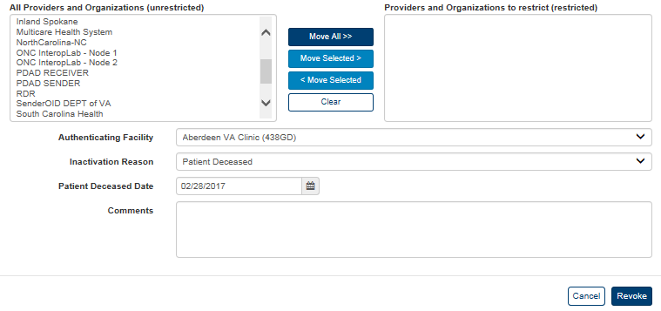

Figure 63: Patient Details Screen with Revoke Restrictions Dialog Box – Patient Deceased

1. Successfully revoking sharing restrictions displays the Patient Details screen. All restrictions are removed by this process and the **View/Modify Restrictions** and **Revoke Restrictions** buttons in the Restrictions section are replaced with the **Manage Restrictions**. If the Veteran has an active eHealth Exchange authorization on file, sharing with all eHealth Exchange organizations (i.e., unrestricted sharing) will resume.
2. The menu at the top of the screen is based on your role when you logged into the application. It allows you to select other options available to your role.



Figure 64: Patient Details Screen after Successful Restrictions Revocation

***To Create or Revoke Patient Health Record Sharing Restrictions with Trusted VA Systems***

VAP Subsystem 2.7 enhancements will allow Veterans to manage their health consent directives electronically through VA systems leveraging the VAP API web services. This functionality enables systems to submit a web service request for consent management information and creates a “plug-in” between the two systems. As VA systems leverage the web service functionality, this User Guide will be updated to note that other entry points for consent management.

## Admin

From a system owner and users perspective, system functions were desired to allow for tracking and management of trusted partners. Additionally, functionality was desired to allow other systems to verify if a partner is trusted prior to accepting or transferring data to be processed by internal VA systems. Within the “Admin” area of the VAP application, pages were created that display the list of partners, details if the partner is active, whether or not these partners are trusted clinical sources, and any associated details related to the Organization such as contact details. VAP Admins have the capability to edit certain details related to a partner, such as name, phone, and check if they are trusted.  Additionally, capability is provided allowing the Admin to export the list of partners to excel. Within Release 2.7.0, administrators will have the

### Batch Announce Patients

Announcements are made to share patient identifiers, such as ICNs, with partner systems to facilitate data sharing. Announcements occur automatically when you authorize sharing of patient records. ROI personnel and other authorized users can make ad hoc announcements by clicking the **Announce** button (Figure 16).

Batch Announcements offer an alternate mechanism to accomplish the above. It allows ROI Administrators to selectively announce to one or many eHealth Exchange organizations.

The fields in the Batch Announce Criteria box on the Batch Announcements Patients screen (Figure 65 and Figure 66) allow you to make announcements to one or more eHealth Exchange organizations for patients who have authorized sharing within a specified date range. Batch Announce functionality allows ROI personnel and other authorized users to announce all the patients who have authorized sharing to a new eHealth Exchange organization when the partner gets access to the application or who have contained in an uploaded Excel or CVS file.

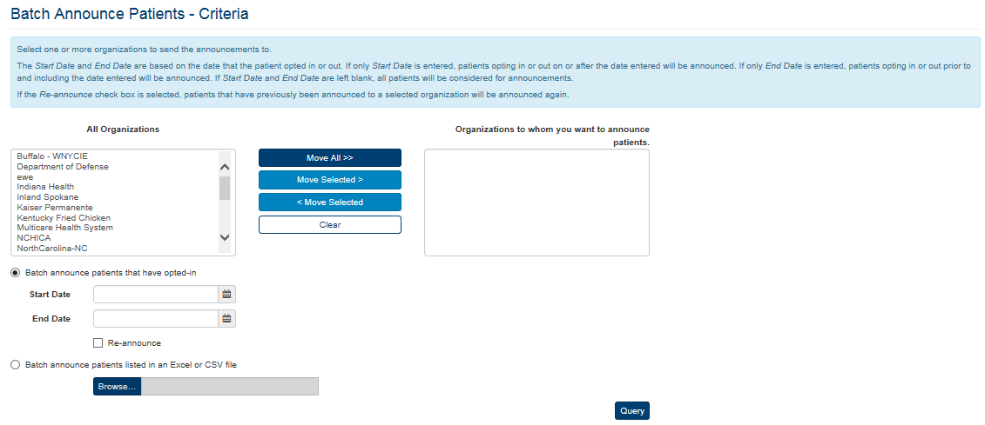

Figure 65: Batch Announcement Patients Screen – No Selections

To Batch Announce Patients That Have Opted-In

1. Click the **Batch Announce Patients** menu item under the **Admin** menu at the top of the screen to display the Batch Announce Patients screen.
2. Select organizations from the list of allowed organizations to which you want to announce patients in the All Organizations box on the left of the screen and move them to the “Organizations to which you want to announce patients” box on the right of the screen.
3. Click the **Move All** >> button to move all organizations from the All Organizations box to the second box. This adds all of these providers and organizations to the list of providers and organizations that will receive announcements.
4. You can choose to add individual organizations to which you want to announce patients who have authorized record sharing. Select one or more organizations from the list in the All Organizations box. Click a single name to select one organization or hold the **Ctrl** key down while clicking more than one organization name to select multiple organizations (Figure 66). Double-clicking on the name of an organization in the list also moves that name to the Organizations to which you want to announce patient’s box.
5. Click the **Move Selected** **>** button to move selected organizations to the Organizations to which you want to announce patients box. The names of the selected organizations disappear from the All Organizations box after they have been moved.
6. You can remove individual organizations that were on the list to which you want to announce the patient. Select one or more organizations from the list on the right side under Organizations to whom you want to announce patient’s box. Click a single name to select one organization or hold the **Ctrl** key down while clicking more than one organization name to select multiple organizations. Double-clicking on the name of an organization in the list also moves that name back to the All Organizations box.
7. Click the **<** **Move Selected** button to move all selected organizations to the All Organizations box. The names of the selected organizations disappear from the Organizations to whom you want to announce patients box after they have been moved.

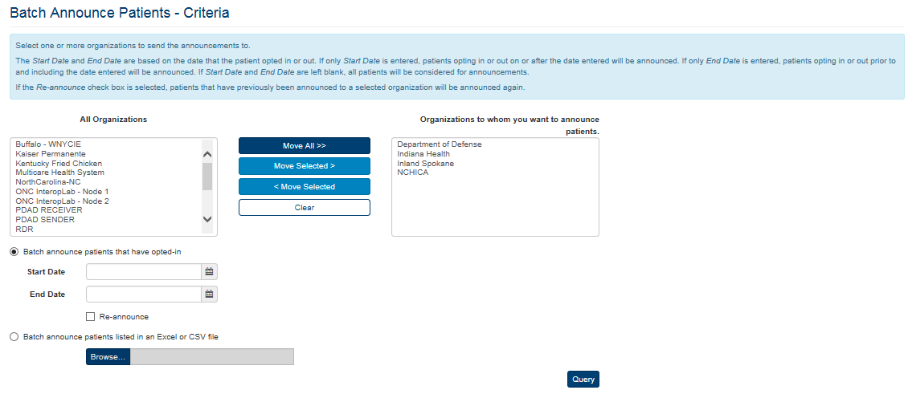

Figure 66: Batch Announcement Patients Screen – Organizations Selected

1. Click the **Clear** button to remove all of the previously selected organizations from the Organizations to whom you want to announce patient’s box. If you exercise this option, you must repopulate the Organizations to which you want to announce patient’s box before you can announce patients.
2. Select “Batch announce patients that have opted-in” radio button.
3. Enter the start date for the announcement in the **Start Date** field in the format mm/dd/yyyy (e.g., 01/05/2015). This date reflects the earliest date from which records will be shared. Leave the date fields blank if you want to announce all of the patients who have authorized record sharing who have not been announced. You can also select the date from the date range picker dropdown.
4. Enter the end date for the announcement in the **End Date** field in the format mm/dd/yyyy (e.g., 01/06/2015). This date reflects the latest date from which records will be shared. Leave this field blank if you only want to announce patients who have authorized record sharing on or after the date entered in the Start Date field. You can also select the date from the date range picker dropdown.
5. Click the **Re-announce** check box if you want to re-announce patients who have authorized record sharing and have previously been announced.
6. Click the **Query** button. This displays the Batch Announce Patients Results screen. This box shows the patient counts associated with the batch announcements directed to each organization (Figure 67). The result shows the number of patients who have been announced to each individual organization.

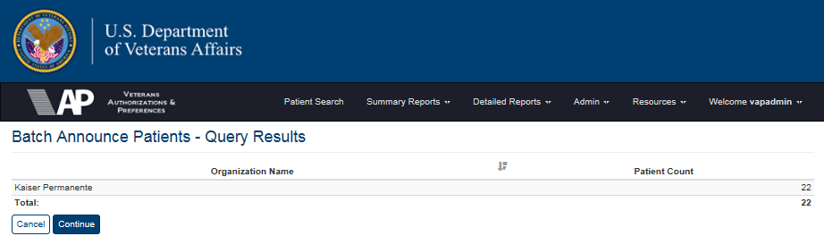

Figure 67: Batch Announce Patients Screen - Announcement Review

1. Click the **Continue** button to begin the announcements and display the Manage Batches Query screen as shown in Figure 67. Clicking this button initiates the Manage Batches process as described in the next section. Click the Cancel button to stop the announcement process.
2. If the search yields no results as shown in Figure 68, no announcements have been made recently. You must return to the Batch Announcements screen, select one or more Organizations, and select a date or range of dates if appropriate. Click the Re-announce check box before you click the Query button. The Batch Announce Patients Query Results screen will display the results for the Organizations that you re-announced.

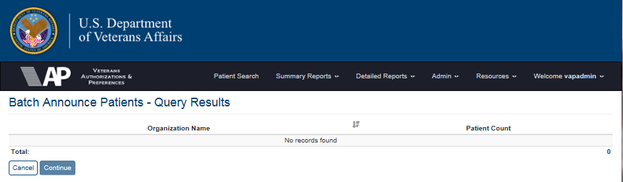

Figure 68: Batch Announce Patients Results Screen - No Patients Found

1. The menu at the top of the screen is based on your role when you logged into the application. It allows you to select other options available to your role.

***To Batch Announce Patients Listed in an Excel or CVS File***

1. Click the **Batch Announce Patients** menu item under the **Admin** menu at the top of the screen to display the Batch Announce Patients screen.
2. Follow Step 2 of the Batch Announce Patient That Have Opted-In section above to select organizations from the list of allowed organizations to which you want to announce patients in the All Organizations box on the left of the screen and move them to the “Organizations to which you want to announce patients” box on the right of the screen.
3. Select “Batch announce patients listed in an Excel or CVS file” radio button.
4. Click the **Browse** button to select the desired file from your local computer (Figure 69).

**Note**: The fields in the Excel or CVS file contain the Patients’ First Names, Last Names, and SSN in a sequence of 9 digits with no hyphens.

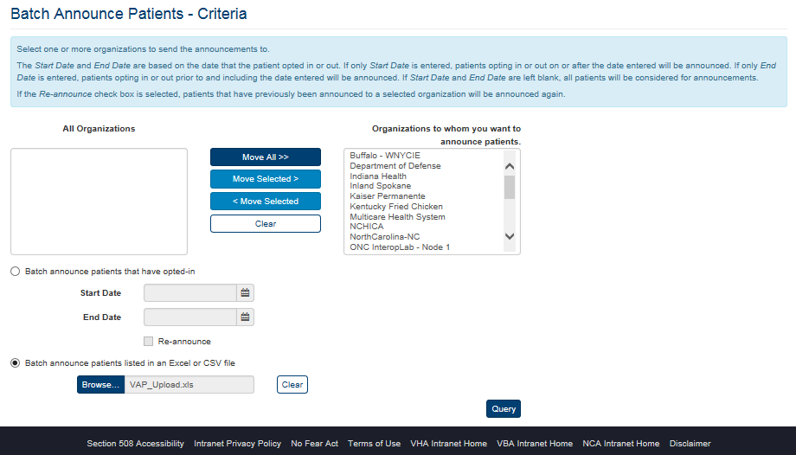

Figure 69: Batch Announce Patients Listed in an Excel or CVS File

1. If you want to remove the previously selected file, select the Clear button. Otherwise, click the **Query** button to upload the file.
2. Click the **Continue** button to begin the announcements or click the Cancel button to stop the announcement process, Figure 70.



Figure 70: Batch Announce Patients from Listed in an Excel or CVS File

### Manage Batches

ROI Administrators can manage batches after selecting the organizations to receive batch announcements. Announcements scheduled to be made to any or all organizations can be deleted from the queue.

***To Manage Batches***

1. Click the **Manage Batches** menu item under **Admin** menu at the top of the screen to display the Manage Batches Query screen (Figure 71). Clicking the **Continue** button on the Batch Announce Patients screen to begin the announcement process also displays the Manage Batch Announcements screen.
2. Enter the start date for the announcement search in the **Start Date** field in the format mm/dd/yyyy. This date reflects the earliest date of the announcements in the search. Leave this field and the End Date field blank to find all announcements regardless of their dates. You can also select the date from the date range picker dropdown.
3. Enter the end date for the announcement in the **End Date** field in the format mm/dd/yyyy. This date reflects the last date of the announcements in the search. Leave this field and the Start Date field blank to find all announcements regardless of their dates. You can also select the date from the date range picker dropdown.

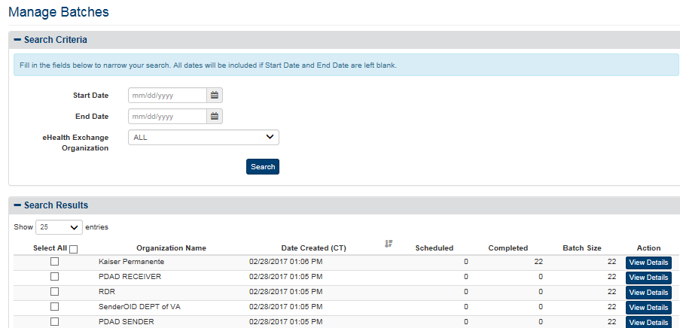

Figure 71: Manage Batches Query Screen

1. Click the arrow at the right of the **eHealth Exchange** **Organization** list box to select the organization you want to display in the report. You can only select one entry from the list. The default option for this list box is “All” so do not select a specific organization if you want to see all eHealth Exchange organizations in the report.
2. Click the **Search** button to display the Batch Announcements Search Results screen (Figure 72).
3. Click the **Show Entries** list box to select the number of records you want to display on each page of the search. The default option for this list box is “25.” In VAP 2.6.0, this has been updated to remove the “All” option for performance reasons. To allow users to display additional options, 250 and 500 records per page were added. This field now allows users to select by 10, 25, 50, 100, 250 and 500.
4. If more records are available than can be displayed on one screen, the **Previous** and **Next** buttons at the bottom right of the screens are activated. You can use these buttons to page back and forward through the list of records found by the search.
5. To select one or more organizations to be deleted from the list of organizations to which the batch announcement are directed, click the check box before the organization name or names (e.g., Kaiser Permanente) to mark them for deletion.

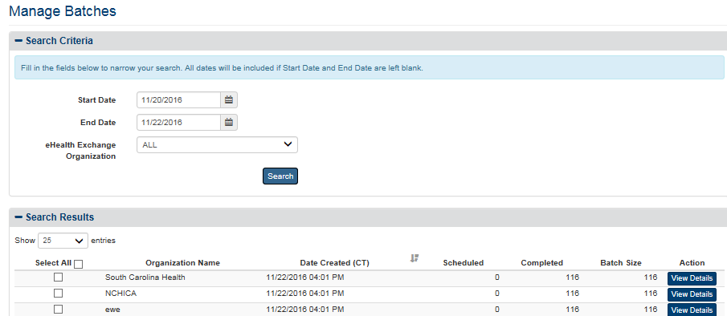

Figure 72: Batch Announcements Search Results Screen

1. When you have marked the organizations to be deleted, click the **Delete** button to remove the selected organizations from the list of organizations that receive the announcements. The list of organizations receiving announcements is refreshed to reflect the deleted organization or organizations.
2. Click the **View Details** button to view a complete list of individuals included in a batch announcement, seen in Figure 73.

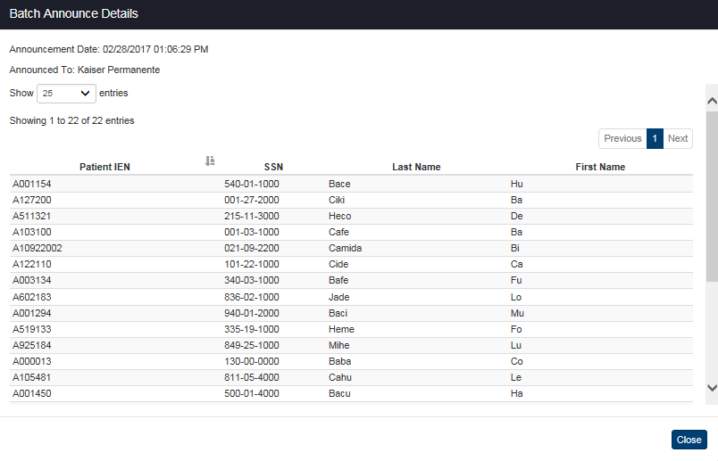

Figure 73: Batch Announce Detail Pop-Up

### Service Audit

The system provides Service Audit Reports which contain a log of all electronic information requests made to the VAP system from VA systems. Each record in these logs includes a source identifier (or which VA system made the web service request to VAP for consent management information). Specifically, a source identifier is descriptive information about the origin of the information request, tracked so that VAP administrators have knowledge of who is making data requests. These audit reports are only available to users with administrator access. The service audit reports can be filtered to identify which web services was called (i.e. Get Restrictions), the duration of the call, if the call was successful, and the domain of the call sender. See Figure 74.

The default display order of the Service Audit report is by the descending order of the “Event Date” field. The report could be sorted by all the columns. The default number of records displayed in the report is 25.

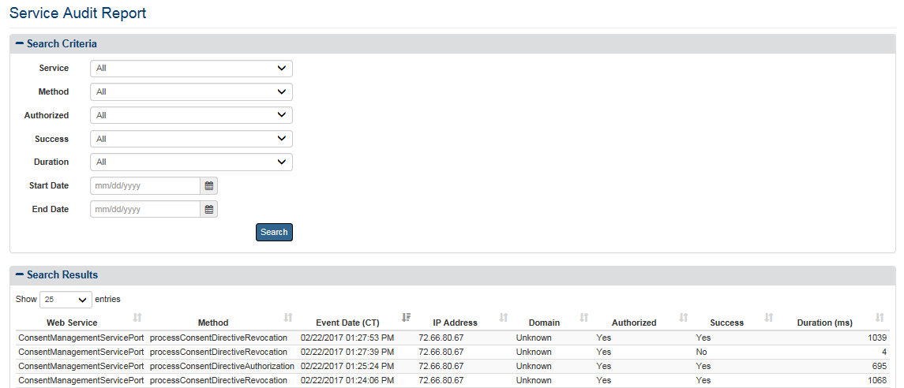

Figure 74: Service Audit Report

### Partner Organization

The VAP application generates a partner management report to provide the ability to track and manage trusted partners, and allow other systems to verify if a partner is trusted prior. The main Partner Organization page provides a tabular view of all the VAP partners, organization information available, and indicates whether or not these are active partners and if these are trusted clinical sources.

**To generate the Partner Organization Report**

To navigate to the Partner Organization view, click on the **Partner Organization** menu item under the **Admin** reports heading.

Once selected, the Partner Organization page will appear. Figure 75 displays the tabular main Partner Organization view. This has various features that allow the VAP Admins to view the VAP partners and export the information displayed onto an Excel spreadsheet. Each row on this view is associated to a different and unique partner. The Active column denotes if this partner is still an active partner or if no longer active (indicated by Yes/No). Columns 2-8 display any information available regarding the partner such as Name, Phone, whether the Partner is a consumer (or not), and Organization ID. If this partner is a trusted clinical source, a “yes” label will be displayed. The Action column allows the User to navigate to the “Edit” page to modify selected attributes of this partner.

**Note**: It is important to note that for the purposes of this section, screenshots of the VAP Production system are not yet deployed. Therefore, all partners displayed within the image correspond to test partners within a VAP testing environment.

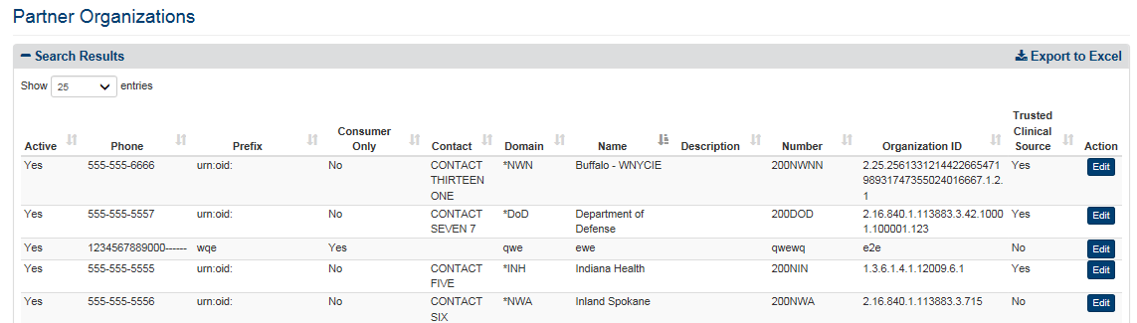

Figure 75: Partner Organizations Report

***To Edit the Organization***

The “Partner Organizations - Edit” view, as displayed within Figure 76, allows the Admin User to modify selected fields. These fields include Organization Name, Organization Description, Organization Number, Contact Name, Contact Phone, and whether the Partner is a trusted source. The Organization Name, Description, Number, Phone, and Contact Name are text fields that allow for special characters and hyphens if needed within the Partner Name.

1. Click on the **Edit** button on the Partner Organization report, seen in Figure 75.

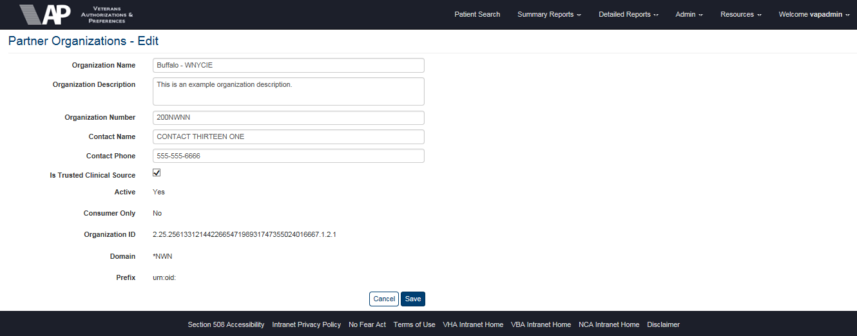

Figure 76: Editing an Existing Partner Organization

1. Enter the name of the organization in the **Organization Name** field box. That is a required entry. Failing to fill out this item box will result in an error message that will not allow you to save changes.
2. Enter the organization description in the **Organization Description** field box. This entry is also a requirement to be able to proceed.
3. Enter the organization number in the **Organization Number** field box. This entry is also a requirement to be able to proceed.
4. Enter the contact name in the **Contact Name** field box.
5. Enter the contact phone number in the **Contact Phone** field. There is no restriction on the format of the numbers.
6. Check the **Is** **trusted clinical source** checkbox if the organization is trusted. Uncheck if otherwise.
7. Click the **Save** button to save changes made.
8. **Cancel** button is to cancel the process of editing Partner Organization. Changes won’t take place.

***To Export the Partner Organizations Report***

1. Select the Export to Excel option on the top-right side of the report section seen in Figure 75.
2. Report data is exported into an Excel spreadsheet. For Excel format, report name, current date, and all filtering criteria are exported as a file header.
3. Report data is exported in the same order of columns as in the generated report and data in the exported file is sorted as it was on the report. The name of the file is generated in the following format: [Report_Title]_YYYYMMDD_HHmmss.xls

**Note**: No privacy warning is displayed prior to the export completing; however, users are reminded to follow standard VA policies and procedures for information handling.

### Monthly Received Documents

The Monthly Received Documents report page is an administrative function added within Release 2.6.0 of VAP. This report is used by VA VLER stakeholders to maintain an audit and count record of users who have received documents, on a per partner basis. This report is set to generate by calendar month and displays the partner organization, the VA user who received a document, and the total count.

1. Select the **Monthly Received Documents** menu item under **Summary Reports** heading, on the menu at the top of the screen, to display the Monthly Received Documents query screen.
2. Click the arrow on the **Start Month/Year** list dropdown to select the data to be included within the generated report.
3. Click the **Search** button to display the Monthly Received Documents Report as shown in Figure 77.

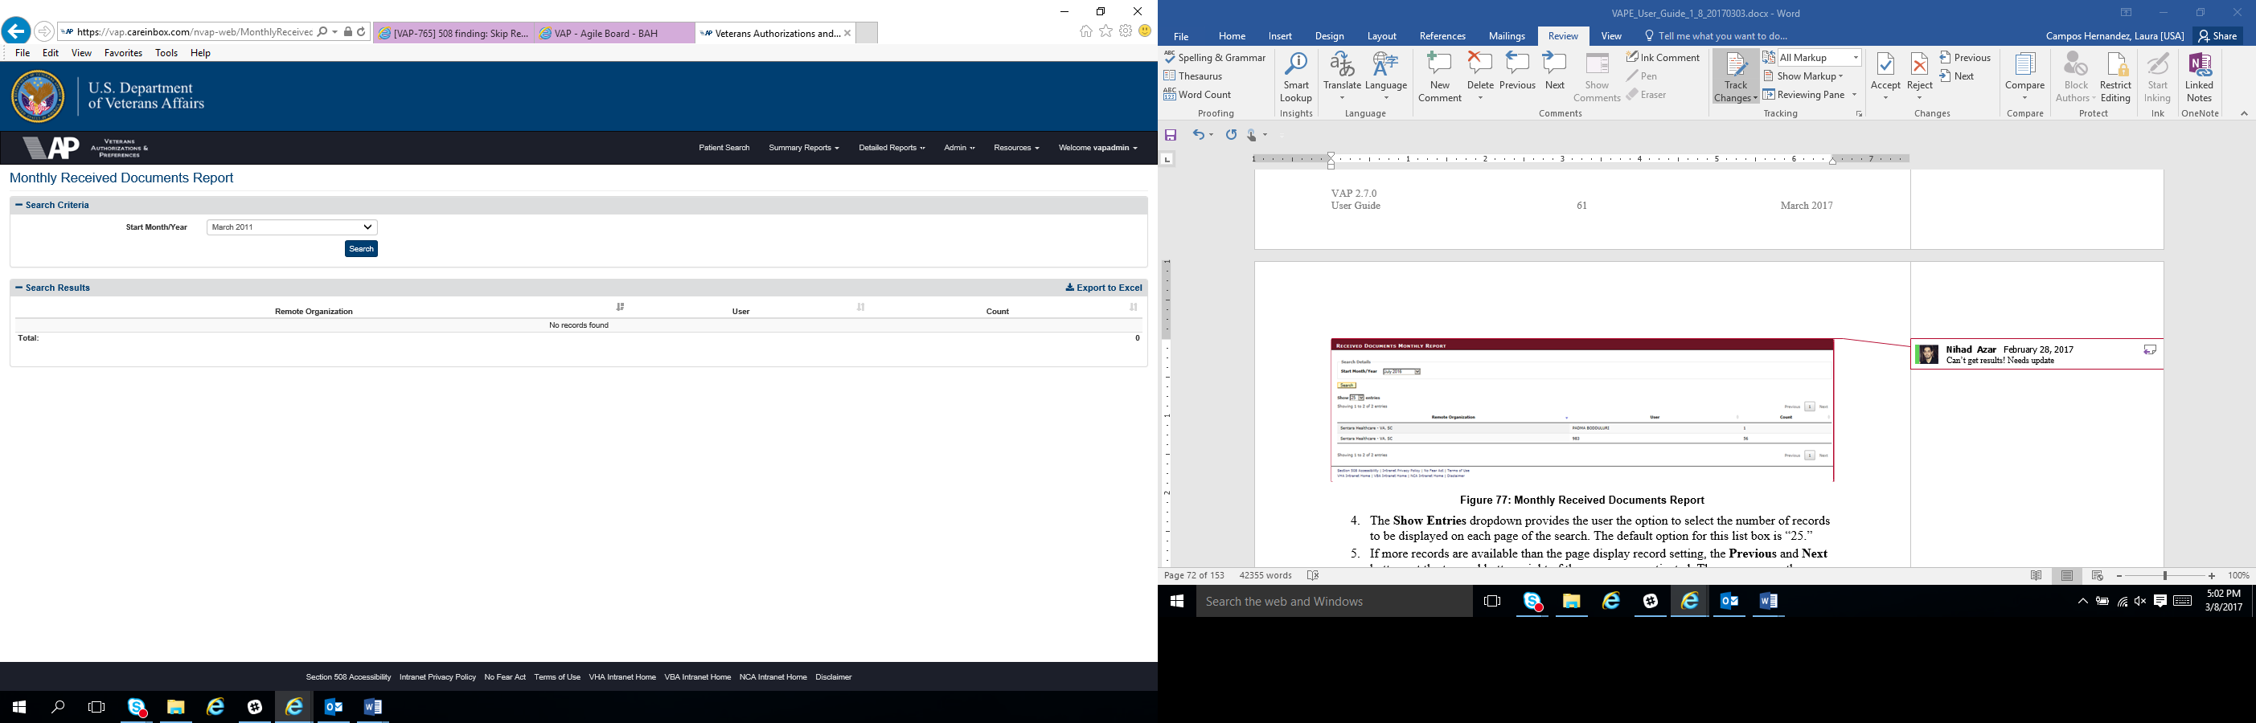

Figure 77: Monthly Received Documents Report

1. The **Show Entries** dropdown provides the user the option to select the number of records to be displayed on each page of the search. The default option for this list box is “25.”
2. If more records are available than the page display record setting, the **Previous** and **Next** buttons at the top and bottom right of the screens are activated. The user can use these buttons to navigate back and forward through the list of records found by the search.
3. Each individual column of the report can be sorted if an up and down arrow icons appear below the column heading. Click the up arrow icon to sort the column by ascending order. Select the down arrow icon to sort the column by descending order.

***To Export the Monthly Received Documents Report***

1. Select the Export to Excel option on the top-right side of the report section seen in Figure 77.
2. Report data is exported into an Excel spreadsheet. For Excel format, report name, current date, and all filtering criteria are exported as a file header.
3. Report data is exported in the same order of columns as in the generated report and data in the exported file is sorted as it was on the report. The name of the file is generated in the following format: [Report_Title]_YYYYMMDD_HHmmss.xls

**Note**: No privacy warning is displayed prior to the export completing; however, users are reminded to follow standard VA policies and procedures for information handling.

### Facilities

The VAP application generates a Facilities report to provide the ability to manage facilities. The VAP administrator will have the capability to add, edit, inactivate, and change parent/child relationships. The main Facilities page provides a tabular view of all the facilities, parents, children, facility information available, and indicates whether or not these are shown in the drop down for when manually entering an authorization.

***To generate the Facilities Report***

To navigate to the Facilities view, click on the **Facilities** menu item under the **Admin** reports heading.

Once selected, the Facilities page will appear. Figure 78 displays the tabular main view. This has various features that allow the VAP Admins to view the facilities and export the information displayed onto an Excel spreadsheet. Each row on this view is associated to a different and unique facility. Columns 1-10 display any information available regarding the facility such as Name, Phone, Address, Station Number, Parent, Child, and VISN. The Allowed column denotes if this facility can be seen in the drop down for when manually entering an authorization (indicated by Yes/No).

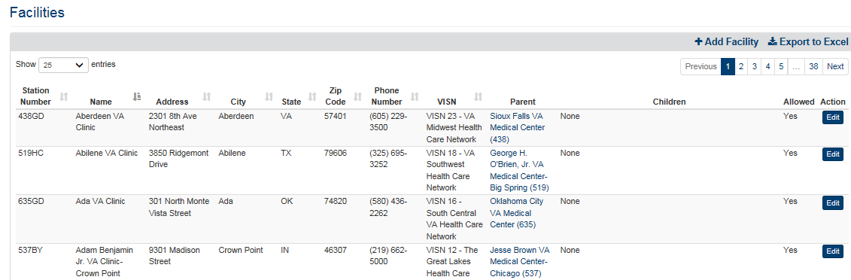

Figure 78: Facilities Report

***To Edit the Facilities***

The “Edit Facility” view, as displayed within Figure 79, allows the Administrator to modify selected fields. These fields include Station Number, Facility Name, Address, City, State, Zip Code, Phone Number, VISN, Parent, and Allowed checkmark. All fields, except for VISN and Parent, are text fields that allow for special characters and hyphens if needed.

1. Click on the **Edit** button on the Facilities report, seen in Figure 78.

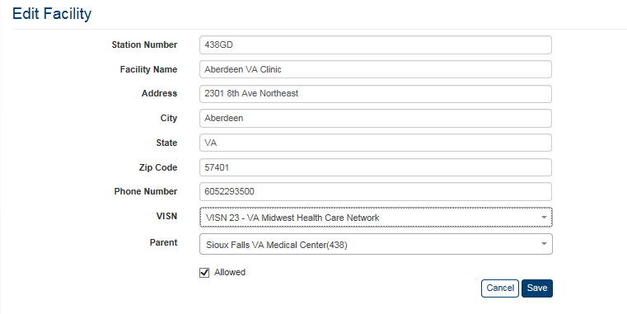

Figure 79: Editing an Existing Facility

1. Enter the station number in the **Station** **Number** filed box. That is a required entry. Failing to fill out this item box will result in an error message that will not allow you to save changes.
2. Enter the name of the facility in the **Facility Name** field box. That is a required entry. Failing to fill out this item box will result in an error message that will not allow you to save changes.
3. Enter the facility address in the **Address** field box. This entry is also a requirement to be able to proceed.
4. Enter the city in the **City** field box. This entry is also a requirement to be able to proceed.
5. Enter the state in the **State** field box. This entry is also a requirement to be able to proceed.
6. Enter the zip code in the **Zip Code** field. There is no restriction on the format of the numbers.
7. Enter the facility phone number in the **Phone** **Number** field. There is no restriction on the format of the numbers.
8. Click on the down arrow to the right of **VISN** to view all VISNs, and make a selection.
9. Click on the down arrow to the right of **Parent** to view all parents, and make a selection. It is important to note that selecting a facility as a parent allows the user to use the “aggregate feature” in summary reports. The reports will the roll-up and aggregate all the counts of the children facilities up to the parent level based on these relationships.
10. Check the **Allowed** checkbox if the facility should be displayed on the dropdown within the Authorizations modal for when manually entering when entering an authorization.
11. Click the **Save** button to save changes made.
12. **Cancel** button is to cancel the process of editing Facility. Changes won’t take place.

***To Add a New Facility***

The “Add Facility” view, as displayed within Figure 80, allows the Admin User to add a new facility. The fields to be filled out include Station Number, Facility Name, Address, City, State, Zip Code, Phone Number, VISN, Parent, and Allowed checkmark. All fields, except for VISN and Parent, are text fields that allow for special characters and hyphens if needed.

1. Click on the **Add Facility** option on the top right of the screen, Figure 78, next to **Export to Excel**.

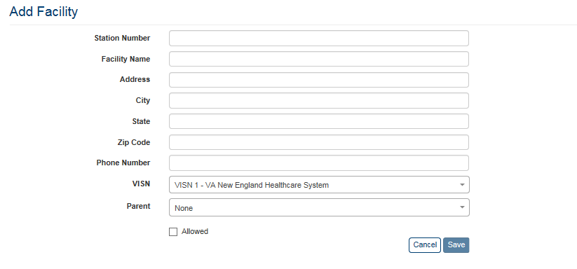

Figure 80: Add New Facility

1. Enter the station number in the **Station** **Number** filed box. That is a required entry. Failing to fill out this item box will result in an error message that will not allow you to save changes.
2. Enter the name of the facility in the **Facility Name** field box. That is a required entry. Failing to fill out this item box will result in an error message that will not allow you to save changes.
3. Enter the facility address in the **Address** field box. This entry is also a requirement to be able to proceed.
4. Enter the city in the **City** field box. This entry is also a requirement to be able to proceed.
5. Enter the state in the **State** field box. This entry is also a requirement to be able to proceed.
6. Enter the zip code in the **Zip Code** field. There is no restriction on the format of the numbers.
7. Enter the facility phone number in the **Phone** **Number** field. There is no restriction on the format of the numbers.
8. Click on the down arrow to the right of **VISN** to view all VISNs, and make a selection.
9. Click on the down arrow to the right of **Parent** to view all parents, and make a selection.
10. Check the **Allowed** checkbox if the facility is allowed to me manually entered when entering an authorization.
11. Click the **Save** button to save changes made.
12. **Cancel** button is to cancel the process of editing Facility. Changes won’t take place.

***To Export the Facilities Report***

1. Select the Export to Excel option on the top-right side of the report section seen in Figure 78.
2. Report data is exported into an Excel spreadsheet. For Excel format, report name, current date, and all filtering criteria are exported as a file header.
3. Report data is exported in the same order of columns as in the generated report and data in the exported file is sorted as it was on the report. The name of the file is generated in the following format: [Report_Title]_YYYYMMDD_HHmmss.xls

**Note**: No privacy warning is displayed prior to the export completing; however, users are reminded to follow standard VA policies and procedures for information handling.

## Generating Summary Reports

The VAP application generates eight (8) summary reports.

* Dashboard
* Disclosures
* Received eHealth Exchange Documents
* Document Size
* Consent Directive
* Opt-In Patients
* Delayed Consent
* Patient Discovery Audit

Each report is described below in more detail. The Report options are available to all users.

### Dashboard

To navigate to the Dashboard view, click on the Dashboard menu item under the Summary Reports heading. A set of widgets, seen in Figure 81, will be displayed just under the Patient Search field. The widgets provide a more advantageous method for tracking performance and statistics of the application with real-time metrics and counts. The four (4) widgets displayed are:

1. Expiring Authorizations (within 30 Days)
2. New Consent Authorizations (by month)
3. VAP Application User Logins (within 24 hours)
4. VAP Application Web Calls (within 24 hours)

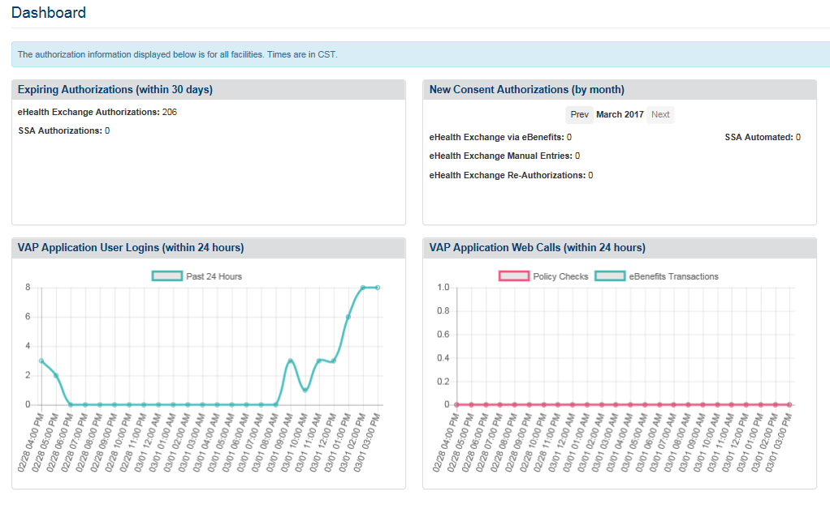

Figure 81: Reporting Dashboard

* The **Expiring Authorizations (within 30 Days)** widget displays two entries: eHealth Exchange Expiring Authorizations, and SSA Expiring Authorizations. The number to the right of each entry represents the number of authorizations expiring within a 30 day window, including today’s date. The counts displayed within the dashboard exclude test patients within the system, and filter results by “All” consents respectively for eHealth Exchange and SSA. If a user has a default facility selected within the VAP application, the counts displayed will be for only the facility selected and do not aggregate the counts of any children facilities. If a facility is not set by the user, as the default facility, then the counts will include all facilities.
* The **New Consent Authorizations (by month)** widget displays four entries: eBenefits, Manually Added, Re-Authorizations, and SSA Automated. The numbers to the right of each entry represent new consents and exclude records for test patients. The count of eBenefits consents is set to include “all eHealth Exchange authorizations” for the consent type. The count of manually added consents is set to include “all eHealth Exchange authorizations” and exclude consents submitted through web services from VA system (e.g., eBenefits). The count for Total Reauthorizations is set to pull all revocations with an inactivation reason of new authorization. If a user has a default facility selected within the VAP application, the counts displayed will be for only the facility selected and do not aggregate the counts of any children facilities. If a facility is not set by the user, as the default facility, then the counts will include all facilities. Use the Previous and Next buttons at the top of the widget to go back and forward through the list of months.
* The **VAP Application User Logins (within 24 hours)** widget displays a graph with the number of VAP system user logins on the vertical axis (Y-Axis) vs past 24-hour Time frame on the horizontal axis (X-Axis). This widget tallies the user logins for the VAP system as a whole, and is not specific to a facility.
* The **VAP Application Web Calls (within 24 hours)** widget displays a graph with the number of web service calls made on the vertical axis (Y-Axis) vs past 24-hour Time frame on the horizontal axis (X-Axis). This widget tallies the user logins for the VAP system as a whole, and is not specific to a facility.

**Note**: Metric counts displayed contain only real patient values and exclude test patients.

### Disclosures Summary

The fields on the Disclosures Summary Report query screen (Figure 82) allow you to select the disclosure source from either eHealth Exchange (Exchange) or Direct Secure Messaging (Direct). For both reports, the user is able to enter a search ranges which inclusive of the start and end date supplied. For the eHealth Exchange Summary Disclosure report, the user is able to select a Patient Preferred facility or all VA Patient Preferred facilities, select an eHealth Exchange organization or all external eHealth Exchange organizations, and include or exclude test patients from the report in the system. The report provides a numerical summary of the disclosures for a selected range of dates at specific combinations of selected eHealth Exchange organizations and Patient Preferred facilities.

Per request, updates were made to clarify whether a VA Facility is an Authenticating Facility or the Patient Preferred Facility. Field labels within the application were updated accordingly. This does not change the data that has been displayed within the system in prior releases; this simply clarifies the source “VA Facility” within the report.

***To Generate a Disclosures Summary Report***

1. Click the **Disclosures** menu item under the **Summary Reports** heading on the menu at the top of the screen to display the Disclosures Summary Report query screen.

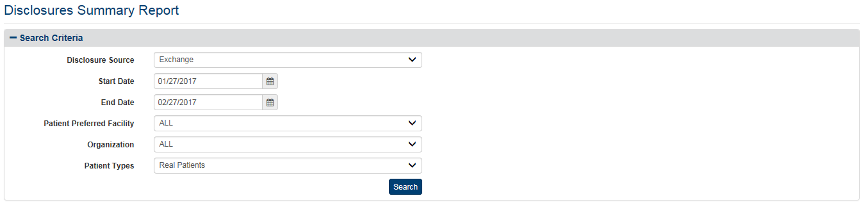

Figure 82: Disclosures Summary Report Query Screen (eHealth Exchange)

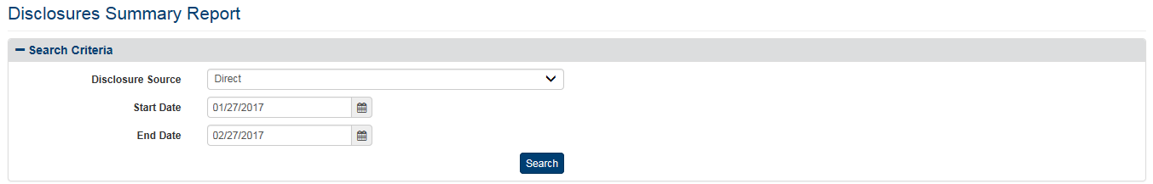

Figure 83: Disclosures Summary Report Query Screen (Direct)

1. Click on the down arrow to select the **Disclosure** **Source** either from Exchange (default) or Direct.
2. For either report, enter the start date for the Disclosures Summary Report in the **Start** **Date** field in the format mm/dd/yyyy (i.e., 02/12/2015). You can also select the date from the date range picker dropdown. **Note**: Do not enter a date in this field or the End Date field if you want to search for all dates.
3. For either report, enter the end date for the Disclosures Summary Report in the **End** **Date** field in the format mm/dd/yyyy (i.e., 02/13/2015). You can also select the date from the date range picker dropdown. **Note**: Do not enter a date in this field or the Start Date field if you want to search for all dates.
4. The Following Steps (5 – 7) are for eHealth Exchange Disclosure Summary Report
5. Click the arrow at the right of the **Patient Preferred Facility** list box to select the facility you want to display in the report. All VA Patient Preferred facilities, not just supported ones, appear in the list. The list is sorted in ascending alphabetical order. You can only select one entry from the list.
6. The default VA Patient Preferred facility associated with the logged on (current) user is automatically selected from the list in the VA Patient Facility list box based on the user’s VA User ID. This default can be changed from **Set Default User** menu item under the **Welcome** menu.
7. The “ALL” option is no longer the default setting. You must select it from the list if you want the report to include all VA Patient Preferred facilities.
8. If you are not sure of the name of a VA Patient Preferred facility, you can search for the facility by typing the beginning letter of the facility description (e.g., If the user types “N” in the VA Facility list box, the selection bar will move to the first VA facility that begins with “N.”) into the blank entry in the list.
9. Click the arrow at the right of the **Organization** list box to select the eHealth Exchange organization you want to display in the report. This reflects the organizations to which the VA disclosed records. You can only select one entry from the list. The default option for this list box is “ALL”. Organization names are formatted and spelled with uniformity across each input form and generated report.
10. Click the arrow at the right of **Patient Types** list box to select the types of patients you want to display in the report. The default option for this list box is “Real Patients”, so do not select a specific option if you want to see Real Patients only. There are three options in the list: All (Real and Test Patients), Real Patients, and Test Patients.
11. For both reports, click the **Search** button to display the Disclosures Summary Report screen for Direct as shown in Figure 83 and for eHealth Exchange as shown in Figure 82.
12. Two of the possible entries in the eHealth Exchange Organization report column need additional explanation. “UNKNOWN” means that the eHealth Exchange Organization could not be resolved by the Enrollment System Redesign (ESR) for the given Patient ID field. “NULL” indicates invalid data from before “UNKNOWN” was defined.
13. Three of the entries in the VA Patient Preferred Facility report column need additional explanation. “UNKNOWN” means that the Patient Preferred Facility could not be resolved by the (ESR) for the given Patient ID. “UNAVAILABLE” means that ESR is not available. “NULL” indicates invalid data from before “UNKNOWN” and “UNAVAILABLE” were defined.
14. If the eHealth Exchange Disclosures Summary Report (or any other report) finds no records (Figure 84), you probably selected your default VA Patient Preferred Facility on the query screen. The entry in the Patient Preferred Facility list box defaults to the VA Facility associated with your user name. Select “All” at the top of the list in the list box or a different VA Facility and search again.



Figure 84: Disclosure Summary Report Screen - No Results Found

1. Each individual column of the report can be sorted if up and down arrow icons appear below the column heading. Click the up arrow icon to sort the column by ascending order. Click the down arrow icon to sort the column by descending order, (“Null,” “Unavailable” and “Unknown” appear in line with the related Patient Preferred Facilities and/or eHealth Exchange Organizations when they occur).

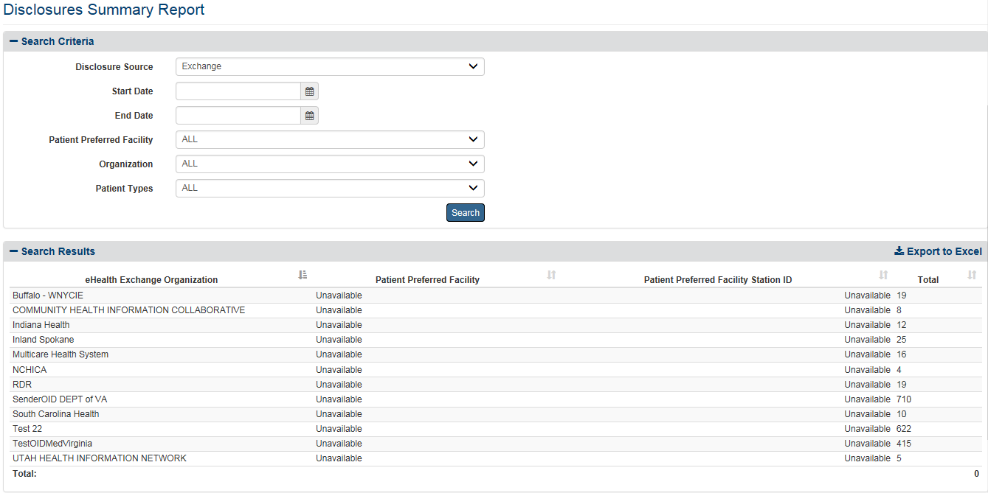

Figure 85: Disclosures Summary Report Screen (eHealth Exchange)

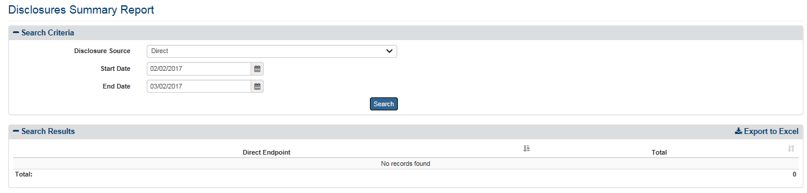

Figure 86: Disclosures Summary Report Screen (Direct)

The eHealth Exchange Report displays the following fields for each listing: eHealth Exchange Organization, Patient Preferred Facility, Patient Preferred Facility Station ID, and a Total indicating the number of disclosures for each combination of eHealth Exchange organization and Patient Facility. A total at the bottom right of the screen indicates the total number of disclosures covered by the report.

The Direct Report displays the following fields for each listing: Direct Endpoint and a total indicating the number of disclosures for Direct. A total at the bottom of the screen indicates the total number of disclosures covered by the report.

***To export the Disclosures Summary report***

1. Select the **Export to Excel** option on the top-right side of the report section seen in Figure 85 and 86.
2. Unlike the detailed reports, no privacy warning is displayed prior to the export completing, as these summary-level reports do not contain personally identifiable information. However, users are reminded to follow standard VA policies and procedures for information handling.
3. Report data is exported into an Excel spreadsheet. For Excel format, report name, current date, and all filtering criteria are exported as a file header.
4. Report data is exported in the same order of columns as in the generated report and data in the exported file is sorted as it was on the report.

**Note:** the “Column Headings” are exported only when there are matching records. If the search did not generate any records, “No records found” message is displayed in the report, as well as in the exported Excel. The name of the file is generated in the following format: [Report_Title]_[Detail/Summary]_Report_YYYYMMDD_HHmmss.[xls/csv]

### Received eHealth Exchange Documents Summary

The fields on the Received eHealth Exchange Documents Summary Report query screen (Figure 87) allow you to enter a range of dates, select a VA Patient Preferred facility or all VA Patient Preferred facilities, select an eHealth Exchange organization or all external eHealth Exchange organizations, and include/exclude test patients. The report provides a numerical summary of the eHealth Exchange documents received for a selected range of dates at specific combinations of selected eHealth Exchange organizations and VA facilities.

***To Generate a Received eHealth Exchange Documents Summary Report***

1. Click the **Received eHealth Exchange Documents** menu item under **Summary Reports** heading on the menu at the top of the screen to display the Received eHealth Exchange Documents Summary Report query screen.
2. Enter the start date for the Received eHealth Exchange Documents Summary Report in the **Start Date** field in the format mm/dd/yyyy (i.e., 02/12/2015). You can also select the date from the date range picker dropdown. **Note**: Do not enter a date in this field or the End Date field if you want to search for all dates.

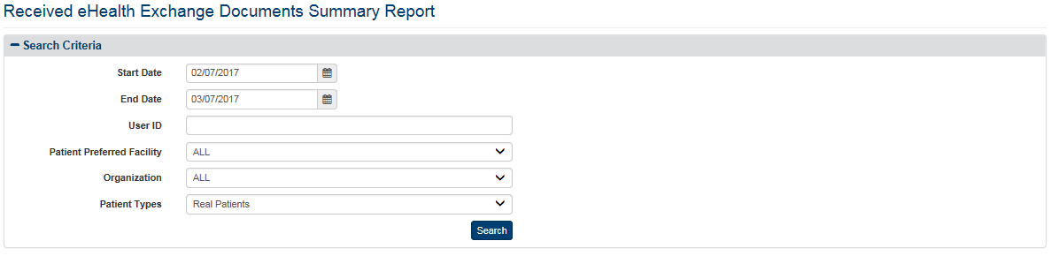

Figure 87: Received eHealth Exchange Documents Summary Report Query Screen

1. Enter the end date for the Received eHealth Exchange Documents Summary Report in the **End Date** field in the format mm/dd/yyyy (i.e., 02/13/2015). You can also select the date from the date range picker dropdown. **Note**: Do not enter a date in this field or the Start Date field if you want to search for all dates.
2. Enter a user ID in the **User** **ID** field if you want to search by a specific user. The User ID field allows the report to be filtered either by full or partial name of the entity associated to the transaction. This field can refer to either the DVA User ID that entered a record. Search on the field is case insensitive, that is “smith” or “SMITH” will produce the same result set. **Note**: Do not enter a User ID in this field if you want to search for all users.
3. Click the arrow at the right of the **Patient Preferred Facility** list box to select the facility you want to display in the report. All Patient Preferred facilities, not just supported ones, now appear in the list. The list, except the entry for the Department of Veterans Affairs, is sorted in ascending alphabetical order. You can only select one entry from the list.
4. The default Patient Preferred facility associated with the logged on (current) user is automatically selected from the list in the VA Patient Facility list box based on the user’s VA User ID. This default can be changed by the user from the **Set Default Facility** menu item.
5. The “ALL” option is no longer the default setting. You must select it from the list if you want the report to include all VA facilities.
6. If you are not sure of the name of a VA facility, you can search for the facility by typing the beginning letter of the facility description (e.g., If the user types “N” in the VA Facility list box, the selection bar will move to the first VA facility that begins with “N.”) into the blank entry in the list.
7. Click the arrow at the right of the **Organization** list box to select the eHealth Exchange organization you want to display in the report. This reflects the organizations from which the VA received records. You can only select one entry from the list. The default option for this list box is “All,” so do not select a specific organization if you want to see all external eHealth Exchange organizations in the report. The “DEPARTMENT OF VETERANS AFFAIRS” entry appears at the end of the list, not in alphabetical order.
8. Click the arrow at the right of **Patient Types** list box to select the types of patients you want to display in the report. The default option for this list box is “Real Patients,” so do not select a specific option if you want to see Real Patients only. There are three options in the list: All (Real and Test Patients), Real Patients, and Test Patients.
9. Click the **Search** button to display the Received eHealth Exchange Documents Report as shown in Figure 88.
10. Two of the possible entries in the eHealth Exchange Organization report column need additional explanation. “UNKNOWN” means that the eHealth Exchange Organization could not be resolved by the Enrollment System Redesign (ESR) for the given Patient ID. “NULL” indicates invalid data from before “UNKNOWN” was defined.
11. Two of the entries that can appear in the VA Patient Preferred Facility report column need additional explanation. “UNKNOWN” means that the Patient Preferred Facility could not be resolved by the Enrollment System Redesign (ESR) for the given Patient ID. “UNAVAILABLE” means that ESR is not available. “NULL” indicates invalid data from before “UNKNOWN” and “UNAVAILABLE” were defined.

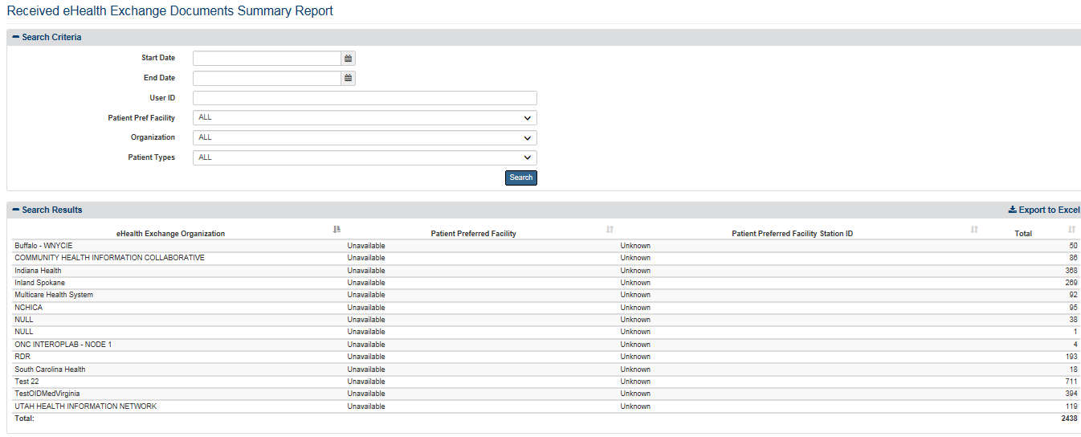

Figure 88: Received eHealth Exchange Documents Summary Report Screen

1. Each individual column of the report can be sorted if up and down arrow icons appear below the column heading. Click the up arrow icon to sort the column by ascending order. Click the down arrow icon to sort the column by descending order. (“Null,” “Unavailable” and “Unknown” appear in line with the related VA Patient Preferred Facilities and/or eHealth Exchange Organizations when they occur.)

The report displays the following fields for each listing: eHealth Exchange Organization, Patient Preferred Facility, Patient Preferred Facility Station ID, and a Total indicating the number of received eHealth Exchange documents for each combination of eHealth Exchange organization and VA facility. A grand total at the bottom of the screen indicates the total number of received eHealth Exchange documents covered by the report.

***To export the Disclosures Summary report***

1. Select the **Export to Excel** option on the top-right side of the report section seen in Figure 88.
2. Unlike the detailed reports, no privacy warning is displayed prior to the export completing, as these summary-level reports do not contain personally identifiable information. However, users are reminded to follow standard VA policies and procedures for information handling.
3. Report data is exported into an Excel spreadsheet. For Excel format, report name, current date, and all filtering criteria are exported as a file header.
4. Report data is exported in the same order of columns as in the generated report and data in the exported file is sorted as it was on the report.

**Note:** the “Column Headings” are exported only when there are matching records. If the search did not generate any records, “No records found” message is displayed in the report, as well as in the exported Excel. The name of the file is generated in the following format: [Report_Title]_[Detail/Summary]_Report_YYYYMMDD_HHmmss.[xls/csv]

**Note**: Not displayed within the VAP User Interface, and only within the export is the Organization Identifier Code (OID).

### Document Size

The fields on the Document Size Report query screen (Figure 89) allow you to enter a range of dates, select an eHealth Exchange Organization or all organizations, and select the Action Type. This report displays the count of received and disclosed documents, to partners, along with the minimum, maximum, and average document sizes for a selected time period. The data within this report is received from the eHealth Exchange system. It is important to note that the file sizes within this report are displayed in kilobytes (kb). VAP does not store this information within its system boundary, and similarly to the Received eHealth Exchange and the Disclosures report, this document is retrieved on demand via web service.

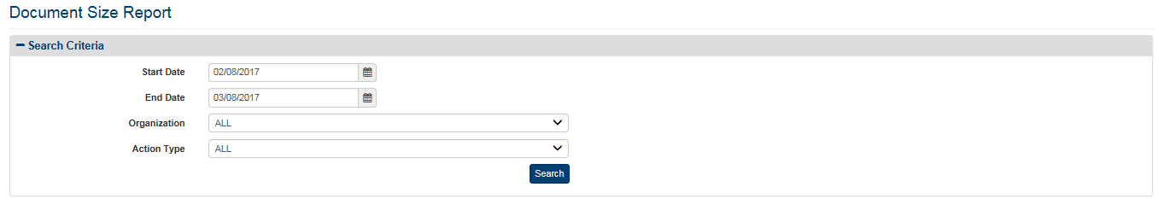

Figure 89: Document Size Report Query Screen

***To Generate a Document Size Report***

1. Click the **Document Size** menu item under **Summary Reports** heading on the menu at the top of the screen to display the Document Size Summary Report query screen.
2. Enter the start date for the Document Size report in the **Start Date** field in the format mm/dd/yyyy (i.e., 02/12/2015). You can also select the date from the date range picker dropdown. **Note**: Do not enter a date in this field or the End Date field if you want to search for all dates.
3. Enter the end date in the **End Date** field in the format mm/dd/yyyy (i.e., 02/13/2015). You can also select the date from the date range picker dropdown. **Note**: Do not enter a date in this field or the Start Date field if you want to search for all dates.
4. Click the arrow at the right of the **Organization** list box to select the eHealth Exchange organization you want to display in the report. All eHealth Exchange Organizations, not just supported ones, now appear in the list and is set as default. The list, except the entry for the Department of Veterans Affairs, is sorted in ascending alphabetical order. You can only select one entry from the list. All Active Organizations are listed followed by the Inactive Organizations.
5. Click the arrow at the right of the **Action Type** list box to select to include the counts of only received documents from partners, disclosed documents to partners, or both. This allows the user to filter out the resultant data within the report by received (inbound) documents only, disclosed (outbound documents), or both.
6. Click the **Search** button to display the Document Size Report as shown in Figure 90.

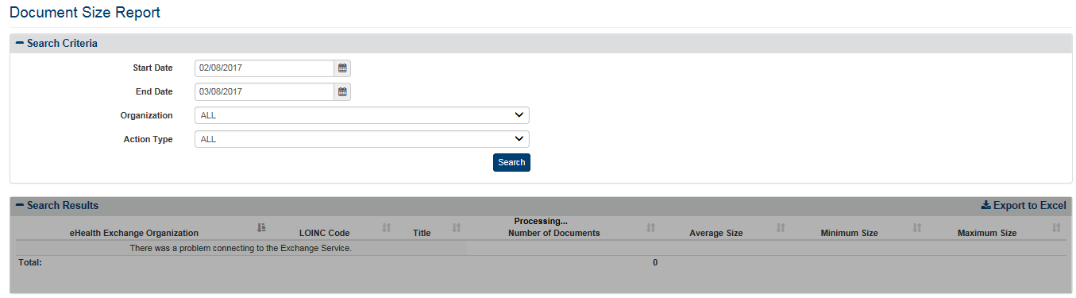

Figure 90: Document Size Report Screen

The report displays the following fields for each listing: eHealth Exchange Organizations, LOINC Code (results type), Title (of documents exchanged), Number of Documents, Average Size (of documents exchanged in kb), Minimum Size (smallest document in kb), and Maximum Size (largest document in kb).

***To export the Document Size report***

1. Select the **Export to Excel** option on the top-right side of the report section seen in Figure 90.
2. Unlike the detailed reports, no privacy warning is displayed prior to the export completing, as these summary-level reports do not contain personally identifiable information. However, users are reminded to follow standard VA policies and procedures for information handling.
3. Report data is exported into an Excel spreadsheet. For Excel format, report name, current date, and all filtering criteria are exported as a file header.
4. Report data is exported in the same order of columns as in the generated report and data in the exported file is sorted as it was on the report.

**Note:** the “Column Headings” are exported only when there are matching records. If the search did not generate any records, “No records found” message is displayed in the report, as well as in the exported Excel. The name of the file is generated in the following format: [Report_Title]_[Detail/Summary]_Report_YYYYMMDD_HHmmss.[xls/csv]

### Consent Directive Summary

The fields on the Consent Directive Summary Report query screen (Figure 91) allow you to enter a range of dates, select an Authenticating facility or all Authenticating facilities, select the consent type, and include/exclude test. This report provides a summary listing of the selected Consent Directive totals for a selected range of dates at the selected Authenticating facility or facilities.

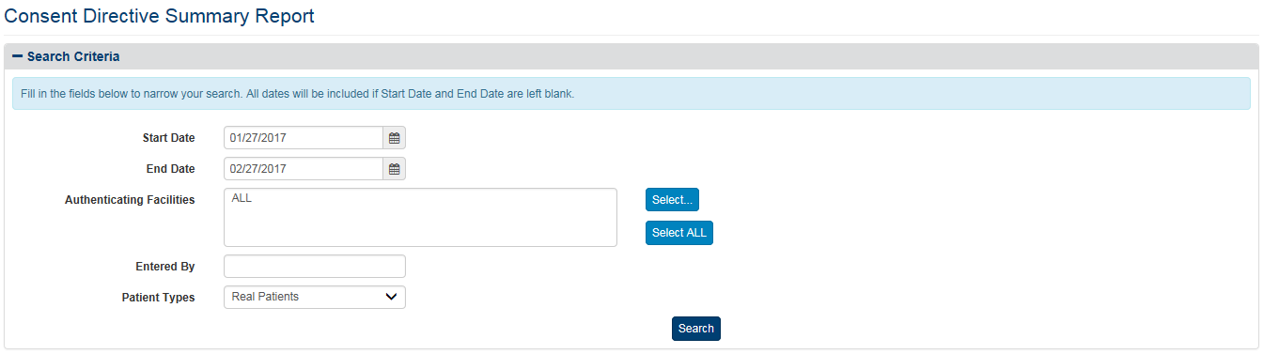

Figure 91: Consent Directive Summary Report Query Screen

***To Generate a Consent Directive Summary Report***

1. Click the **Consent Directive** menu item under **Summary Reports** heading on the menu at the top of the screen to display the Consent Directive Summary Report query screen.
2. Enter the start date for the Consent Directive Summary Report in the **Start Date** field in the format mm/dd/yyyy (i.e., 02/12/2015). You can also select the date from the date range picker dropdown. **Note**: Do not enter a date in this field or the End Date field if you want to search for all dates.
3. Enter the end date for the Consent Directive Summary Report in the **End Date** field in the format mm/dd/yyyy (i.e., 02/13/2015). You can also select the date from the date range picker dropdown. **Note**: Do not enter a date in this field or the Start Date field if you want to search for all dates.
4. Click the **Select** button at the right of Authenticating Facilities to select one or more facilities you want to display in the report. The default authenticating facility filter is set to the User Default Facility. This default can be changed by the user from the **Set Default Facility** menu item under the **Welcome** menu. The “ALL” option is the default setting, unless a default facility is selected. You must select the Select All button if you want the report to include all VA facilities.
5. A pop-up window will show displaying all VISNs, their associated facilities, and your selection in three (3) separate sections.
6. For each section, you may Select/Unselect all from the top right, seen in Figure 92 below. The first and second columns are used to filter by VISN and Facilities. The third column to the right displays the selected VISNs and Facilities to be included within the resultant report.
7. The VISN column, to the left-hand side of the pop-up, displays all 21 VISNs stored within the VAP application. This column allows the user to filter and/unselect by VISNs.
8. The middle column, “Facilities” shows a listing of all the Facilities. By default, facilities in the middle section are grouped by VISN. This default can be changed if you uncheck the “Display facilities grouped by VISN” box, under the middle section, highlighted in Figure 92. Once unchecked, facilities will be listed in alphabetical order. If any VISNs, from the VISN column are unchecked, the Facilities list will update to remove these facilities from the view.
9. Once the selection is made and the first two columns, VISNs and Facilities, are filtered, the last column to the right, “Your Selection” will display the resultant facilities associated with the filter selection from the other two boxes.
10. The other two checkboxes within this page are “Include consents with unknown VISN,” and “Aggregate data at the facility level.” By default, both are unchecked. If selected, aggregate data at the facility level, this means the data will be rolled-up and aggregated to the parent-level. All children-level facilities will not be displayed and the counts will be included within the parent. Within Release 2.7.0, this functionality was modified to not use the 3 and 5-digit facility codes, but to base this off of the relationships set within the Facilities administrator section of the VAP application.
11. Click **OK** to confirm your selection and implement it in the search results.
12. Click **Cancel** on the bottom right to cancel your selection and go back to the previously selected filter option. Click **Restore last selection** to go back to the last selection of facilities used. For example, if the last selection you made only included VISN 1 facilities, clicking this button on a window that is displaying all facilities will change the selection to show only VISN 1 facilities.

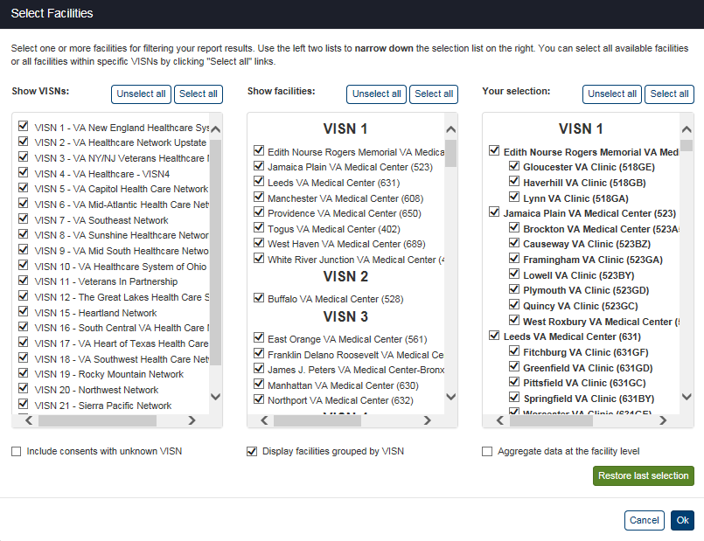

Figure 92: Select Facilities Pop-Up Windows

1. Click the arrow at the right of **Patient Types** list box to select the types of patients you want to display in the report. The default option for this list box is “Real Patients”, so do not select a specific option if you want to see Real Patients only. There are three options in the list: All (Real and Test Patients), Real Patients, and Test Patients.
2. Click the **Search** button to display the Consent Directive Summary Report as shown in Figure 93 and Figure 99.
3. The entries that can appear in the VA Facility report column need additional explanation. “UNKNOWN” means that the Patient Preferred Facility could not be resolved by the Enrollment System Redesign (ESR) for the given Patient ID. “UNAVAILABLE” means that ESR is not available. “NULL” indicates invalid data from before “UNKNOWN” and “UNAVAILABLE” were defined.

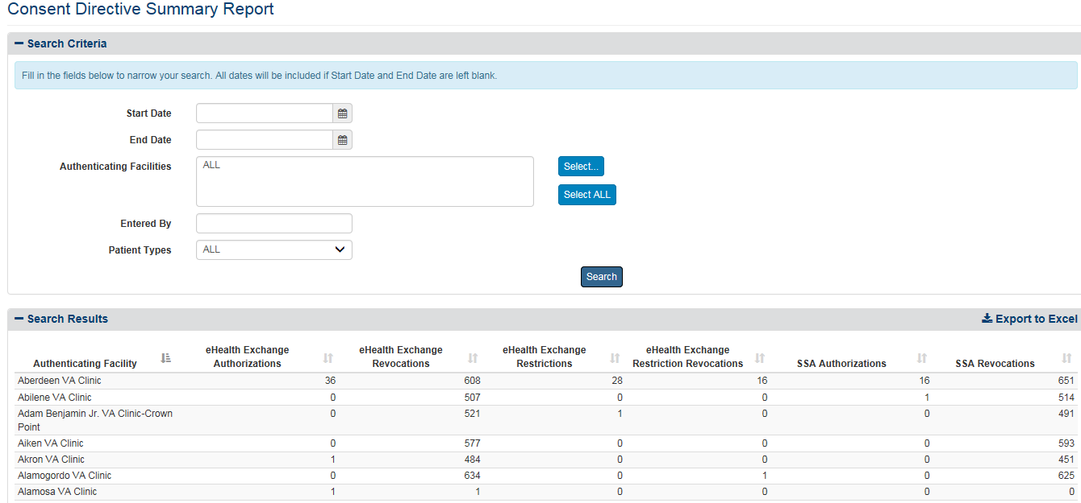

Figure 93: Consent Directive Summary Report Screen (Top)

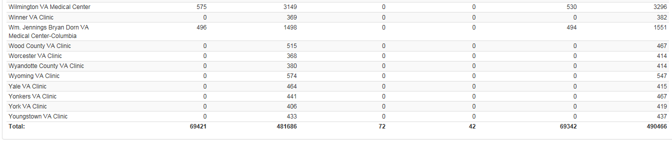

Figure 94: Consent Directive Summary Report Screen (Bottom)

1. Each individual column of the report can be sorted if up and down arrow icons appear below the column heading. Click the up arrow icon to sort the column by ascending order. Click the down arrow icon to sort the column by descending order. (“Null,” “Unavailable,” and “Unknown” appear in line with the related Authenticating Facilities and/or eHealth Exchange Organizations when they occur).
2. The menu at the top of the screen is based on your role when you logged into the application. It allows you to select other options available to your role.

The report displays the following fields for each listing: Authenticating Facility, eHealth Exchange Authorizations, eHealth Exchange Revocations, eHealth Exchange Restrictions, eHealth Exchange Restriction Revocations, SSA Authorizations, and SSA Revocations.

***To export the Consent Directive Summary report***

1. Select the **Export to Excel** option on the top-right side of the report section seen in Figure 93.
2. Unlike the detailed reports, no privacy warning is displayed prior to the export completing, as these summary-level reports do not contain personally identifiable information. However, users are reminded to follow standard VA policies and procedures for information handling.
3. Report data is exported into an Excel spreadsheet. For Excel format, report name, current date, and all filtering criteria are exported as a file header.
4. Report data is exported in the same order of columns as in the generated report and data in the exported file is sorted as it was on the report.

**Note:** the “Column Headings” are exported only when there are matching records. If the search did not generate any records, “No records found” message is displayed in the report, as well as in the exported Excel. The name of the file is generated in the following format: [Report_Title]_[Detail/Summary]_Report_YYYYMMDD_HHmmss.[xls/csv]

### Opt-In Summary

The Opt-In Summary Report displays the transaction history without regard to current status of all patients currently in opt in status as shown in Figure 95.

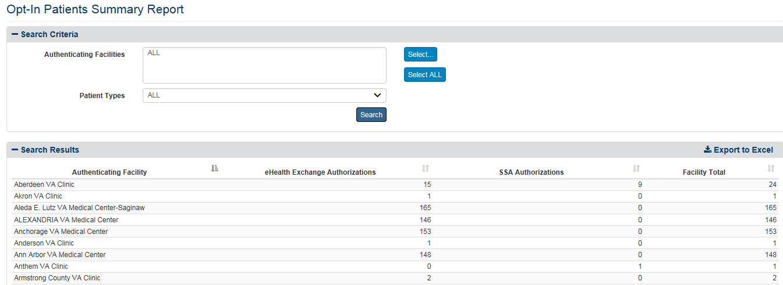

Figure 95: Opt-In Summary Report Results (top)

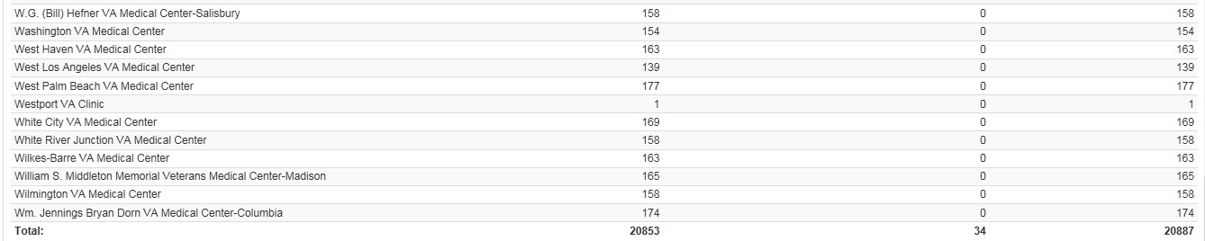

Figure 96: Opt-In Summary Report Results (bottom)

***To Generate an Opt-In Summary Report***

1. Click the **Opt-In Patients** menu item under **Summary Reports** heading on the menu at the top of the screen to display the Opt-In Summary Report query screen.
2. Click the **Select** button at the right of Authenticating Facilities to select one or more facilities you want to display in the report. The default authenticating facility filter is set to the User Default Facility. This default can be changed by the user from the **Set Default Facility** menu item under the **Welcome** menu. The “ALL” option is the default setting, unless a default facility is selected. You must select the Select All button if you want the report to include all VA facilities.
3. A pop-up window will show displaying all VISNs, their associated facilities, and your selection in three (3) separate sections.
4. For each section, you may Select/Unselect all from the top right, as highlighted in Figure 97 below. The first and second columns are used to filter by VISN and Facilities. The third column to the right displays the selected VISNs and Facilities to be included within the resultant report.
5. The VISN column, to the left-hand side of the pop-up, displays all 21 VISNs stored within the VAP application. This column allows the user to filter and/unselect by VISNs.
6. The middle column, “Facilities” shows a listing of all the Facilities. By default, facilities in the middle section are grouped by VISN. This default can be changed if you uncheck the “Display facilities grouped by VISN” box, under the middle section, highlighted in Figure 97. Once unchecked, facilities will be listed in alphabetical order. If any VISNs, from the VISN column are unchecked, the Facilities list will update to remove these facilities from the view.
7. Once the selection is made and the first two columns, VISNs and Facilities, are filtered, the last column to the right, “Your Selection” will display the resultant facilities associated with the filter selection from the other two boxes.
8. The other two checkboxes within this page are “Include consents with unknown VISN,” and “Aggregate data at the facility level.” By default, both are unchecked.
9. Click **OK** to confirm your selection and implement it in the search results.
10. Click **Cancel** on the bottom right to cancel your selection and go back to the previously selected filter option. Click **Restore last selection** to go back to the last selection of facilities used. For example, if the last selection you made only included VISN 1 facilities, clicking this button on a window that’s displaying all facilities will change the selection to show only VISN 1 facilities.



Figure 97: Select Facilities Pop-Up Windows

1. Click the arrow at the right of **Patient Types** list box to select the types of patients you want to display in the report. The default option for this list box is “Real Patients”, so do not select a specific option if you want to see Real Patients only. There are three options in the list: All (Real and Test Patients), Real Patients, and Test Patients.

The report, seen in Figure 95 and 96 under search fields, displays the Authenticating Facility, eHealth Exchange Authorization, SSA Authorization, and Facility Total.

***To export the Opt-In Patient Summary report***

1. Select the **Export to Excel** option on the top-right side of the report section seen in Figure 95.
2. Unlike the detailed reports, no privacy warning is displayed prior to the export completing, as these summary-level reports do not contain personally identifiable information. However, users are reminded to follow standard VA policies and procedures for information handling.
3. Report data is exported into an Excel spreadsheet. For Excel format, report name, current date, and all filtering criteria are exported as a file header.
4. Report data is exported in the same order of columns as in the generated report and data in the exported file is sorted as it was on the report.

**Note:** the “Column Headings” are exported only when there are matching records. If the search did not generate any records, “No records found” message is displayed in the report, as well as in the exported Excel. The name of the file is generated in the following format: [Report_Title]_[Detail/Summary]_Report_YYYYMMDD_HHmmss.[xls/csv]

### Delayed Consent Summary

The Delayed Consent Summary Report, Figure 98, allows you to select Authenticating Facility(s), reason or reasons for delay, days since delayed, consent type, and patient types. This report provides a summary listing of the selected Delayed Consent totals at the selected Authenticating facility or facilities.

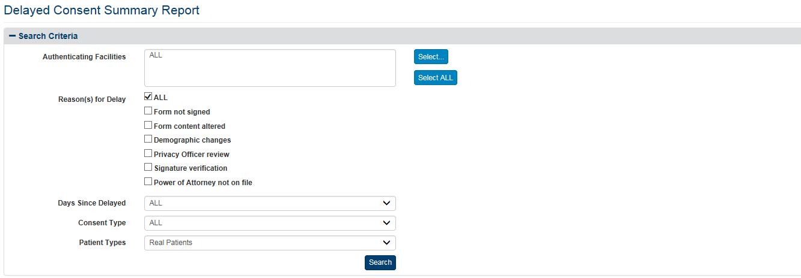

Figure 98: Delayed Consent Summary Report

***To Generate a Delayed Consent Summary Report***

1. Click the **Delayed Consent** menu item under **Summary Reports** heading on the menu at the top of the screen to display the Delayed Consent Summary Report query screen.
2. Click the **Select** button at the right of Authenticating Facilities to select one or more facilities you want to display in the report. The default authenticating facility filter is set to the User Default Facility. This default can be changed by the user from the **Set Default Facility** menu item under the **Welcome** menu. The “ALL” option is no longer the default setting. You must select the Select All button if you want the report to include all VA facilities.
3. A pop-up window will show displaying all VISNs, their associated facilities, and your selection in three (3) separate sections.
4. For each section, you may Select/Unselect all from the top right, as highlighted in Figure 99 below. The first and second columns are used to filter by VISN and Facilities. The third column to the right displays the selected VISNs and Facilities to be included within the resultant report.
5. The VISN column, to the left-hand side of the pop-up, displays all 21 VISNs stored within the VAP application. This column allows the user to filter and/unselect by VISNs.
6. The middle column, “Facilities” shows a listing of all the Facilities. By default, facilities in the middle section are grouped by VISN. This default can be changed if you uncheck the “Display facilities grouped by VISN” box, under the middle section, highlighted in Figure 99. Once unchecked, facilities will be listed in alphabetical order. If any VISNs, from the VISN column are unchecked, the Facilities list will update to remove these facilities from the view.
7. Once the selection is made and the first two columns, VISNs and Facilities, are filtered, the last column to the right, “Your Selection” will display the resultant facilities associated with the filter selection from the other two boxes.
8. The other two checkboxes within this page are “Include consents with unknown VISN,” and “Aggregate data at the facility level.” By default, both are unchecked.
9. Click **OK** to confirm your selection and implement it in the search results.
10. Click **Cancel** on the bottom right to cancel your selection and go back to the previously selected filter option. Click **Restore last selection** to go back to the last selection of facilities used. For example, if the last selection you made only included VISN 1 facilities, clicking this button on a window that’s displaying all facilities will change the selection to show only VISN 1 facilities.



Figure 99: Select Facilities Pop-Up Windows

1. Check one or multiple of the **reason(s) for delay** checkboxes that you want to display in your Delayed Consent Summary Report. By default, “ALL” reasons for delay will be displayed. Do not select a specific option if you want to see all reasons in the report.
2. Click the arrow at the right of the **Days Since Delayed** list box to select the range of days, since the status have been delayed, you want to display in the report.
3. Click the arrow at the right of the **Consent Type** list box to select the types of consent you want to display in the report. The default option for this list box is “ALL,” so do not select a specific option if you want to see all types of consent. There are two other options in the list: eHealth Exchange Authorizations, SSA Authorizations. You can only select one entry from the list.
4. Click the arrow at the right of **Patient Types** list box to select the types of patients you want to display in the report. The default option for this list box is “Real Patients,” so do not select a specific option if you want to see Real Patients only. There are three options in the list: All (Real and Test Patients), Real Patients, and Test Patients.

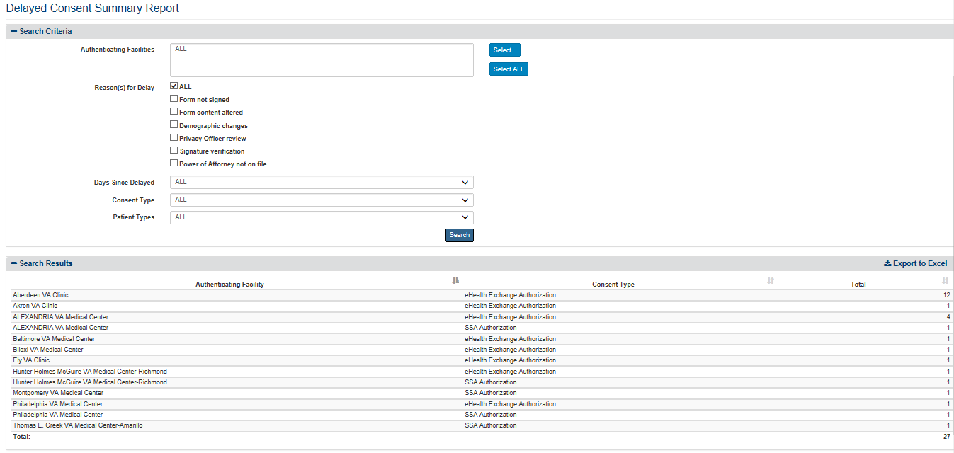

Figure 100: Delayed Consent Summary Report

1. Click the Search button to display the Delayed Consent Summary Report as shown in Figure 100.
2. Two of the possible entries in the eHealth Exchange Organization report column need additional explanation. “UNKNOWN” means that the eHealth Exchange Organization could not be resolved by the Enrollment System Redesign (ESR) for the given Patient ID. “NULL” indicates invalid data from before “UNKNOWN” was defined.
3. Two of the entries that can appear in the VA Facility report column need additional explanation. “UNKNOWN” means that the Patient Preferred Facility could not be resolved by the Enrollment System Redesign (ESR) for the given Patient ID. “UNAVAILABLE” means that ESR is not available. “NULL” indicates invalid data from before “UNKNOWN” and “UNAVAILABLE” were defined.
4. Each individual column of the report can be sorted if up and down arrow icons appear below the column heading. Click the up arrow icon to sort the column by ascending order. Click the down arrow icon to sort the column by descending order. (“Null,” “Unavailable,” and “Unknown” appear in line with the related VA Facilities and/or eHealth Exchange Organizations when they occur.)
5. The menu at the top of the screen is based on your role when you logged into the application. It allows you to select other options available to your role.

**Note**: The report displays the Authenticating Facility, Consent Type, and Total.

***To export the Delayed Consent Summary report***

1. Select the **Export to Excel** option on the top-right side of the report section seen in Figure 100.
2. Unlike the detailed reports, no privacy warning is displayed prior to the export completing, as these summary-level reports do not contain personally identifiable information. However, users are reminded to follow standard VA policies and procedures for information handling.
3. Report data is exported into an Excel spreadsheet. For Excel format, report name, current date, and all filtering criteria are exported as a file header.
4. Report data is exported in the same order of columns as in the generated report and data in the exported file is sorted as it was on the report.

**Note:** the “Column Headings” are exported only when there are matching records. If the search did not generate any records, “No records found” message is displayed in the report, as well as in the exported Excel. The name of the file is generated in the following format: [Report_Title]_[Detail/Summary]_Report_YYYYMMDD_HHmmss.[xls/csv]

### Patient Discovery Audit Summary

The Patient Discovery Audit Summary Report, Figure 101, allows you to enter a range of dates, select a Patient Preferred facility or all Patient Preferred facilities, and select an eHealth Exchange Organization or all eHealth Exchange Organization. This report displays a summary listing of the number of real vs. test patient transactions and whether they succeeded or failed as shown in Figure 101. The Patient Discovery audit log is ordered to ensure that the sequence of events recorded is a reflection of what actually transpired.

**Note**: During Release 2.5.0, per request, updates were made to clarify whether a VA Facility is an Authenticating Facility or the Patient Preferred Facility. Field labels within the application were updated accordingly. This does not change the data that has been displayed within the system in prior releases, this simply clarifies the source “VA Facility” within the report.

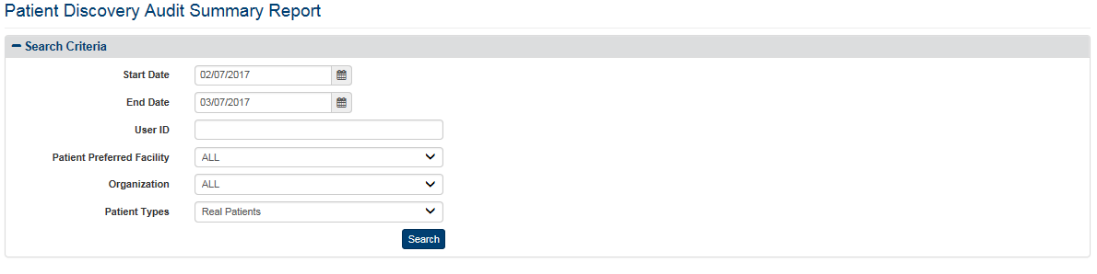

Figure 101: Patient Discovery Audit Summary Report

***To Generate an Patient Discovery Audit Summary Report***

1. Click the **Patient Discovery Audit** menu item under **Summary Reports** heading on the menu at the top of the screen to display the Patient Discovery Audit Summary Report query screen.
2. Enter the start date for the Patient Discovery Audit Summary Report in the **Start Date** field in the format mm/dd/yyyy (i.e., 07/20/2015). You can also select the date from the date range picker dropdown. **Note**: Do not enter a date in this field or the End Date field if you want to search for all dates.
3. Enter the end date for the Patient Discovery Audit Summary Report in the **End Date** field in the format mm/dd/yyyy (i.e., 10/18/2015). You can also select the date from the date range picker dropdown. **Note**: Do not enter a date in this field or the Start Date field if you want to search for all dates.
4. Enter a user ID in the **User ID** field if you want to search for a specific user. **Note**: Do not enter a User ID in this field if you want to search for all users.
5. Click the arrow at the right of the **Patient Preferred Facility** list box to select the facility you want to display in the report. All VA facilities, not just supported ones, now appear in the list and is set as default. The list, except the entry for the Department of Veterans Affairs, is sorted in ascending alphabetical order. You can only select one entry from the list.
6. The default Patient Preferred facility associated with the logged on (current) user is automatically selected from the list in the Patient Facility list box based on the user’s VA User ID. This default can be changed by the user from the **Set Default Facility** menu item.
7. The “ALL” option is no longer the default setting. You must select it from the list if you want the report to include all VA facilities.
8. If you are not sure of the name of a VA facility, you can search for the facility by typing the beginning letter of the facility description (e.g., If the user types “N” in the VA Facility list box, the selection bar will move to the first VA facility that begins with “N.”) into the blank entry in the list.
9. Click the arrow at the right of the **Organization** list box to select the eHealth Exchange organization you want to display in the report. All eHealth Exchange Organizations, not just supported ones, now appear in the list and is set as default. The list, except the entry for the Department of Veterans Affairs, is sorted in ascending alphabetical order. You can only select one entry from the list. All Active Organizations are listed followed by the Inactive Organizations.
10. Click the arrow at the right of **Patient Types** list box to select the types of patients you want to display in the report. The default option for this list box is “Real Patients”, so do not select a specific option if you want to see Real Patients only. There are three options in the list: All (Real and Test Patients), Real Patients, and Test Patients.
11. Click the **Search** button to display the Patient Discovery Audit Summary Report as shown in Figure 102.

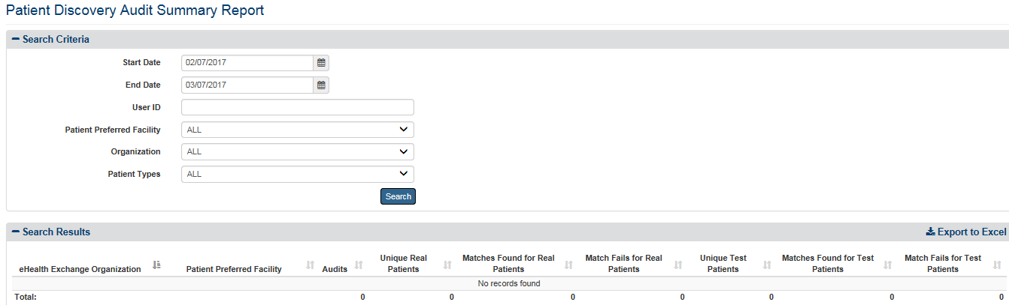

Figure 102: Patient Discovery Audit Summary Report Results

The report, Figure 102, displays the eHealth Exchange Organization, Patient Preferred Facility, Audits, Unique Real Patients, Matches Found for Real Patients, Match Fails for Real Patients, Unique Test Patients, Matches Found for Test Patients, and Match Fails for Test Patients. The total audits are shown at the bottom of the report page.

***To export the Patient Discovery Audit Summary report***

1. Select the **Export to Excel** option on the top-right side of the report section seen in Figure 102.
2. Unlike the detailed reports, no privacy warning is displayed prior to the export completing, as these summary-level reports do not contain personally identifiable information. However, users are reminded to follow standard VA policies and procedures for information handling.
3. Report data is exported into an Excel spreadsheet. For Excel format, report name, current date, and all filtering criteria are exported as a file header.
4. Report data is exported in the same order of columns as in the generated report and data in the exported file is sorted as it was on the report.

**Note:** the “Column Headings” are exported only when there are matching records. If the search did not generate any records, “No records found” message is displayed in the report, as well as in the exported Excel. The name of the file is generated in the following format: [Report_Title]_[Detail/Summary]_Report_YYYYMMDD_HHmmss.[xls/csv]

## Generating Detailed Reports

The VAP application generates eight (8) detailed reports.

* Disclosures
* Received eHealth Exchange Documents
* Consent Directive
* Opt-In Patients
* Expiring Consent
* Delayed Consent
* Patient Discovery Audit
* Scheduled Exports

Each report is described below in more detail. The Report options are available to all users.

If there is a document which linked to a row in a report (i.e., a **View** link appears at the end of the row), the document may be viewed by clicking the link. The displayed document can then be printed by clicking the Printer icon at the top of the screen. This process is detailed below at the end of Section 4.6.1 Disclosures Report.

### Disclosures Detailed

The fields on the Accounting of Disclosure Report query screen (Figure 103) allow you to create an accounting of disclosures report for all health information released to non-VA providers through the use of Exchange or Direct, enter a Veteran’s SSN, Last Name and First Name, enter a range of Start Date and End Date, select an authenticating facility or all facilities, select an eHealth Exchange organization or all external eHealth Exchange organizations, include/exclude test patients and set the number of records per page for the report. This report provides a detailed listing of one or multiple records of patient information for one or more Veterans for a selected range of dates with a combination of selected VA facilities and eHealth Exchange organization or organizations.

***To Generate an Accounting of Disclosures Report***

1. Click the **Disclosures** menu item under **Detailed Reports** heading on the menu at the top of the screen to display the Accounting of Disclosures Report query screen.
2. Click on the down arrow to select the **Disclosure** **Source** either from Exchange (default) or Direct.
3. Enter the SSN for a specific patient in the format ######### (no hyphens) in the **SSN** field. Do not enter a SSN in this field or names in the Last Name and First Name fields if you want to search for all patients in the context of the other parameters you enter.
4. Enter a last name for one or more patients in the **Last** **Name** field. Leave the SSN and First Name fields blank if you want to search for patients with the same Last Name. Do not enter a last name in this field or a first name in the First Name field if you want to search for a patient based on his or her SSN.

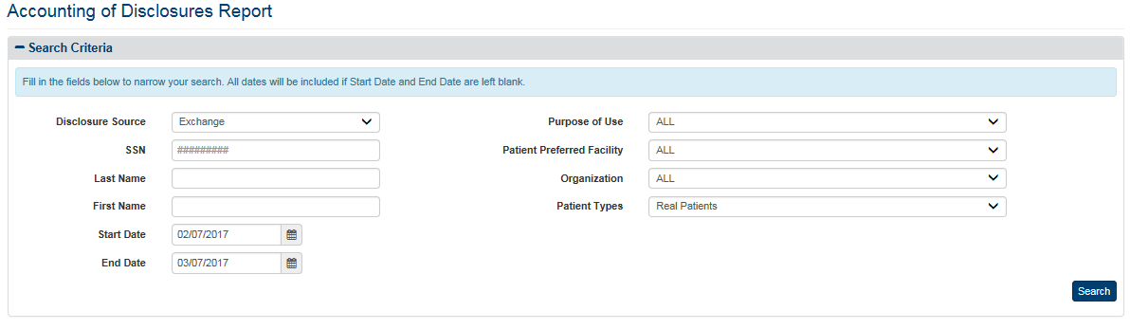

Figure 103: Accounting of Disclosures Report Query Screen (Exchange)

1. Enter a first name for one or more patients in the First Name field. Leave the SSN and Last Name fields blank if you want to search for patients with the same first name. Do not enter a first name in this field or a last name in the Last Name field if you want to search for a patient based on his or her SSN.
2. Enter the start date for the Accounting of Disclosures Report in the **Start Date** field in the format mm/dd/yyyy (i.e., 02/12/2015). You can also select the date from the date range picker dropdown. **Note**: Do not enter a date in this field or the End Date field if you want to search for all dates.
3. Enter the end date for the Accounting of Disclosures Report in the **End Date** field in the format mm/dd/yyyy (i.e., 02/13/2015). You can also select the date from the date range picker dropdown. **Note**: Do not enter a date in this field or the Start Date field if you want to search for all dates.
4. Click the arrow at the right of the **Purpose of Use** list box to select one entry of the following options: Treatment, Emergency, or Coverage.
5. Click the arrow at the right of the **Patient Preferred Facility** list box to select the facility you want to display in the report. All VA Patient Preferred facilities, not just supported ones, appear in the list. The list, except the entry for the Department of Veterans Affairs, is sorted in ascending alphabetical order. You can only select one entry from the list.
6. The default VA facility associated with the logged on (current) user is automatically selected from the list in the VA Patient Facility list box based on the user’s VA User ID. This default can be changed by the user from the **Set Default Facility** menu item.
7. The “ALL” option is no longer the default setting. You must select it from the list if you want the report to include all VA Patient Preferred facilities. If you are generating this report for a specific patient request, select the “ALL” option to ensure that all records that have been disclosed for that particular patient are returned.
8. If you are not sure of the name of a VA facility, you can search for the facility by typing the beginning letter of the facility description (e.g., If the user types “N” in the VA Patient Preferred Facility list box, the selection bar will move to the first VA facility that begins with “N.”) into the blank entry in the list.
9. Click the arrow at the right of the **Organization** list box to select the eHealth Exchange organization you want to display in the report. This reflects the organizations to which the VA disclosed records. You can only select one entry from the list. The default option for this list box is “All,” so do not select a specific organization if you want to see all external eHealth Exchange organizations in the report.
10. If you are generating this report for a specific patient request, select the “All” option to ensure that all records that have been disclosed for that particular patient are returned.
11. The “DEPARTMENT OF VETERANS AFFAIRS” entry appears at the end of the list, not in alphabetical order.
12. Click the arrow at the right of **Patient Types** list box to select the types of patients you want to display in the report. The default option for this list box is “Real Patients,” so do not select a specific option if you want to see Real Patients only. There are three options in the list: All (Real and Test Patients), Real Patients, and Test Patients.
13. Click the **Search** button to display the Accounting of Disclosures Report as shown in Figure 104 for Exchange Disclosures and as shown in Figure 105 for Direct Disclosures.
14. The entries in the VA Facility report column need additional explanation. “UNKNOWN” means that the Patient Preferred Facility could not be resolved by the Enrollment System Redesign (ESR) for the given Patient ID. “UNAVAILABLE” means that ESR is not available. “NULL” indicates invalid data from before “UNKNOWN” and “UNAVAILABLE” were defined.
15. The possible entries in the eHealth Exchange Organization report column need additional explanation. “UNKNOWN” means that the eHealth Exchange Organization could not be resolved by the ESR for the given Patient ID. “NULL” indicates invalid data from before “UNKNOWN” was defined.
16. Click the **Show Entries** list box to select the number of records you want to display on each page of the search. The default option for this list box is “25.” In VAP 2.6.0, this has been updated to remove the “All” option for performance reasons. To allow users to display additional options, 250 and 500 records per page were added. This field now allows users to select by 10, 25, 50, 100, 250 and 500.

In Figure 104, SSN (9 digits), Patient Last Name, Patient First Name, Date of Disclosures, Disclosures, Patient Preferred Facility, Patient Preferred Facility Station ID, eHealth Exchange Organization, User ID, Purpose of Use, User Role, and View are available fields for the Disclosures Report if the disclosure source from eHealth Exchange.

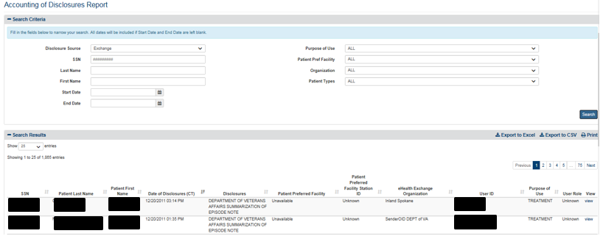

Figure 104: Accounting of Disclosures Report Screen (Exchange)

1. In Figure 105, SSN (9 digits), Patient Last Name, Patient First Name, Date of Disclosures, Disclosures, Direct Address, User ID, and Purpose of Use are available fields for the Disclosures Report if the disclosure source from Direct.

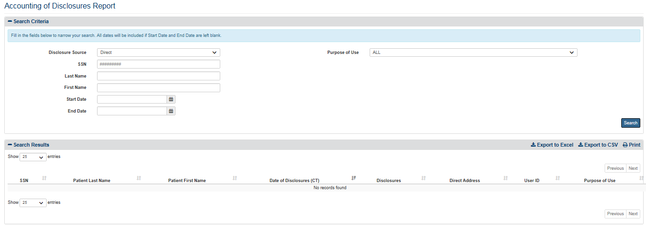

Figure 105: Accounting of Disclosures Report Screen (Direct)

1. A View link in Figure 104 at the end of each listing allows authorized users to review the actual record disclosed on a Document View screen (Figure 105 and Figure 106). The entries in the Disclosures column of the report indicate whether the View links display Summarization of Episode Notes (C32) or Discharge Summarization Notes (C62) or other C62 documents if they are available. The C62 documents can be viewed in a non-editable PDF format. Since the C62 documents are unstructured, the generated PDFs simply capture the unstructured information in PDF format without any manipulations.
2. If the entry in this column reads "Department of Veterans Affairs Summarization of Episode Note," the View link displays a C32 Form as shown in Figure 106. The Summarization of Episode Note (C32) displays the information available on the specific C32 form referenced in the report. (Entries linked to different rows can have different content.) The information that can appear in this document is discussed above in detail in Section 4.2.2 Health Summary (C32) Tab (Figure 22 to Figure 25).

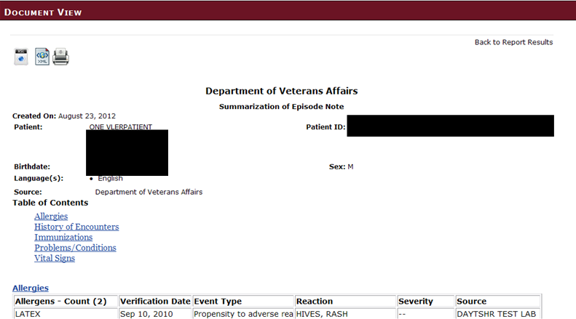

Figure 106: Document View Screen for Summarization of Episode Note

1. If the entry reads "Department of Veterans Affairs Discharge Summary," the View link displays a C62 Form as shown in Figure 107. The Discharge summarization note (C62) shows the following information about the discharged patient: date the note was created, patient first name, patient last name, patient address, Patient ID, home telephone number, birth date, sex, language(s), source of the note (VA Facility and author), emergency contact information, and date the note was electronically generated. (Entries linked to different rows have different content.) Other C62-related documents may be available.
2. Click the **View attachment** link (immediately above the Emergency Contact information section) to display the following detailed Discharge summarization note information in a text file: local title (Discharge Summary), standard title (Discharge Summary), dictated date (mm, dd, yyyy), entry date (mm, dd, yyyy), name of person dictating the note, attending [provider], urgency (e.g., Routine), status (e.g., Completed), date of admission (mm/dd/yyyy), date of discharge (mm/dd/yyyy), principle discharge diagnosis, additional diagnoses, consultant(s), procedure(s), brief admission history, brief admission physical exam, admission lab/EKG/x-ray results, hospital course, condition on discharge, discharge instructions (activity, diet, medications, special Instructions, and follow-up plans), and provider and cosigner signatures. Different fields may appear on different documents.

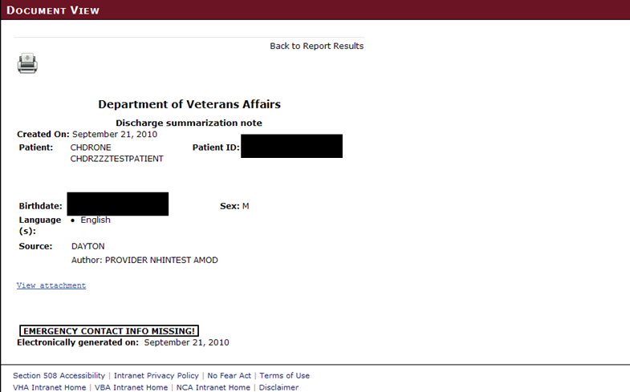

Figure 107: Document View Screen for Discharge Summarization Note

**Note**: If the .txt file does not display properly when opened, you may need to modify the program that is associated with opening the file. See the instructions in **Appendix** **A**.

1. Click the Back to Report Results link to exit either Document View screen and return to the report display.
2. Click the Printer icon in the upper left corner of the Document View screen to open a standard Windows Print dialog box (Figure 108) that allows you to print the document.
3. Click the **Print** button to send the document to a printer. You can print the document using standard Windows printing functionality.
4. Warning! The documents printed with this option display personal health information. They should be retrieved quickly from the printer and managed in accordance with all applicable privacy rules and standards.
5. Click the **Cancel** button to clear the dialog box and return to the Document View screen.
6. The **Apply** button is activated if you change any of the settings in the Print dialog box. Click the button to apply any changes you made.

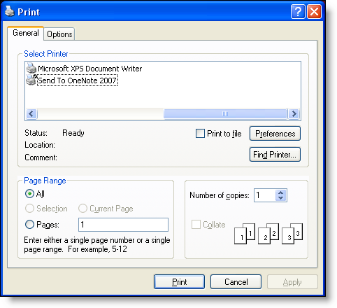

Figure 108: Print Dialog Box

1. If more records are available than can be displayed on one screen, the **Previous** and **Next** buttons at the top and bottom right of the screens are activated. You can use these buttons to page back and forward through the list of records found by the search.
2. Each individual column of the report can be sorted if up and down arrow icons appear below the column heading. Click the up arrow icon to sort the column by ascending order. Click the down arrow icon to sort the column by descending order. (“Unknown” and “Unavailable” sort to the top in ascending order sorts while other facilities and organizations sort alphabetically in ascending order. “Unknown” and “Unavailable” sort to the bottom in descending order sorts while other facilities and organizations sort alphabetically in descending order.)
3. The menu at the top of the screen is based on your role when you logged into the application. It allows you to select other options available to your role.

As shown in Figure 104, the report displays the following fields for each listing: SSN, Patient Last Name, Patient First Name, Date of Disclosure (including time), Disclosures, Patient Preferred Facility, Patient Preferred Facility Station ID, eHealth Exchange Organization (the organization to which the VA disclosed records), User ID (of the person who retrieved the data), Purpose of Use (i.e., how the information disclosed will be used (Coverage (SSA), Emergency, and Treatment), User Role, and a **View** link.

As shown in Figure 105, the report displays the following fields for each listing: SSN, Patient Last Name, Patient First Name, Date of Disclosure (including time), Disclosures, Direct Address, User ID (of the person who retrieved the data), and Purpose of Use (i.e., how the information disclosed will be used (Coverage (SSA), Emergency, and Treatment).

***To export the Delayed Consent Detailed report***

1. Select the **Export to Excel** or **Export to CSV** option on the top-right side of the report section seen in Figures 104 and 105.
2. Unlike the summary reports, a privacy warning, Figure 109, is displayed prior to the export completing, as these detailed-level reports contain personally identifiable information.
3. For Excel, report data is exported into a spreadsheet. For Excel format, report name, current date, and all filtering criteria are exported as a file header.
4. Report data is exported in the same order of columns as in the generated report and data in the exported file is sorted as it was on the report.

**Note:** the “Column Headings” are exported only when there are matching records. If the search did not generate any records, “No records found” message is displayed in the report, as well as in the exported Excel. The name of the file is generated in the following format: [Report_Title]_[Detail/Summary]_Report_YYYYMMDD_HHmmss.[xls/csv]

**Note**: Not displayed within the VAP User Interface, and only in the Export, the VAP system displays Organization Identifier Code (OID).

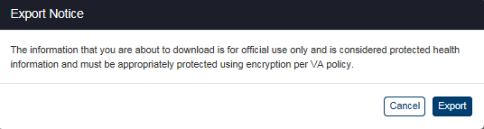

Figure 109: Export Warning Message and Exported Excel

### Received eHealth Exchange Documents Detailed

The fields on the Received eHealth Exchange Documents Report query screen (Figure 110) allow you to enter a Veteran’s SSN and name or select all Veterans, enter a range of dates, select a Patient Preferred facility or all Patient Preferred facilities, select an eHealth Exchange organization or all external eHealth Exchange organizations, include/exclude test patients and set the number of records per page for the report. This report provides a detailed listing of reports requested and received for one or more patients for a selected range of dates with a combination of selected VA Patient Preferred facilities and eHealth Exchange organizations.

***To Generate a Received eHealth Exchange Documents Report***

1. Click the **Received eHealth Exchange Documents** menu item under the **Detailed Reports** heading on the menu at the top of the screen to display the Received eHealth Exchange Documents Report query screen.

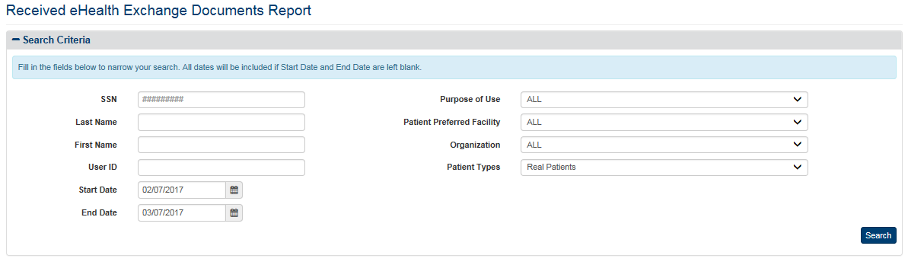

Figure 110: Received eHealth Exchange Documents Report Query Screen

1. Enter the SSN for a specific patient in the format ######### (no hyphens) in the **SSN** field. Do not enter a SSN in this field or names in the Last Name and First Name fields if you want to search for all patients in the context of the other parameters you enter.
2. Enter a last name for one or more patients in the **Last Name** field. Leave the SSN and First Name fields blank if you want to search for patients with the same last name. Do not enter a last name in this field or a first name in the First Name field if you want to search for a patient based on his or her SSN.
3. Enter a first name for one or more patients in the **First Name** field. Leave the SSN and Last Name fields blank if you want to search for patients with the same first name. Do not enter a First name in this field or a last name in the Last Name field if you want to search for a patient based on his or her SSN.
4. Enter a user ID in the **User ID** field if you want to search for a specific user. **Note**: Do not enter a User ID in this field if you want to search for all users.
5. Enter the start date for the Received eHealth Exchange Document Report in the **Start Date** field in the format mm/dd/yyyy (e.g., 02/12/2015). You can also select the date from the date range picker dropdown. **Note**: Do not enter a date in this field or the End Date field if you want to search for all dates.
6. Enter the end date for the Consent Directive Report in the **End Date** field in the format mm/dd/yyyy (e.g., 02/14/2015). You can also select the date from the date range picker dropdown. **Note**: Do not enter a date in this field or the Start Date field if you want to search for all dates.
7. Click the arrow at the right of the **Purpose of Use** list box to select one entry of the following options: Treatment, Emergency, or Coverage.
8. Click the arrow at the right of the **Patient Preferred Facility** list box to select the facility you want to display in the report. All VA Patient Preferred facilities, not just supported ones, now appear in the list. You can only select one entry from the list.
9. The default Patient Preferred VA facility associated with the logged on (current) user is automatically selected from the list in the VA Patient Preferred Facility list box based on the user’s VA User ID. This default can be changed by the user from the **Set Default Facility** menu item.
10. The “ALL” option is no longer the default setting. You must select it from the list if you want the report to include all VA Patient Preferred facilities.
11. If you are not sure of the name of a VA Patient Preferred facility, you can search for the facility by typing the beginning letters of the facility description (e.g., If the user types “N” in the VA Facility list box, the selection bar will move to the first VA facility that begins with “N.”) into the blank entry in the list.
12. Click the arrow at the right of the **Organization** list box to select the eHealth Exchange organization you want to display in the report. You can only select one entry from the list. The default option for this list box is “All,” so do not select a specific organization if you want to see all external eHealth Exchange organizations in the report. The “DEPARTMENT OF VETERANS AFFAIRS” entry appears at the end of the list, not in alphabetical order.
13. Click the **Search** button to display the Received eHealth Exchange Documents Report as shown in Figure 111.
14. Three of the entries in the VA Patient Preferred Facility report column need additional explanation. “UNKNOWN” means that the Patient Preferred Facility could not be resolved by the Enrollment System Redesign (ESR) for the given Patient ID. “UNAVAILABLE” means that ESR is not available. “NULL” indicates invalid data from before “UNKNOWN” and “UNAVAILABLE” were defined.
15. Two of the possible entries in the eHealth Exchange Organization report column need additional explanation. “UNKNOWN” means that the eHealth Exchange Organization could not be resolved by the ESR for the given Patient ID. “NULL” indicates invalid data from before “UNKNOWN” was defined.
16. Click the **Show Entries** list box to select the number of records you want to display on each page of the search. The default option for this list box is “25.” In VAP 2.6.0, this has been updated to remove the “All” option for performance reasons. To allow users to display additional options, 250 and 500 records per page were added. This field now allows users to select by 10, 25, 50, 100, 250 and 500.
17. A View link at the end of each listing allows authorized users to review the actual record requested (Figure 110). The Printer icon at the top left of the screen displaying the record allows you to print the document. Click the link to open a standard Windows File Download dialog box. Steps 15-17 of Section 4.6.1 Disclosures Report, and Figure 106 to Figure 108 detail this process.
18. For some reports there may be a View Attachment link above the Emergency Contact information. Click the link to open the report. **Note**: If the report does not display properly when the link is clicked you may need to modify the program that is associated with opening the file. **See Appendix A Section 7.2** for help setting Windows to open the document with the correct application.
19. If more records are available than can be displayed on one screen, the Previous and Next buttons at the top and bottom right of the screens are activated. You can use these buttons to page back and forward through the list of records found by the search.
20. Each individual column of the report can be sorted if up and down arrow icons appear below the column heading. Click the up arrow icon to sort the column by ascending order. Click the down arrow icon to sort the column by descending order. (“Unknown” and “Unavailable” sort to the top in ascending order sorts while other facilities and organizations sort alphabetically in ascending order. “Unknown” and “Unavailable” sort to the bottom in descending order sorts while other facilities and organizations sort alphabetically in descending order.)
21. The menu at the top of the screen is based on your role when you logged into the application. It allows you to select other options available to your role.

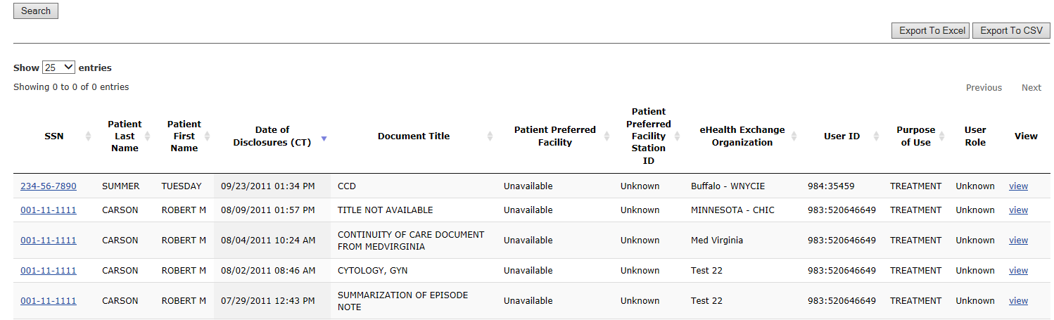

Figure 111: Received eHealth Exchange Documents Report Screen

The report displays the following fields for each listing: SSN, Patient Last Name, Patient First Name, Date Received (including time), Document Title (name of the document), Patient Preferred Facility, Patient Preferred Facility Station ID, eHealth exchange Organization (source of the document), User ID (person requesting the disclosure), Purpose of Use (i.e., how the information disclosed will be used: Coverage (SSA), Emergency, and Treatment), User Role, and a **View** link.

The “USER ID” column is parsed in the Excel as four columns: User ID, User Facility Code, User Facility, and User Name.

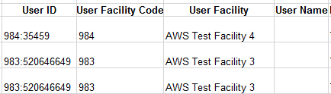

***To export the Received eHealth Exchange Documents Detailed report***

1. Select the **Export to Excel** or **Export to CSV** option on the top-right side of the report section seen in Figure 111.
2. Unlike the summary reports, a privacy warning, Figure 112, is displayed prior to the export completing, as these detailed-level reports contain personally identifiable information.
3. For Excel, report data is exported into a spreadsheet. For Excel format, report name, current date, and all filtering criteria are exported as a file header.
4. Report data is exported in the same order of columns as in the generated report and data in the exported file is sorted as it was on the report.

**Note:** the “Column Headings” are exported only when there are matching records. If the search did not generate any records, “No records found” message is displayed in the report, as well as in the exported Excel. The name of the file is generated in the following format: [Report_Title]_[Detail/Summary]_Report_YYYYMMDD_HHmmss.[xls/csv]



Figure 112: Export Warning Message

**Note**: Not displayed within the VAP User Interface, and only in the Export, the VAP system displays Organization Identifier Code (OID), as highlighted in Figure 113.

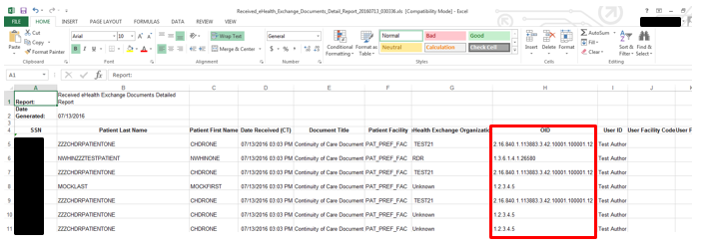

Figure 113: Exported Received eHealth Exchange Documents Report Displaying OID (Excel)

### Consent Directive Detailed

The fields on the Consent Directive Report query screen (Figure 114) allow you to enter a Veteran’s SSN and name or select all Veterans, enter a range of dates, select an Authenticating facility or all Authenticating facilities, select the actions to be covered, select a type of consent or all types, select a reason for revoking record sharing or all reasons, include/exclude test patients and set the number of records per page for the report. This report provides a detailed listing of specified authorization, restriction, and revocation activity for one or more patients for a selected range of dates at selected VA Authenticating facilities.

***To Generate a Consent Directive Report***

1. Click the **Consent** **Directive** menu item under the **Detailed Reports** heading on the menu at the top of the screen to display the Consent Directive Report query screen.

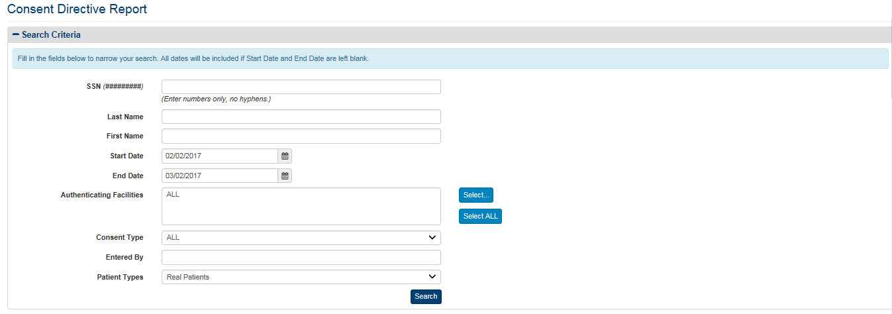

Figure 114: Consent Directive Report Query Screen

1. Enter the SSN for a specific patient in the format ######### (no hyphens) in the **SSN** field. Do not enter a SSN in this field or names in the Last Name and First Name fields if you want to search for all patients in the context of the other parameters you enter.
2. Enter a last name for one or more patients in the **Last Name** field. Leave the SSN and First Name fields blank if you want to search for patients with the same last name. Do not enter a last name in this field or a first name in the First Name field if you want to search for a patient based on his or her SSN.
3. Enter a first name for one or more patients in the **First Name** field. Leave the SSN and Last Name fields blank if you want to search for patients with the same first name. Do not enter a First name in this field or a last name in the Last Name field if you want to search for a patient based on his or her SSN.
4. Enter the start date for the Consent Directive Report in the **Start Date** field in the format mm/dd/yyyy (e.g., 02/12/2015). You can also select the date from the date range picker dropdown. **Note**: Do not enter a date in this field or the End Date field if you want to search for all dates.
5. Enter the end date for the Consent Directive Report in the **End Date** field in the format mm/dd/yyyy (e.g., 02/13/2015). You can also select the date from the date range picker dropdown. **Note**: Do not enter a date in this field or the Start Date field if you want to search for all dates.
6. Click the **Select** button at the right of **Authenticating Facilities** to select one or more facilities you want to display in the report. The default authenticating facility filter is set to the User Default Facility. This default can be changed by the user from the **Set Default Facility** menu item under the **Welcome** menu. The “ALL” option is the default setting, unless a default facility is selected. You must select the Select All button if you want the report to include all VA facilities.
7. A pop-up window will show displaying all VISNs, their associated facilities, and your selection in three (3) separate sections.
8. For each section, you may Select/Unselect all from the top right, as highlighted in Figure 115 below. The first and second columns are used to filter by VISN and Facilities. The third column to the right displays the selected VISNs and Facilities to be included within the resultant report.
9. The VISN column, to the left-hand side of the pop-up, displays all 21 VISNs stored within the VAP application. This column allows the user to filter and/unselect by VISNs.
10. The middle column, “Facilities” shows a listing of all the Facilities. By default, facilities in the middle section are grouped by VISN. This default can be changed if you uncheck the “Display facilities grouped by VISN” box, under the middle section, highlighted in Figure 115. Once unchecked, facilities will be listed in alphabetical order. If any VISNs, from the VISN column are unchecked, the Facilities list will update to remove these facilities from the view.
11. Once the selection is made and the first two columns, VISNs and Facilities, are filtered, the last column to the right, “Your Selection” will display the resultant facilities associated with the filter selection from the other two boxes.
12. The other two checkboxes within this page are “Include consents with unknown VISN,” and “Aggregate data at the facility level.” By default, both are unchecked.
13. Click **OK** to confirm your selection and implement it in the search results.
14. Click **Cancel** on the bottom right to cancel your selection and go back to the previously selected filter option. Click **Restore last selection** to go back to the last selection of facilities used. For example, if the last selection you made only included VISN 1 facilities, clicking this button on a window that’s displaying all facilities will change the selection to show only VISN 1 facilities.



Figure 115: Select Facilities Pop-Up Windows

1. Click the arrow at the right of the **Consent Type** list box to select the types of consent you want to display in the report. The default option for this list box is “ALL,” so do not select a specific option if you want to see all types of consent. There are eight other options in the list: All Authorizations, All Revocations, eHealth Exchange Authorizations, SSA Authorizations, eHealth Exchange Revocations, SSA Revocations, eHealth Exchange Restrictions, and eHealth Exchange Restrictions Revocations. You can only select one entry from the list.
2. The **Inactivation Reason** list box is not pictured in Figure 114. It does not appear on the query screen until one of the Revocation entries in the Consent Type list box is selected. When the field does appear, click the arrow at the right of this list box to select the reason why the Consent Directive became inactive. The default option for this list box is “ALL,” so do not select a specific option if you want to see all inactivation reasons. There are six options in the list: ALL, New Authorization, Patient Deceased, Entered in Error, Authorization Expired, and Revoked. You can only select one entry from the list.
3. Enter a name or “User ID” in the **Entered By** field to filter by either full or partial name of the entity associated with the transaction. This field can refer to either DVA User ID that entered a record (for example, "smith"), or a system that initiated a transaction (for example, "eBenefits"). Search on this field is case insensitive; that is, values of "smith" and "SMITH" will produce the same result set.
4. Click the **Search** button to display the Consent Directive Report as shown in Figure 117.
5. Click the **Show Entries** list box to select the number of records you want to display on each page of the search. The default option for this list box is “25.” In VAP 2.6.0, this has been updated to remove the “All” option for performance reasons. To allow users to display additional options, 250 and 500 records per page were added. This field now allows users to select by 10, 25, 50, 100, 250 and 500.
6. The entries in the VA Authenticating Facility report column need additional explanation. “UNKNOWN” means that the Patient Preferred Facility could not be resolved by the Enrollment System Redesign (ESR) for the given Patient ID. “UNAVAILABLE” means that ESR is not available. “NULL” indicates invalid data from before “UNKNOWN” and “UNAVAILABLE” were defined.
7. A **View** button at the end allows authorized users to review the actual record requested (Figure 118) when available. Click the **View** button to view.
8. A **View Restriction** button at the end, Figure 117 and 118, allows authorized users to review the restriction details of the restricted organization(s), seen in Figure 116.

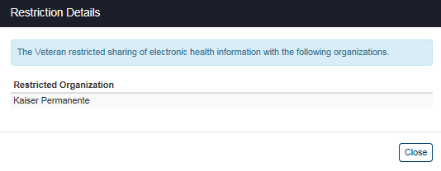

Figure 116: Restriction Details (Restricted Organizations)

1. If more records are available than can be displayed on one screen, the **Previous** and **Next** buttons at the top and bottom right of the screens are activated. You can use these buttons to page back and forward through the list of records found by the search.
2. Each individual column of the report can be sorted if up and down arrow icons appear below the column heading. Click the up arrow icon to sort the column by ascending order. Click the down arrow icon to sort the column by descending order. (“Null,” “Unavailable,” and “Unknown” appear inline when they occur.)

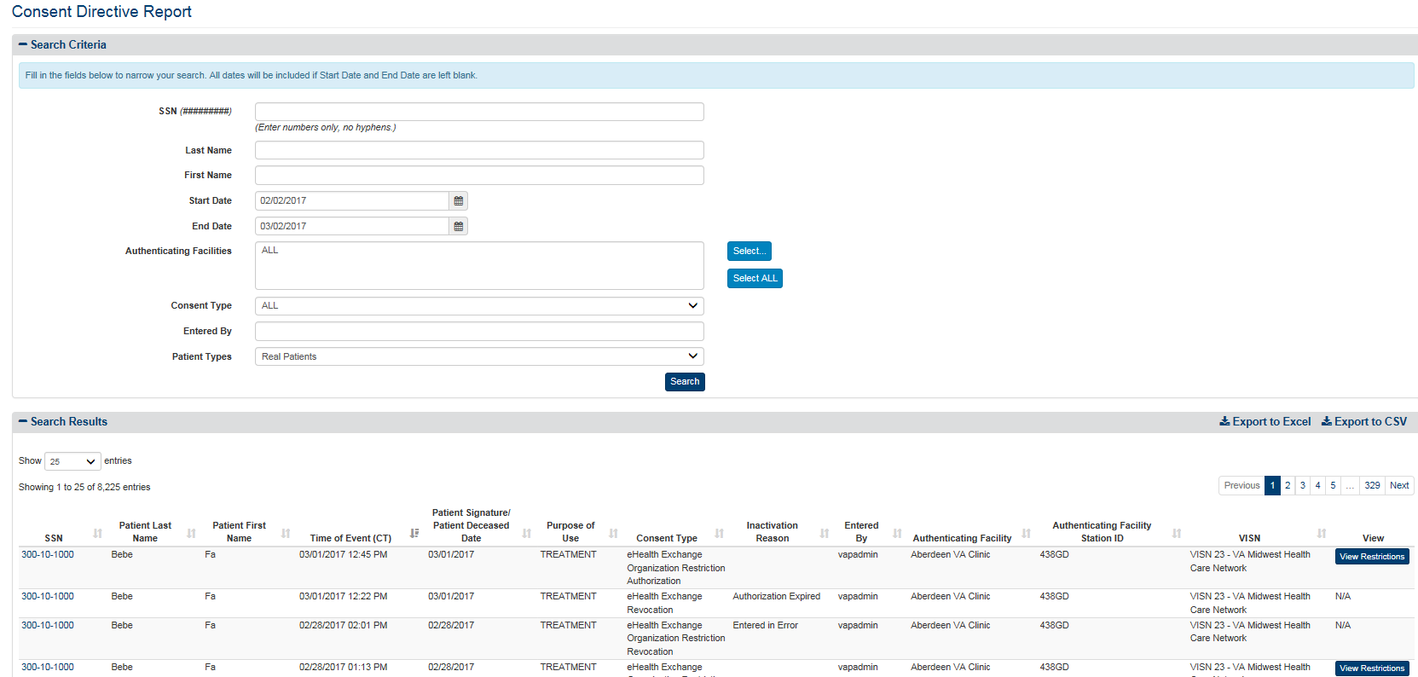

Figure 117: Consent Directive Detailed Report Screen

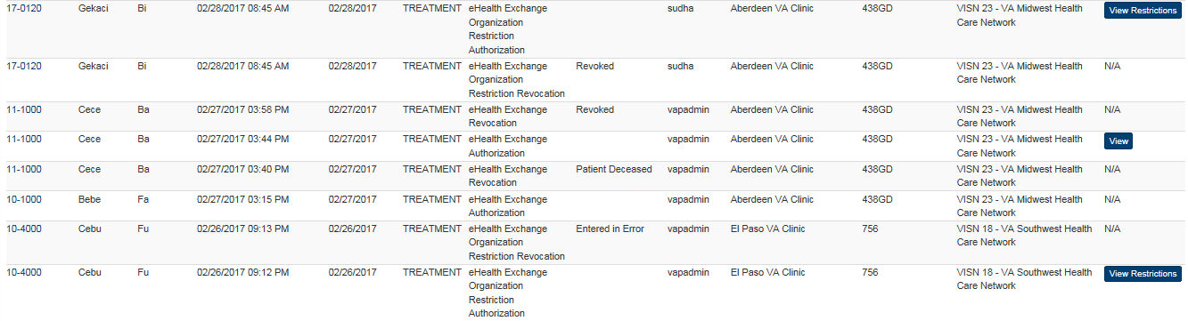

Figure 118: Consent Directive Detailed Report Screen (Showing View)

1. The menu at the top of the screen is based on your role when you logged into the application. It allows you to select other options available to your role.

The report displays the following fields for each listing: SSN, Patient Last Name, Patient First Name, Time of Event (including date), Patient Signature / Patient Deceased Date, Purpose of Use (i.e., how the information disclosed will be used: Coverage (SSA), Emergency, and Treatment), Consent Type, Inactivation Reason, Entered By (person initiating the event listed), Authenticating Facility, Authenticating Facility Station ID, VISN, and a **View** link.

***To export the Consent Directive Detailed report***

1. Select the **Export to Excel** or **Export to CSV** option on the top-right side of the report section seen in Figure 117.
2. Unlike the summary reports, a privacy warning, Figure 119, is displayed prior to the export completing, as these detailed-level reports contain personally identifiable information.
3. For Excel, report data is exported into a spreadsheet. For Excel format, report name, current date, and all filtering criteria are exported as a file header.
4. Report data is exported in the same order of columns as in the generated report and data in the exported file is sorted as it was on the report.

**Note:** the “Column Headings” are exported only when there are matching records. If the search did not generate any records, “No records found” message is displayed in the report, as well as in the exported Excel. The name of the file is generated in the following format: [Report_Title]_[Detail/Summary]_Report_YYYYMMDD_HHmmss.[xls/csv]



Figure 119: Export Warning Message

### Opt-In Detailed

The fields on the Opt-In Detailed Report query screen (Figure 120) allow you to enter VA Authenticating Facility, Consent Type, and set the number of records per page for the report. This report provides a detailed listing of opt-in patients at selected VA Authenticating facilities.

***To Generate an Opt-In Detailed Report***

1. Click the **Opt-In Patients** menu item under the **Detailed Reports** heading on the menu at the top of the screen to display the Opt-In Detailed Report query screen.

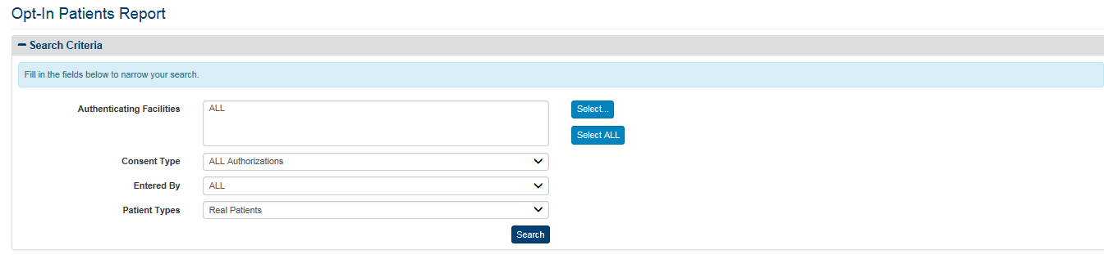

Figure 120: Opt-In Detailed Report Query Screen

1. Click the **Select** button at the right of **Authenticating Facilities** to select one or more facilities you want to display in the report. The default authenticating facility filter is set to the User Default Facility. This default can be changed by the user from the **Set Default Facility** menu item under the **Welcome** menu. The “ALL” option is the default setting, unless a default facility is selected. You must select the Select All button if you want the report to include all VA facilities.
2. A pop-up window will show displaying all VISNs, their associated facilities, and your selection in three (3) separate sections.
3. For each section, you may Select/Unselect all from the top right, as highlighted in Figure 121 below. The first and second columns are used to filter by VISN and Facilities. The third column to the right displays the selected VISNs and Facilities to be included within the resultant report.
4. The VISN column, to the left-hand side of the pop-up, displays all 21 VISNs stored within the VAP application. This column allows the user to filter and/unselect by VISNs.
5. The middle column, “Facilities” shows a listing of all the Facilities. By default, facilities in the middle section are grouped by VISN. This default can be changed if you uncheck the “Display facilities grouped by VISN” box, under the middle section, highlighted in Figure 121. Once unchecked, facilities will be listed in alphabetical order. If any VISNs, from the VISN column are unchecked, the Facilities list will update to remove these facilities from the view.
6. Once the selection is made and the first two columns, VISNs and Facilities, are filtered, the last column to the right, “Your Selection” will display the resultant facilities associated with the filter selection from the other two boxes.
7. The other two checkboxes within this page are “Include consents with unknown VISN,” and “Aggregate data at the facility level.” By default, both are unchecked.
8. Click **OK** to confirm your selection and implement it in the search results.
9. Click **Cancel** on the bottom right to cancel your selection and go back to the previously selected filter option. Click **Restore last selection** to go back to the last selection of facilities used. For example, if the last selection you made only included VISN 1 facilities, clicking this button on a window that’s displaying all facilities will change the selection to show only VISN 1 facilities.



Figure 121: Select Facilities Pop-Up Windows

1. The default option for **Consent Type** is ALL Authorizations. If you want to select a specific Consent Type, click on the drop down arrow to choose from the list. The other two options are eHealth Exchange Authorizations, and SSA Authorizations.
2. Click the arrow at the right of the **Entered By** list box to select if an individual or eBenefits entered the consent information. The default option for this list box is “ALL,” so do not select a specific option if you want to see everyone who entered consent information. There are two other options in the list: eBenefits and Employee. You can only select one entry from the list.
3. Click the **Search** button to display the Opt-Detailed Report shown in Figure 122.
4. Click the **Show Entries** list box to select the number of records you want to display on each page of the search. The default option for this list box is “25.” In VAP 2.6.0, this has been updated to remove the “All” option for performance reasons. To allow users to display additional options, 250 and 500 records per page were added. This field now allows users to select by 10, 25, 50, 100, 250 and 500.
5. If more records are available than can be displayed on one screen, the **Previous** and **Next** buttons at the top and bottom right of the screens are activated. You can use these buttons to page back and forward through the list of records found by the search.
6. Each individual column of the report can be sorted if up and down arrow icons appear below the column heading. Click the up arrow icon to sort the column by ascending order. Click the down arrow icon to sort the column by descending order.
7. The menu at the top of the screen is based on your role when you logged into the application. It allows you to select other options available to your role.

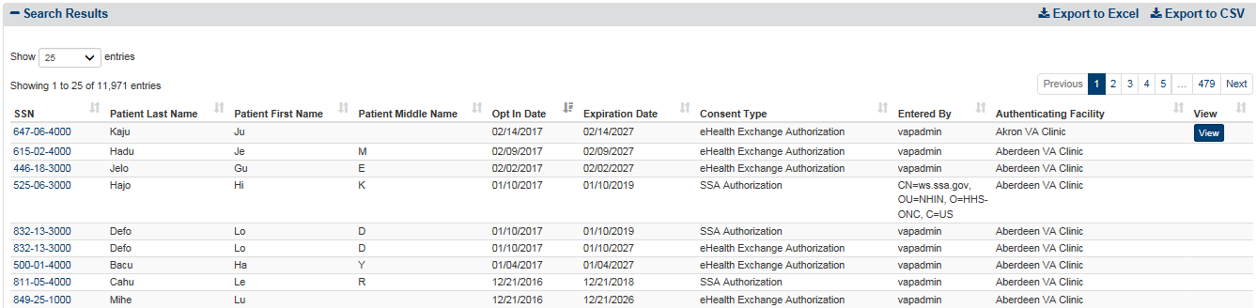

Figure 122: Opt-In Patients Detailed Report Screen

The report displays the following fields for each listing: SSN, Patient Last Name, Patient First Name, Patient Middle Name, Consent Type, Opt-In Date, Expiration Date, Entered By, Authenticating Facility, and a View column.

***To export the Opt-In Patient Detailed report***

1. Select the **Export to Excel** or **Export to CSV** option on the top-right side of the report section seen in Figure 122.
2. Unlike the summary reports, a privacy warning, Figure 123, is displayed prior to the export completing, as these detailed-level reports contain personally identifiable information.
3. For Excel, report data is exported into a spreadsheet. For Excel format, report name, current date, and all filtering criteria are exported as a file header.
4. Report data is exported in the same order of columns as in the generated report and data in the exported file is sorted as it was on the report.

**Note:** the “Column Headings” are exported only when there are matching records. If the search did not generate any records, “No records found” message is displayed in the report, as well as in the exported Excel. The name of the file is generated in the following format: [Report_Title]_[Detail/Summary]_Report_YYYYMMDD_HHmmss.[xls/csv]



Figure 123: Export Warning Message

### Expiring Consent

The Expiring Consent Report provides a detailed listing of consents at selected range in days which were set in the Expiring Consent Notification, Section 4.8. The fields on the Expiring Consent Report query screen (Figure 124) allow you to set the number of records per page for the report and include/exclude test patients as well as filter on Authenticating Facility, Consent Type, and Entered By. It is important to note that the Expiring Consent Report is only for upcoming expirations and doesn’t track historical expired patients (i.e. deceased, etc.).

***To Generate an Expiring Consent Report***

1. Click the **Expiring Consent** menu item under the **Detailed Reports** heading on the menu at the top of the screen to display the Expiring Consent Report query screen.

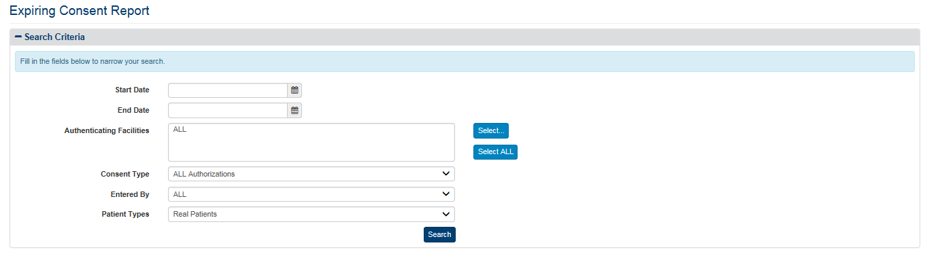

Figure 124: Expiring Consent Report Query Screen

1. The **Start Date** and **End Date** run as default within the range of the days which were set for the Days until Expiration of the Expiring Consent Notification, Figure 124.
2. Click the **Select** button at the right of **Authenticating Facilities** to select one or more facilities you want to display in the report. The default authenticating facility filter is set to the User Default Facility. This default can be changed by the user from the **Set Default Facility** menu item under the **Welcome** menu. The “ALL” option is the default setting, unless a default facility is selected. You must select the Select All button if you want the report to include all VA facilities.
3. A pop-up window will show displaying all VISNs, their associated facilities, and your selection in three (3) separate sections.
4. For each section, you may Select/Unselect all from the top right, as highlighted in Figure 125 below. The first and second columns are used to filter by VISN and Facilities. The third column to the right displays the selected VISNs and Facilities to be included within the resultant report.
5. The VISN column, to the left-hand side of the pop-up, displays all 21 VISNs stored within the VAP application. This column allows the user to filter and/unselect by VISNs.
6. The middle column, “Facilities” shows a listing of all the Facilities. By default, facilities in the middle section are grouped by VISN. This default can be changed if you uncheck the “Display facilities grouped by VISN” box, under the middle section, highlighted in Figure 125. Once unchecked, facilities will be listed in alphabetical order. If any VISNs, from the VISN column are unchecked, the Facilities list will update to remove these facilities from the view.
7. Once the selection is made and the first two columns, VISNs and Facilities, are filtered, the last column to the right, “Your Selection” will display the resultant facilities associated with the filter selection from the other two boxes.
8. The other two checkboxes within this page are “Include consents with unknown VISN,” and “Aggregate data at the facility level.” By default, both are unchecked.
9. Click **OK** to confirm your selection and implement it in the search results.
10. Click **Cancel** on the bottom right to cancel your selection and go back to the previously selected filter option. Click **Restore last selection** to go back to the last selection of facilities used. For example, if the last selection you made only included VISN 1 facilities, clicking this button on a window that’s displaying all facilities will change the selection to show only VISN 1 facilities.



Figure 125: Select Facilities Pop-Up Windows

1. The default option for **Consent Type** is ALL Authorizations. If you want to select a specific Consent Type, click on the drop down arrow to choose from the list.
2. The default option for **Entered By** is ALL. If you want to select a specific Entered By, click on the drop down arrow to choose from the list.
3. Click the **Search** button to display the Expiring Consent Report shown in Figure 126.
4. Click the **Show Entries** list box to select the number of records you want to display on each page of the search. The default option for this list box is “25.” In VAP 2.6.0, this has been updated to remove the “All” option for performance reasons. To allow users to display additional options, 250 and 500 records per page were added. This field now allows users to select by 10, 25, 50, 100, 250 and 500.
5. If more records are available than can be displayed on one screen, the **Previous** and **Next** buttons at the top and bottom right of the screens are activated. You can use these buttons to page back and forward through the list of records found by the search.
6. Each individual column of the report can be sorted if up and down arrow icons appear below the column heading. Click the up arrow icon to sort the column by ascending order. Click the down arrow icon to sort the column by descending order.
7. The menu at the top of the screen is based on your role when you logged into the application. It allows you to select other options available to your role.

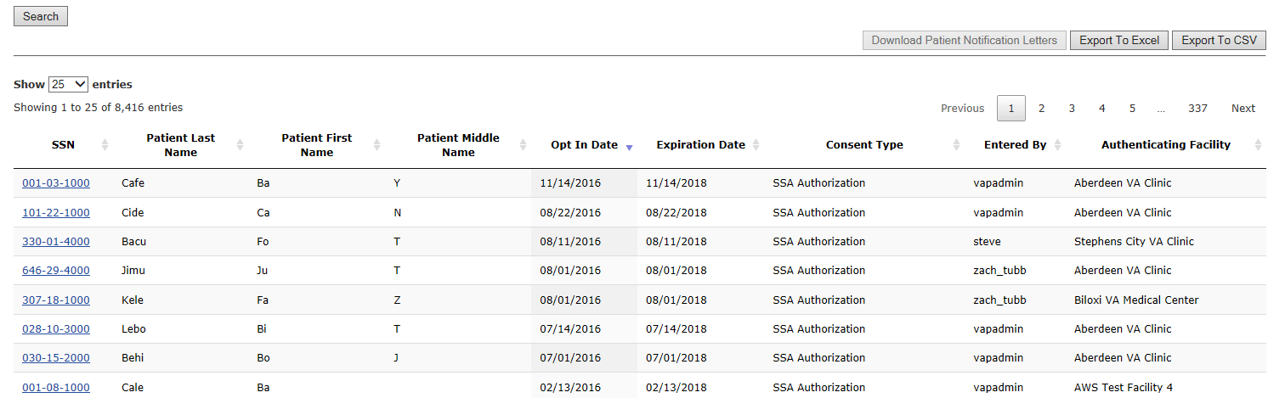

Figure 126: Expiring Consent Report Screen

The report displays the following fields for each listing: SSN, Patient Last Name, Patient First Name, Patient Middle Name, Opt-In Date, Expiration Date, Consent Type, Entered By, and Authenticating Facility.

***To export the Expiring Consent Detailed report***

1. Select the **Export to Excel** or **Export to CSV** option on the top-right side of the report section seen in Figure 126.
2. Unlike the summary reports, a privacy warning, Figure 127, is displayed prior to the export completing, as these detailed-level reports contain personally identifiable information.
3. For Excel, report data is exported into a spreadsheet. For Excel format, report name, current date, and all filtering criteria are exported as a file header.
4. Report data is exported in the same order of columns as in the generated report and data in the exported file is sorted as it was on the report.

**Note:** the “Column Headings” are exported only when there are matching records. If the search did not generate any records, “No records found” message is displayed in the report, as well as in the exported Excel. The name of the file is generated in the following format: [Report_Title]_[Detail/Summary]_Report_YYYYMMDD_HHmmss.[xls/csv]



Figure 127: Export Warning Message

### Delayed Consent Detailed

The Delayed Consent Detailed Report, Figure 128, allows you to select one or multiple SSN’s, Last Name, First Name, Authenticating facilities(s), reason or reasons for delay, days since delayed, consent type, and patient types. This report provides a summary listing of the selected Delayed Consent totals at the selected Authenticating facility or facilities.

***To Generate a Delayed Consent Detailed Report***

1. Click the **Delayed** **Consent** menu item under **Detailed Reports** heading on the menu at the top of the screen to display the Delayed Consent Detailed Report query screen.

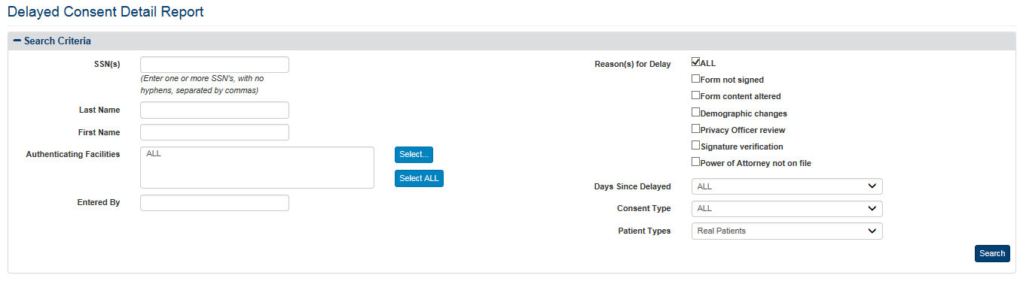

Figure 128: Delayed Consent Detail Report

1. Enter one or multiple SSNs, separated by comma, in the format ######### (no hyphens) in the **SSN** field. Do not enter a SSN in this field or names in the Last Name and First Name fields if you want to search for all patients in the context of the other parameters you enter.
2. Enter a last name for one or more patients in the **Last** **Name** field. Leave the SSN and First Name fields blank if you want to search for patients with the same last name. Do not enter a last name in this field or a first name in the First Name field if you want to search for a patient based on his or her SSN.
3. Enter a first name for one or more patients in the **First Name** field. Leave the SSN and Last Name fields blank if you want to search for patients with the same first name. Do not enter a First name in this field or a last name in the Last Name field if you want to search for a patient based on his or her SSN.
4. Click the **Select** button at the right of **Authenticating Facilities** to select one or more facilities you want to display in the report. The default authenticating facility filter is set to the User Default Facility. This default can be changed by the user from the **Set Default Facility** menu item under the **Welcome** menu. The “ALL” option is the default setting, unless a default facility is selected. You must select the Select All button if you want the report to include all VA facilities.
5. A pop-up window will show displaying all VISNs, their associated facilities, and your selection in three (3) separate sections.
6. For each section, you may Select/Unselect all from the top right, as highlighted in Figure 129 below. The first and second columns are used to filter by VISN and Facilities. The third column to the right displays the selected VISNs and Facilities to be included within the resultant report.
7. The VISN column, to the left-hand side of the pop-up, displays all 21 VISNs stored within the VAP application. This column allows the user to filter and/unselect by VISNs.
8. The middle column, “Facilities” shows a listing of all the Facilities. By default, facilities in the middle section are grouped by VISN. This default can be changed if you uncheck the “Display facilities grouped by VISN” box, under the middle section, highlighted in Figure 129. Once unchecked, facilities will be listed in alphabetical order. If any VISNs, from the VISN column are unchecked, the Facilities list will update to remove these facilities from the view.
9. Once the selection is made and the first two columns, VISNs and Facilities, are filtered, the last column to the right, “Your Selection” will display the resultant facilities associated with the filter selection from the other two boxes.
10. The other two checkboxes within this page are “Include consents with unknown VISN,” and “Aggregate data at the facility level.” By default, both are unchecked.
11. Click **OK** to confirm your selection and implement it in the search results.
12. Click **Cancel** on the bottom right to cancel your selection and go back to the previously selected filter option. Click **Restore last selection** to go back to the last selection of facilities used. For example, if the last selection you made only included VISN 1 facilities, clicking this button on a window that’s displaying all facilities will change the selection to show only VISN 1 facilities.



Figure 129: Select Facilities Pop-Up Windows

1. Check one or multiple of the **reason(s) for delay** checkboxes that you want to display in your Delayed Consent Detailed Report. By default, all reasons for delay will be displayed. Do not select a specific option if you want to see all reasons in the report.
2. Click the arrow at the right of the **Days Since Delayed** list box to select the range of days, since the status have been delayed, you want to display in the report.
3. Click the arrow at the right of the **Consent Type** list box to select the types of consent you want to display in the report. The default option for this list box is “ALL,” so do not select a specific option if you want to see all types of consent. There are two options in the list: eHealth Exchange Authorizations and SSA Authorizations. You can only select one entry from the list.
4. Click the arrow at the right of **Patient Types** list box to select the types of patients you want to display in the report. The default option for this list box is “Real Patients”, so do not select a specific option if you want to see Real Patients only. There are three options in the list: All (Real and Test Patients), Real Patients, and Test Patients.
5. Enter a name or “User ID” in the **Entered By** field to filter by either full or partial name of the entity associated with the transaction. This field can refer to either DVA User ID that entered a record (for example, "smith"), or a system that initiated a transaction (for example, "eBenefits"). Search on this field is case insensitive; that is, values of "smith" and "SMITH" will produce the same result set.
6. Click the **Search** button to display the Delayed Consent Report shown in Figure 130.

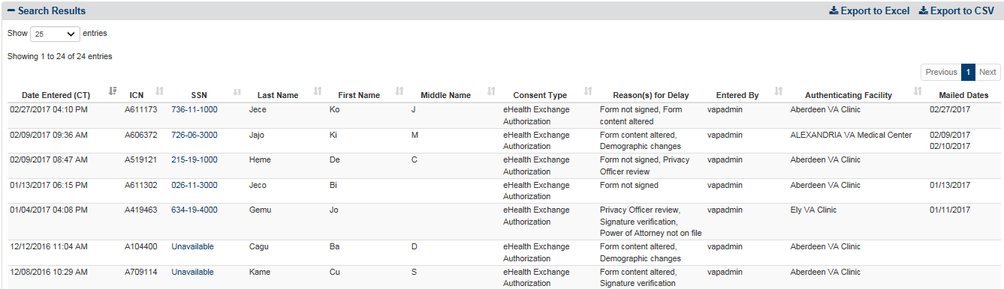

Figure 130: Delayed Consent Detail Report

1. Click the **Show Entries** list box to select the number of records you want to display on each page of the search. The default option for this list box is “25.” In VAP 2.6.0, this has been updated to remove the “All” option for performance reasons. To allow users to display additional options, 250 and 500 records per page were added. This field now allows users to select by 10, 25, 50, 100, 250 and 500.
2. If more records are available than can be displayed on one screen, the **Previous** and **Next** buttons at the bottom right of the screens are activated. You can use these buttons to page back and forward through the list of records found by the search.
3. Each individual column of the report can be sorted if up and down arrow icons appear below the column heading. Click the up arrow icon to sort the column by ascending order. Click the down arrow icon to sort the column by descending order.
4. The menu at the top of the screen is based on your role when you logged into the application. It allows you to select other options available to your role.

The report displays the following fields for each listing: Date Entered (CT), ICN, SSN, Patient Last Name, Patient First Name, Patient Middle Initial, Consent Type, Reason(s) for Delay, Entered By, Authenticating Facility, and Mailed Dates.

***To export the Delayed Consent Detailed report***

1. Select the **Export to Excel** or **Export to CSV** option on the top-right side of the report section seen in Figure 130.
2. Unlike the summary reports, a privacy warning, Figure 131, is displayed prior to the export completing, as these detailed-level reports contain personally identifiable information.
3. For Excel, report data is exported into a spreadsheet. For Excel format, report name, current date, and all filtering criteria are exported as a file header.
4. Report data is exported in the same order of columns as in the generated report and data in the exported file is sorted as it was on the report.

**Note:** the “Column Headings” are exported only when there are matching records. If the search did not generate any records, “No records found” message is displayed in the report, as well as in the exported Excel. The name of the file is generated in the following format: [Report_Title]_[Detail/Summary]_Report_YYYYMMDD_HHmmss.[xls/csv]



Figure 131: Export Warning Message

### Patient Discovery Audit Detailed

The fields in the Search Details box on the Patient Discovery Audit Report query screen (Figure 132) allow you to enter the SSN, First Name and Last Name, User ID, set a range of dates, select MPI results and an eHealth Exchange organization or organizations, include/exclude test patients, and set the number of records per page for the report. This report provides a detailed listing of messages received about one or more patients for a selected range of dates at the selected eHealth Exchange organization or organizations.

***To Generate a Patient Discovery Audit Report***

1. Click the **Patient Discovery Audit** menu item under **Detailed Reports** heading on the menu at the top of the screen to display the Patient Discovery Audit Report query screen.
2. Enter one or multiple SSNs, separated by comma, in the format ######### (no hyphens) in the **SSN** field. Do not enter a SSN in this field or names in the Last Name and First Name fields if you want to search for all patients in the context of the other parameters you enter.
3. Enter a last name for one or more patients in the **Last Name** field. Leave the SSN and First Name fields blank if you want to search for patients with the same last name. Do not enter a last name in this field or a first name in the First Name field if you want to search for a patient based on his or her SSN.
4. Enter a first name for one or more patients in the **First Name** field. Leave the SSN and Last Name fields blank if you want to search for patients with the same first name. Do not enter a First name in this field or a last name in the Last Name field if you want to search for a patient based on his or her SSN.
5. Enter a user ID in the **User ID** field if you want to search for a specific user. **Note**: Do not enter a User ID in this field if you want to search for all users.
6. Enter the start date for the Patient Discovery Audit Report in the **Start Date** field in the format mm/dd/yyyy (e.g., 06/11/2014). You can also select the date from the date range picker dropdown. **Note**: Do not enter a date in this field or the End Date field if you want to search for all dates.

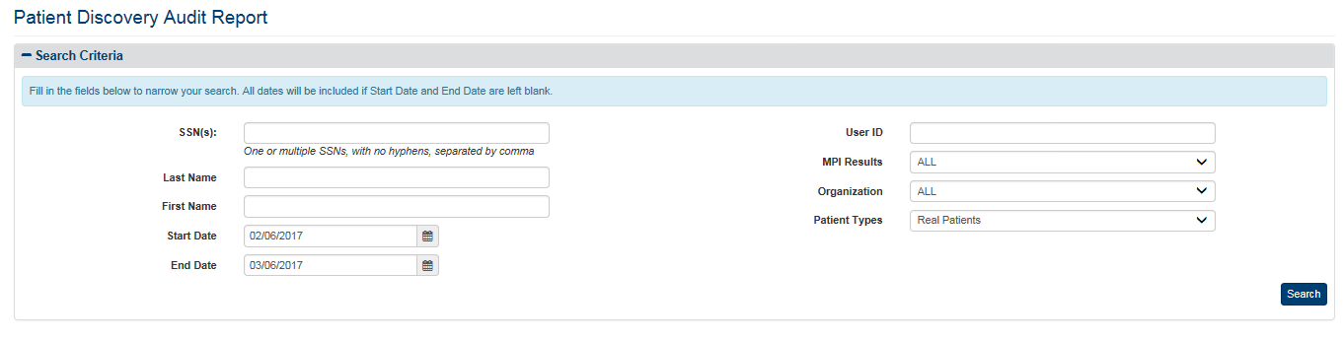

Figure 132: Patient Discovery Audit Report Query Screen

1. Enter the end date for the Patient Discovery Audit Report in the **End Date** field in the format mm/dd/yyyy (e.g., 06/25/2014). You can also select the date from the date range picker dropdown. **Note**: Do not enter a date in this field or the Start Date field if you want to search for all dates.
2. Click the arrow at the right of the **MPI Results** list box to select the MPI results you want to display in the report. The default option for this list box is “All,” so do not select a specific result if you want to see all MPI results in the report. Other options in the list are Match Found and Match Failed. You can only select one entry from the list. If you select Match Found you will be able to see a report containing only the failed matches and when they occurred.
3. Click the arrow at the right of the **Organization** list box to select the eHealth Exchange organization you want to display in the report. You can only select one entry from the list. The default option for this list box is “All,” so do not select a specific organization if you want to see all external eHealth Exchange organizations in the report. The “DEPARTMENT OF VETERANS AFFAIRS” entry appears at the end of the list, not in alphabetical order.
4. Click the arrow at the right of **Patient Types** list box to select the types of patients you want to display in the report. The default option for this list box is “Real Patients,” so do not select a specific option if you want to see Real Patients only. There are three options in the list: All (Real and Test Patients), Real Patients, and Test Patients.
5. Click the **Search** button to display the Patient Discovery Audit Report as shown in Figure 133.
6. Click the **Show Entries** list box to select the number of records you want to display on each page of the search. The default option for this list box is “25.” In VAP 2.6.0, this has been updated to remove the “All” option for performance reasons. To allow users to display additional options, 250 and 500 records per page were added. This field now allows users to select by 10, 25, 50, 100, 250 and 500.
7. If more records are available than can be displayed on one screen, the **Previous** and **Next** buttons at the top and bottom right of the screens are activated. You can use these buttons to page back and forward through the list of records found by the search.
8. Each individual column of the report can be sorted if up and down arrow icons appear below the column heading. Click the up arrow icon to sort the column by ascending order. Click the down arrow icon to sort the column by descending order.
9. The menu at the top of the screen is based on your role when you logged into the application. It allows you to select other options available to your role.

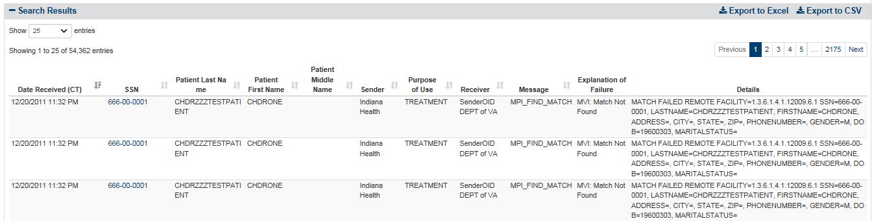

Figure 133: Patient Discovery Audit Report Screen (Top)

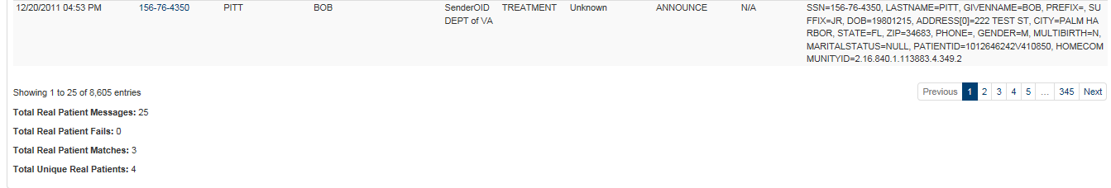

Figure 134: Patient Discovery Audit Report Screen (Bottom) without Test Patients

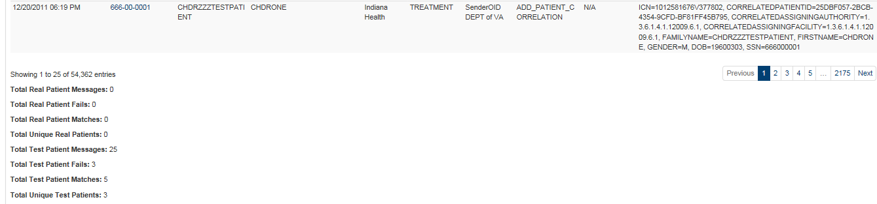

Figure 135: Patient Discovery Audit Report Screen (Bottom) with Test Patients

The report displays the following fields for each listing:

* Date Received
* SSN (or SSN Unknown for patients whose SSN cannot be established)
* Patient Last Name
* Patient First Name
* Patient Middle Name (The Middle Name column only displays if middle name is tracked in Exchange)
* Sender
* Sender OID (When exported to Excel or CSV, Figure 137)
* Purpose of Use (i.e., how the information disclosed will be used: Coverage (SSA), Emergency, and Treatment)
* Receiver
* Receiver OID (When exported to Excel or CSV, Figure 137)
* Message
* Explanation of Failure
* Details

At the bottom left of the report screen shows the real/test patient messages, real/test patient fails, real/test patient matches, and unique teal/test patients.

The Details column displays the Patient’s Place of Birth City and State, Date of Birth, Mother’s Maiden Name, Social Security Number, Phone Number, and Address. The Details column also if there was a failure to announce patients (listed below). Announcement failure may occur due to one of the following reasons:

* Failure – Partner did not respond with Patient information
  + A response was not received from the partner, for the announce call.
* Failure – Outbound PD: Partner is not registered with the system
  + A partner is not registered with the system (Partner is not permitting patient discovery requests). Therefore, the announce was not sent out from eHealth Exchange to this partner.

Within Build 2.6.0, the Patient Discovery Audit logging in the eHealth Exchange Audit table was modified for announces. Typically, one row was displayed due to the fan-out functionality implemented. As part of this release, eHealth Exchange will record a row for every patient-partner announce transaction. Thus, if the announce was sent to five partners for one individual, five rows will be displayed within the report. If there was a failure, for either of the two reasons above, for example, for 2 of the 5 announces failed, then two of the rows will show for which patient-partner the failures was recorded.

***To export the Patient Discovery Audit Detailed report***

1. Select the **Export to Excel** or **Export to CSV** option on the top-right side of the report section seen in Figure 133.
2. Unlike the summary reports, a privacy warning is displayed prior to the export completing, as these detailed-level reports contain personally identifiable information.
3. For Excel, report data is exported into a spreadsheet. For Excel format, report name, current date, and all filtering criteria are exported as a file header.
4. Report data is exported in the same order of columns as in the generated report and data in the exported file is sorted as it was on the report.

**Note:** the “Column Headings” are exported only when there are matching records. If the search did not generate any records, “No records found” message is displayed in the report, as well as in the exported Excel. The name of the file is generated in the following format: [Report_Title]_[Detail/Summary]_Report_YYYYMMDD_HHmmss.[xls/csv]



Figure 136: Export Warning Message

**Note**: Not displayed within the VAP User Interface, and only in the Export, the VAP system displays Organization Identifier Code (OID), as highlighted in Figure 137.

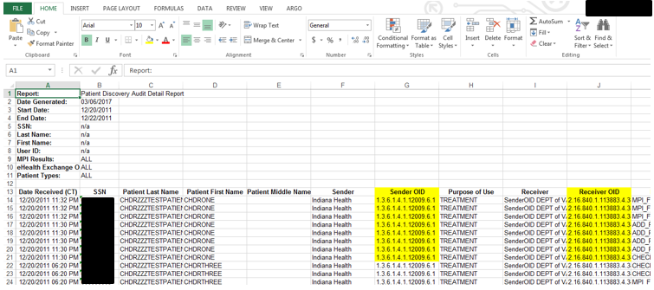

Figure 137: Exported Patient Discovery Audit Report Displaying OID (Excel)

### Scheduled Exports

The Scheduled Exports provides a detailed listing of completed exports available for download. For exports that are under 1000 rows, the user will be prompted to download their report immediately; however, for reports that exceed the 1000 rows, the user will be prompted to navigate to Scheduled Exports for download, as seen in the export privacy warning message seen in figure 138.

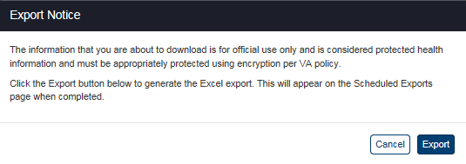

Figure 138: Export Warning Message (Reports Exceeding 1000 Rows)

1. Click the **Scheduled** **Exports** menu item under **Detailed Reports** heading on the menu at the top of the screen to display the Scheduled Exports query screen.
2. Click the **Show Entries** list box, shown in Figure 139, to select the number of records you want to display on each page of the search. The default option for this list box is “25.”

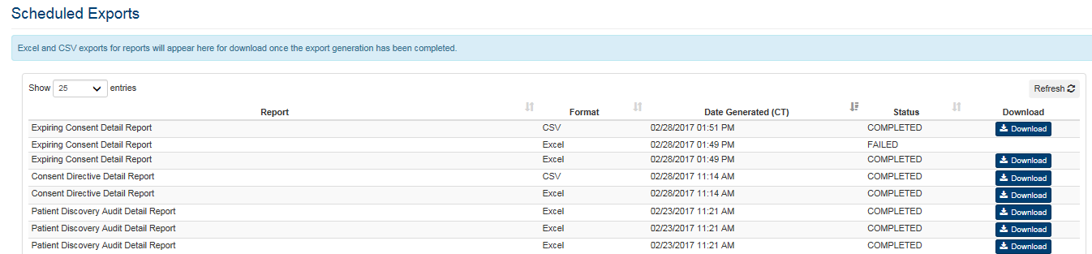

Figure 139: Scheduled Exports Report

1. If more records are available than can be displayed on one screen, the **Previous** and **Next** buttons at the bottom right of the screens are activated. You can use these buttons to page back and forward through the list of records found by the search.
2. Click the **Refresh** button on the top right on the report to refresh results.
3. Each individual column of the report can be sorted if up and down arrow icons appear below the column heading. Click the up arrow icon to sort the column by ascending order. Click the down arrow icon to sort the column by descending order.
4. The menu at the top of the screen is based on your role when you logged into the application. It allows you to select other options available to your role.
5. The report displays the following fields for each listing: Report, Format, Date Generated (CT), Status, and Download.

### Data Quality Report

The Data Quality Report will allow for easy access of XML Clinical Document Architectures (CDAs) in bulk. This is essential to a more efficient performance of data quality analysis on VA and Partner documentation. To start the generation of these XML files, the user must select the Data Quality menu tab from the VAP homepage, this will display the query interface.

1. Business Analysts will specify a date range for the query (a month range is highly recommended for optimum download speed)
2. Select the “All” option from the eHealth Exchange Organization dropdown menu to retrieve files from all partners or select one organization to specify a partner to query.
3. Click the Generate button to start the download process, this action will display the File Open Dialog Box which will give an option open or save the generated zip file

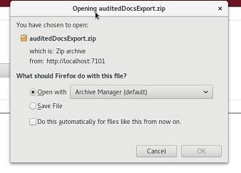

Figure 140: File Open Dialog Box

1. Select Open with a default archive tool or plugin to view the zipped folder. If the ALL option was selected from the eHealth Exchange Organization dropdown menu, this folder will further contain partner folders. The XML files extracted are available in the respective folders, by partner site.

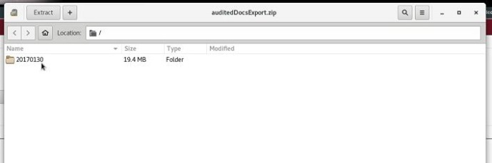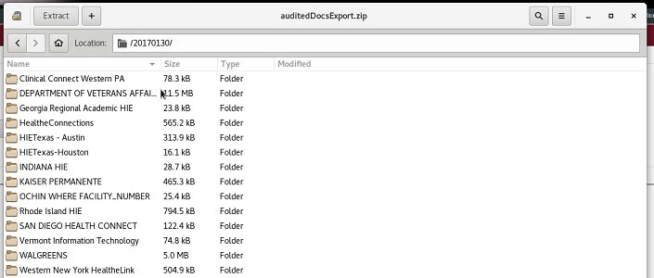

Figure 141: Generated Archive Folder/s

1. Select a specific partner folder to view the exported data labeled by document type.
2. Select an XML file to display its content in XML format (machine must have a plugin/tool installed that can display XML files appropriately).

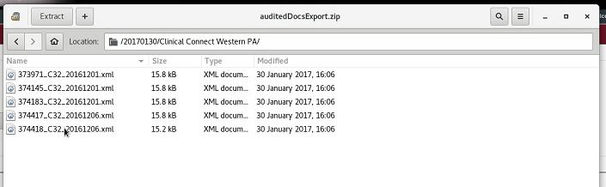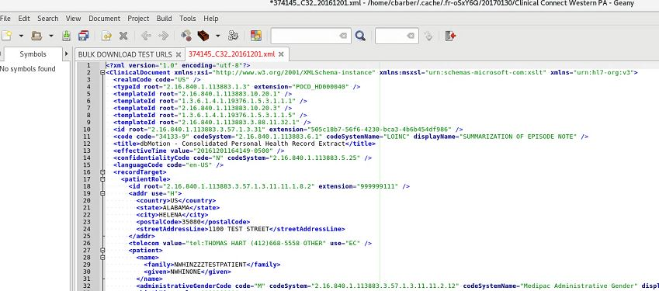

Figure 142: Generated XML Files

VAP retrieves the Consolidated - Clinical Document Architecture (C-CDA) Health Summary Continuity of Care document (CCD) from eHealth Exchange Adapter (Adapter), upon being invoked as the authorization context handler for Adapter operations.

The following patient record file types can be downloaded from the SQA Adapter database: C32s, CCDAs, CCDs, C62s, and Progress Notes.

With this enhancement, VA Business Analyst can easily access XML CDAs sent from and received by the VA from a standard secure network file sharing system to quickly perform data quality analysis on VA and Partner documentation.

## Viewing the User Guide

The User Guide (this document) for the current VAP application can be viewed by selecting the **User Guide** option on the menu at the top under the **Welcome** menu. This option displays the version stored in the Technical Service Project Repository (TSPR).

***To View the User Guide for the Application***

Click the User Guide menu item under the Welcome menu at the top of any screen to view the current User Guide (this document) for the VAP application.

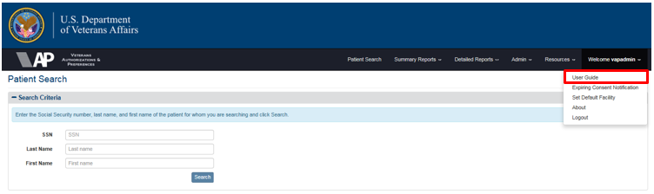

Figure 143: User Guide Option under Welcome Menu

## Expiring Consent Notification

The Expiring Consent Notification is the configuration mechanism for automatically running expiring consent reports of patients whose consent for participation in HIE is within a user specified expiration window (i.e., 90 days) and can be sent to a distribution list.

***To Schedule Expiring Consent Details***

Click the Expiring Consent Notification menu item under the Welcome menu at the top of the screen to display the Expiring Consent Notification query screen (Figure 141).

1. Set the **Frequency** (i.e. Daily, Weekly, Monthly)
2. Set the **Days Until Expiration** (i.e., 5, 10, 15, 20, 30, or 90)

**Note**: The date range of Expiring Consent Report, Section 4.6.5, will automatically set as default for Start Date and End Date within the range of the days (i.e., 90) which were set for the **Days until Expiration**.

1. Set the **Distribution List** with one email address per line
2. Click on **Save**

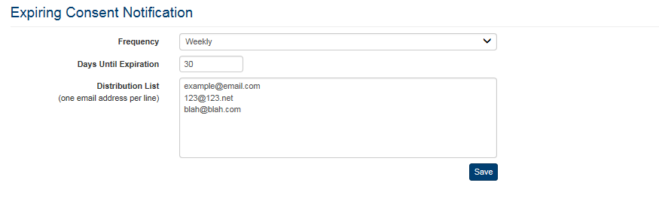

Figure 144: Expiring Consent Notification Query Screen

When **Save** is clicked, the user will receive an email notification in the appropriate time. The email contains a link that will take the user to the report with the previously identified date range Figure 142.

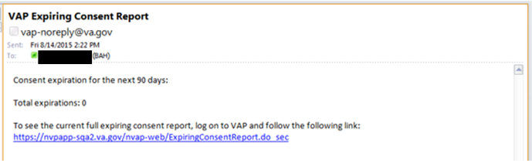

Figure 144: VAP Expiring Consent Report Email

## Setting a Default Facility

Set Default Facility allows users to designate a facility preference, which will be associated with the user for VAP Consent Management and VAP Reporting (Figure 143). There are several scenarios where users might want to set a default facility:

A user might not have a designated default facility because the user ID is not associated with a pilot site.

* A user might have an ID which is not associated with any facility in VistA
* An automatic default facility is in place for a user ID associated with a pilot site but the user wishes to change it to a different default facility.
* A manual default facility is in place, but the user wishes to change it.

### Setting a Default Facility When No Default is in Place

1. From the top menu bar, click the Set Default Facility option under the Welcome menu (Figure 143).

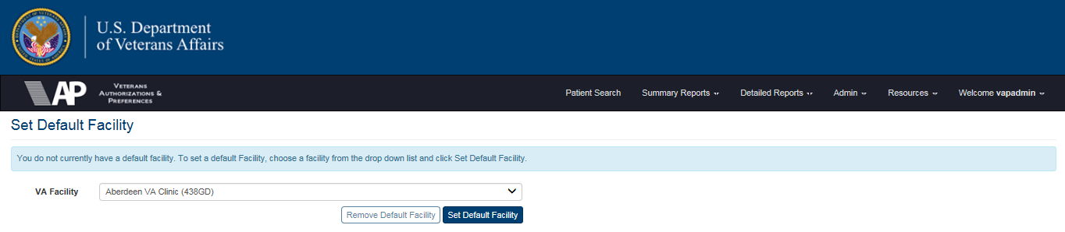

Figure 145: Set Default Facility Screen

1. A message indicates that no default facility is currently set. This message occurs because the User ID does not correspond to a VistA facility and no manual facility has been established. Since default facility is set, the first facility listed in the VA Facility dropdown box is displayed.
2. From the **VA Facility** dropdown list, select a new default facility.
3. Click the **Set Default Facility** button to designate the selected facility as the default (Figures 143 and 144).

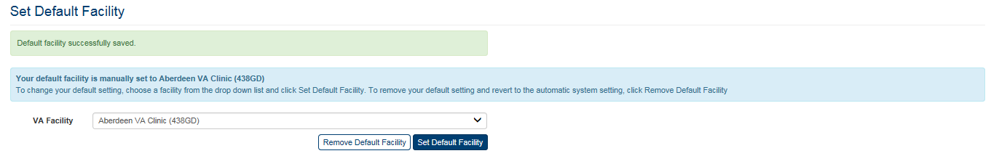

Figure 146: Set Default Facility – Manually Set

### Changing the Automatic Default Facility

The automatically assigned default facility can be changed for users who were assigned a facility based on their User ID (Figure 145).

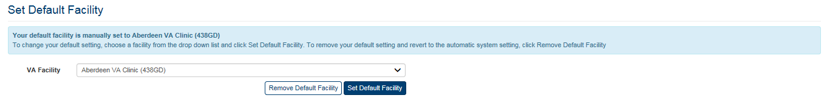

Figure 147: Changing the Automatic Default Facility

1. From the **VA Facility** dropdown list, select a new facility. The new default facility is now displayed.
2. Click **Set Default Facility**. The new facility now appears as the default facility and a message indicates that the default facility has been manually set.

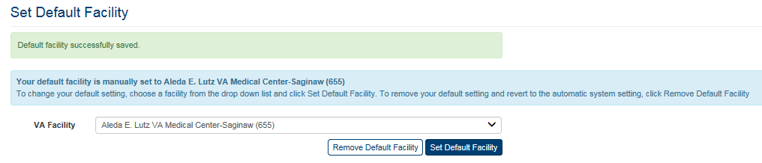

Figure 148: Default Facility Changed

1. To revert to the automatic default facility, click the **Remove Default Facility** button (Figure 146).
2. The default facility reverts back to the facility that was selected automatically based on the user’s assignment to a pilot site.

## Viewing Build Information

The current build number for the application can be viewed by selecting the About VAP option on the menu at the top of any screen except the Login screen. This information also is displayed at the bottom of the Login screen (Figure 4).

***To View Build Information for the Application***

1. Click the **About** VAP menu item under the **Welcome** menu at the top of any screen to view the current build information for the VAP application. (Figure 147 shows the link on the Patient Search screen, but ROI Reporters will not see this screen. They see one of the summary or detailed report screens.)

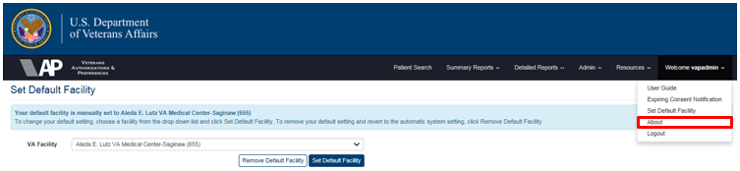

Figure 149: The About VAP Option Under the Welcome Menu

1. The Build Information screen (Figure 148) displays the message “The Current Version of VAP is: 2.7.0.0303”. **Note** in Production, these numbers will be followed by the VA Release convention (aka. 2.7.0). There is no other information on this screen.
2. Select an option on the menu at the top of the screen to return to the application.

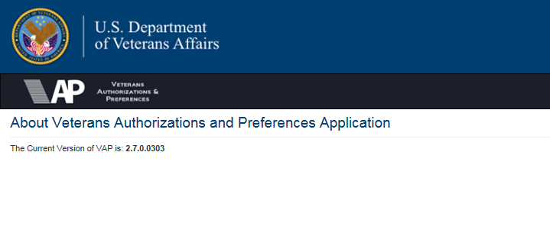

Figure 150: About VAP Screen

# Troubleshooting

## Special Instructions for Error Correction

Table 4: VAP 2.7 Error Messages with Causes and Resolutions

| User Interface | Error | Cause | Resolution | Notes |
| --- | --- | --- | --- | --- |
| VAP Login Screen | Username is required.  Password is required. | The Username and Password fields must both be filled before pressing the **Login** button. Either or both of these errors can occur depending on which fields were filled in and which were not. | Both the Username and Password fields must be filled before pressing the **Login** button. |  |
| VAP Login Screen | Invalid username and/or password were entered. | Both the Username and Password fields were entered, but the username and/or password was not entered correctly before pressing the **Login** button. | Enter a valid username and password before pressing the **Login** button. |  |
| VAP Login Screen | Username is not valid. | Both the Username and Password fields were filled, but the username entered is not a valid username. | Enter a valid username and password before pressing the **Login** button. |  |
| VAP Patient Search Screen | SSN is required.  Last Name is required.  First Name is required. | The SSN, Last Name, and First Name fields must be filled before pressing the **Search** button. Any or all of these errors can occur depending on which fields were filled in and which were not. | The SSN, Last Name, and First Name fields must all be filled in before pressing the **Search** button. |  |
| VAP Patient Search Screen | SSN is not valid. | The SSN field needs to contain nine (9) numeric characters. This error occurs if less than nine (9) numeric characters or any non-numeric characters are entered. | The SSN field must contain exactly nine (9) numeric and no other characters before pressing the **Search** button. (The Last Name and First Name fields must also be filled.) |  |
| VAP Patient Search Screen | Last Name is not valid.  First Name is not valid. | The Last Name and First Name fields must contain alphabetic characters only. Some special characters, such as periods and apostrophes, are allowed. Either or both of these errors can occur depending on which fields were filled incorrectly. | The Last Name and First Name fields must contain only alphabetic characters before pressing the **Search** button. (Some special characters are allowed, such as periods and apostrophes.) | The team needs to determine the entire list of special characters allowed. |
| Revoke eHealth Exchange Screen | Patient Signature Date must be after the date the authorization was signed. | This message occurs when you choose the “Revoked” option on the Revoke eHealth Exchange screen if the patient signature date entered is earlier than the date the authorization was originally signed. | The Patient Signature Date field on the Revoke eHealth Exchange screen must be filled with a date later than the date the authorization was originally signed if you choose "Revoked" as the reason. |  |
| Revoke or Terminate eHealth Exchange Organization Restriction Screen | Patient Signature Date must be after the date the authorization was signed. | This message occurs when you choose the “Revoked” option on the Revoke or Terminate eHealth Exchange Organization Restriction screen if the patient signature date entered is earlier than the date the restrictions were originally signed. | The Patient Signature Date field on the Revoke or Terminate eHealth Exchange Organization Restriction screen must be filled with a date later than the date the restrictions were originally signed if you choose "Revoked" as the reason. |  |
| Revoke SSA Screen | Patient Signature Date must be after the date the authorization was signed. | This message occurs when you choose the “Revoked” option on the Revoke SSA screen if the patient signature date entered is earlier than the date the authorization was originally signed. | The Patient Signature Date field on the Revoke SSA screen must be filled with a date later than the date the authorization was originally signed if you choose "Revoked" as the reason. |  |
| Batch Announce Patients Screen | End Date must be a later date than Start Date. | This message occurs when the start date entered is later than the end date entered. | The start date entered must occur before the end date entered or be the same date as the end date. |  |
| Batch Announce Patients Screen | Start Date is not a valid date.  End Date is not a valid date. | This message occurs when the dates entered in the Start Date and/or End Date fields are not valid dates or are not in the proper format (mm/dd/yyyy). Either or both of these errors can occur depending on which fields were filled incorrectly. | The start and end dates entered must be valid dates and must be in the format: mm/dd/yyyy. |  |
| Batch Announce Patients Screen | Organization is required. | This message occurs when no organizations were moved to the "Organizations to whom you want to announce patients" box. | You must select at least one organization from the "All Organizations" list box to announce and move it to the "Organizations to whom you want to announce patients" list box. |  |
| Manage Batches Screen (Search) | End Date must be a later date than Start Date. | This message occurs when the start date entered is later than the end date entered. | The start date entered must occur before the end date entered or be the same date as the end date. |  |
| Manage Batches Screen (Search) | Start Date is not a valid date.  End Date is not a valid date. | This message occurs when the dates entered in the Start Date and/or End Date fields are not valid dates or are not in the proper format (mm/dd/yyyy). Either or both of these errors can occur depending on which fields were filled incorrectly. | The start and end dates entered must be valid dates and must be in the format: mm/dd/yyyy. |  |
| Disclosures Summary Report Screen (Search) | End Date must be a later date than Start Date. | This message occurs when the start date entered is later than the end date entered. | The start date entered must occur before the end date entered or be the same date as the end date. |  |
| Disclosures Summary Report Screen (Search) | Start Date is not a valid date.  End Date is not a valid date. | This message occurs when the dates entered in the Start Date and/or End Date fields are not valid dates or are not in the proper format (mm/dd/yyyy). Either or both of these errors can occur depending on which fields were filled incorrectly. | The start and end dates entered must be valid dates and must be in the format: mm/dd/yyyy. |  |
| Received eHealth Exchange Documents Summary Report Screen (Search) | End Date must be a later date than Start Date. | This message occurs when the start date entered is later than the end date entered. | The start date entered must occur before the end date entered or be the same date as the end date. |  |
| Received eHealth Exchange Documents Summary Report Screen (Search) | Start Date is not a valid date.  End Date is not a valid date. | This message occurs when the dates entered in the Start Date and/or End Date fields are not valid dates or are not in the proper format (mm/dd/yyyy). Either or both of these errors can occur depending on which fields were filled incorrectly. | The start and end dates entered must be valid dates and must be in the format: mm/dd/yyyy. |  |
| Consent Directive Summary Report Screen (Search) | End Date must be a later date than Start Date. | This message occurs when the start date entered is later than the end date entered. | The start date entered must occur before the end date entered or be the same date as the end date. |  |
| Consent Directive Summary Report Screen (Search) | Start Date is not a valid date.  End Date is not a valid date. | This message occurs when the dates entered in the Start Date and/or End Date fields are not valid dates or are not in the proper format (mm/dd/yyyy). Either or both of these errors can occur depending on which fields were filled incorrectly. | The start and end dates entered must be valid dates and must be in the format: mm/dd/yyyy. |  |
| Accounting of Disclosures Report Screen (Search) | End Date must be a later date than Start Date. | This message occurs when the start date entered is later than the end date entered. | The start date entered must occur before the end date entered or be the same date as the end date. |  |
| Accounting of Disclosures Report Screen (Search) | Start Date is not a valid date.  End Date is not a valid date. | This message occurs when the dates entered in the Start Date and/or End Date fields are not valid dates or are not in the proper format (mm/dd/yyyy). Either or both of these errors can occur depending on which fields were filled incorrectly. | The start and end dates entered must be valid dates and must be in the format: mm/dd/yyyy. |  |
| Accounting of Disclosures Report Screen (Search) | SSN is not valid. | The SSN field needs to contain nine (9) numeric characters. This error occurs if less than nine (9) numeric characters or any non-numeric characters are entered. | The SSN field must contain exactly nine (9) numeric and no other characters before pressing the **Search** button. (The Last Name and First Name fields must also be filled.) |  |
| Received eHealth Exchange Documents Report Screen (Search) | End Date must be a later date than Start Date. | This message occurs when the start date entered is later than the end date entered. | The start date entered must occur before the end date entered or be the same date as the end date. |  |
| Received eHealth Exchange Documents Report Screen (Search) | Start Date is not a valid date.  End Date is not a valid date. | This message occurs when the dates entered in the Start Date and/or End Date fields are not valid dates or are not in the proper format (mm/dd/yyyy). Either or both of these errors can occur depending on which fields were filled incorrectly. | The start and end dates entered must be valid dates and must be in the format: mm/dd/yyyy. |  |
| Received eHealth Exchange Documents Report Screen (Search) | SSN is not valid. | The SSN field needs to contain nine (9) numeric characters. This error occurs if less than nine (9) numeric characters or any non-numeric characters are entered. | The SSN field must contain exactly nine (9) numeric and no other characters before pressing the **Search** button. (The Last Name and First Name fields must also be filled.) |  |
| Consent Directive Detailed Report Screen (Search) | End Date must be a later date than Start Date. | This message occurs when the start date entered is later than the end date entered. | The start date entered must occur before the end date entered or be the same date as the end date. |  |
| Consent Directive Detailed Report Screen (Search) | Start Date is not a valid date.  End Date is not a valid date. | This message occurs when the dates entered in the Start Date and/or End Date fields are not valid dates or are not in the proper format (mm/dd/yyyy). Either or both of these errors can occur depending on which fields were filled incorrectly. | The start and end dates entered must be valid dates and must be in the format: mm/dd/yyyy. |  |
| Consent Directive Detailed Report Screen (Search) | SSN is not valid. | The SSN field needs to contain nine (9) numeric characters. This error occurs if less than nine (9) numeric characters or any non-numeric characters are entered. | The SSN field must contain exactly nine (9) numeric and no other characters before pressing the **Search** button. (The Last Name and First Name fields must also be filled.) |  |
| Patient Discovery Audit Report Screen (Search) | End Date must be a later date than Start Date. | This message occurs when the start date entered is later than the end date entered. | The start date entered must occur before the end date entered or be the same date as the end date. |  |
| Patient Discovery Audit Report Screen (Search) | Start Date is not a valid date.  End Date is not a valid date. | This message occurs when the dates entered in the Start Date and/or End Date fields are not valid dates or are not in the proper format (mm/dd/yyyy). Either or both of these errors can occur depending on which fields were filled incorrectly. | The start and end dates entered must be valid dates and must be in the format: mm/dd/yyyy. |  |

# Acronyms and Abbreviations

Table 5 lists the acronyms of this User Guide.

Table 5: Acronyms

| Term | Definition |
| --- | --- |
| 508 | Section 508 Accessibility |
| AITC | Austin Information Technology Center |
| CSV | Comma-Separated Values |
| DoD | Department of Defense |
| ESR | Enrollment System Redesign |
| HC IdM | Healthcare Identity Management |
| HIE | Health Information Exchange |
| HITSP | Healthcare Information Technology Standards Panel |
| ICN | Integration Control Number (VistA) |
| ID | Identifier or Identification |
| MVI | Master Veteran Index |
| PDF | Portable Document Format |
| PII | Personally Identifiable Information |
| POC | Point of Contact |
| ROI | Release of Information |
| SSA | Social Security Administration |
| SSN | Social Security Number |
| TSPR | Technical Service Project Repository |
| UG | User Guide |
| UI | User Interface |
| URL | Uniform Resource Locator |
| VA | Department of Veterans Affairs |
| VAP | Veterans Authorizations and Preferences |
| VHA | Veterans Health Administration |
| VistA | Veterans Health Information Systems and Technology Architecture |
| VLER | Virtual Lifetime Electronic Record |
| WWW | World Wide Web |
| XML | Extensible Markup Language |

# Appendix

## Definitions

Table 6 lists the definitions of this User Guide.

Table 6: Definitions

| Term | Definition |
| --- | --- |
| Authorized | The patient has expressed authorization for inclusion in the health information exchange and allowed all of his or her data to be shared. |
| Clinician | Clinicians interact with the VAP system indirectly through the eHealth Exchange Gateway and Adapter applications when requesting information for a Veteran who has authorized record sharing. When the clinician (or clinical system) makes a request for information through the VA eHealth Exchange Gateway, an inquiry is made to the VAP to determine whether the request should be fulfilled or denied. If the request is fulfilled, a report containing the patient’s health summary data is returned to the clinical system (and the clinician). |
| Consent Directive | A Consent Directive as the record of a healthcare consumer’s privacy policy that grants or withholds consent for one or more principals (identified entity or role) performing one or more operations (e.g., access, amend, collect, delete, disclose, or use) for purposes, such as health status evaluation by third parties, operations, payment, public health, quality measures, research, treatment; or marketing or under certain conditions (e.g., unconscious a specified time period or in an emergency). |
| Release of Information (ROI) | ROI is the disclosure of individually-identifiable health information to carry out treatment, payment, or health care operations. |
| Restricted | The patient has expressed authorization for provider or organizational exclusions in the health data to be shared. |
| Revoked | The patient has elected, either by not submitting a required authorization or by revoking a previously submitted authorization, not to participate in the health information exchange. |
| ROI Administrator | ROI Administrators use the VAP system through a Web portal to support administration of user access and roles within the system. The Administrators generate Batch Announcements in addition to all tasks supported by the ROI Operator and ROI Reporter roles. These users see the Patient Search screen when they log into the application. |
| ROI Operator | ROI Operators use the VAP system through a Web portal to support searching for patients and authorizing, restricting, or revoking sharing of patient health record data with the network of partners and communities participating in the eHealth Exchange in addition to all tasks supported by the ROI Reporter role. These users see the Patient Search screen when they log into the application. |
| ROI Reporter | ROI Reporters use the VAP system through a Web portal to run detailed and summary reports. These users see the Consent Directive Summary Report screen when they log into the application. |
| ROI Tester | ROI Testers use the VAP system through a Web portal to view the XML code and perform other functions required for testing in addition to all tasks supported by the ROI Administrator, ROI Operator, and ROI Reporter roles. This role is only available to the developers and select VA personnel and other authorized users who do testing. These users see the Patient Search screen when they log into the application. |
| Section 508 Accessibility | Section 508 of the Rehabilitation Act of 1973, as amended (29 U.S.C. 794d) requires that when Federal agencies develop, procure, maintain, or use electronic and information technology, Federal employees with disabilities have access to and use of information and data that is comparable to the access and use by Federal employees who are not individuals with disabilities, unless an undue burden would be imposed on the agency. Section 508 also requires that individuals with disabilities, who are members of the public seeking information or services from a Federal agency, have access to and use of information and data that is comparable to that provided to the public who are not individuals with disabilities, unless an undue burden would be imposed on the agency. |
| Veteran | Veterans interact with the VAP system through the eBenefits portal. The portal allows them to electronically file a Consent Directive to share their VA data with the partners and communities participating in the eHealth Exchange. The portal allows the Veterans to control when their data is shared and with which communities or partners their data is shared. |

## Appendix A

1. Appendix - Changing the File Type Associated with a Document

If a report does not display properly when the link is clicked you may need to modify the program associated with opening the .txt file.

1. From the Start button, click My Computer.
2. Select Tools and click Folder Options (Figure 149).

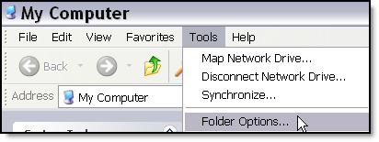

Figure 151: Error Messages with Causes and Resolutions

1. Click on the File Types tab and scroll down to the file type extension details to change, in this case TXT (Figure 150).

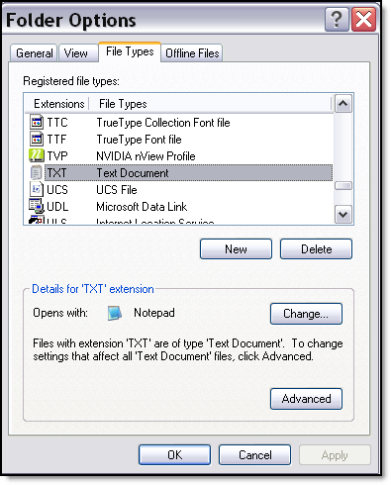

Figure 152: File Types

1. Click the Change button.
2. In the Open With window click Notepad or WordPad (Figure 151).

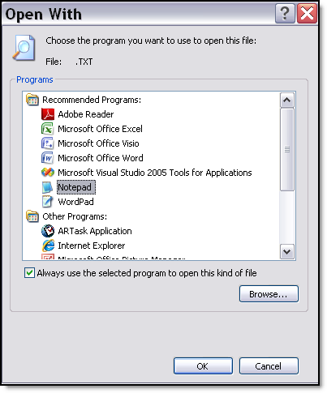

Figure 153: Open With Dialog Box

1. Make sure and check the box for Always use the selected program to open this kind of file and then click OK.

## Appendix B

1. Batch Announce

* Component: Adapter/Legacy VAP
* Version: 2.7
* Product Owner: Joe Paiva
* Development Manager: Amy Neilson
* Analyst: Cathy Garlesky

Announcements are notifications for exchanging Veteran Identifier information with partner systems thereby facilitating subsequent health-information exchange between VA and its partners. These identifiers once exchanged are also termed correlations.

The key actors involved with announcements are:

* VA’s CONNECT Gateway/ eHealth Exchange Adapter – Handles all messaging and communication pertinent to announcements.
* The MVI – A VA repository that reconciles multiple identifiers for a patient including, VistA facility level identifiers and partner correlations, with an enterprise-wide unique identifier. The eHealth Exchange Adapter collaborates with the MVI during announcements.
* VAP – It provisions a GUI capability for VA staff to initiate announcements. **Note** that the announcements are not actually performed by VAP. VAP captures announcement subject (patient) and target (partner) information and defers to the eHealth Exchange Adapter to carry out the announcement.
* Partner Systems – Front-ended by the CONNECT Gateway/equivalent thereof; these systems share their identifiers for the patient with the VA if certain demographic traits match across the two systems.

Announcements can be:

* Patient Centric – Announcements to all organizations for a given patient.
* Organization Centric – Announcements for all opted-in patients to one or more organization(s).

Batch announcements are organization centric announcements. They are high volume announcements and are performed infrequently. The main drivers for batch announcements are scenarios such as those listed below:

* A partner might have recently on-boarded with the VA and correlations would need to be established for the first time.
* VA and/or its partners might have modified Veteran identifiers and they would need to be re-correlated.
  1. Challenges

The complexity of batch announcements stems from dependency on a multitude of systems and a high magnitude of volume and presents the following challenges:

* Announcements could span numerous days and weeks:

1. Availability of all the dependent systems for the entire duration of the announcements needs to be ensured.
2. Maintenance patches, system upgrades on one or more of the dependent systems would need to be factored in.
3. Restrictions on when announcements can be performed exist. Ex: MVI stipulates that high volume batch announcements can only be performed during off-hours and weekends.
   1. Batch Announce Steps

To overcome challenges described above the following steps should be performed:

* Perform analysis to determine the scope of the announcements, split them across multiple batches and establish a schedule for these batches.
* Coordination with all stakeholders and dependent systems based on the schedule, modifications to the schedule if needed, and eventual execution of the batches.
  1. Analysis

Scope of the announcements needs to be determined. The following questions could help establish the scope:

1. How many partners are the announcements targeted to?
2. How many opted-in patients are being announced?
3. Should all opted-in patients be announced?
4. Should all patients opted-in within a certain time-frame be announced?

Answers to these questions can be provided by the Business via a Service Request submitted to the eHealth Exchange Adapter/Legacy VAP team (see Section B.4).

Once the scope is determined, the candidate patients for announcement are distributed across numerous batches based on opt-in date ranges for those patients, thereby establishing a submission schedule. Important considerations for sizing a batch are that:

1. Batches cannot run beyond stipulated durations.
2. MVI has off hour batch announce execution stipulations.
3. Here’s an empirical observation - *Announcements for 1000 opted-in patients took roughly 2.5 hours to complete (approx. 7 announcements/minute) during announcements to CHIC Minnesota. The duration could vary from partner to partner. It is recommended that trial announcements be performed to get a better metric as to the rate at which a partner processes announcements.*
   1. Coordination and Execution

These are to be performed by Business, IdM, eHealth Exchange Adapter/Legacy VAP, and Partner Integration.

1. Business roles and responsibilities:
2. Submit a Service Request (SR) to the IdM team requesting that they manually de-correlate the Correlations within the MVI. De-correlation may or may not be required, but coordination with the MVI is still required with details about the announcements – scope, duration et.al.
3. *Email the VA EPMO (Sam Hamilton) with the below information: (**Note**: Contact the Product Support group, April Scott and James Hartlin for latest partner name and OID information.)
4. Full Name of Partner
5. Partner OID
6. Date Authorizations (Opt-Ins) began that resulted in correlations with that Partner
7. List of Date ranges and number of patients opted in
8. Date Announces can start (Partner systems available)
9. Expected number of correlations. \***Note**: Use this step until a formal Service Request (SR) process is in place.
10. IdM roles and responsibilities:
11. Go through their approval process with the SR received from Business.
12. Develop a script to unlink the correlations (if applicable).
13. Schedule the date/time on the AITC Calendar for running the script
14. Run the script
15. Notify Business when completed
16. Product Development Team:
17. Submit a Help Desk Request by calling the National Service Desk 1-888-596-4357.
18. eHealth Exchange Adapter/Legacy VAP
19. Perform analysis
20. Create schedule/plan
21. Run batches in the production system
22. Monitor all batches for Announce errors
23. Validate and document successes and errors
24. Evaluate and document correlation count
25. Validate correlations count against expected correlation count
26. Provide a report of the batch announce results to the business
    1. Story Description

* Event: Batch Announce (Figure 152)
* Actor: eHealth Exchange Adapter/Legacy VAP Team

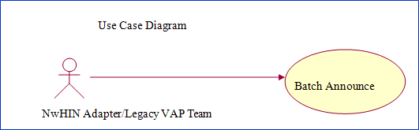

Figure 154: Batch Announce Use Case Diagram

* 1. Conversation/Narrative

The business will email the VA EPMO with a table provided as a rough indicator as to the scope of the batch announcements. The table will indicate the number of patients that were opted-in for the site in question and the date ranges of opt-ins. Each line item could perhaps constitute a batch.

Then eHealth Exchange Adapter/Legacy VAP team can utilize the Consent Directive Summary Report and evaluate the number of opt-ins for the business-specified date ranges. If the number of opt-ins is large, the likelihood of the batch executing for a long time is very high. It must then be determined if the batches need to be split up further to satisfy stipulated execution time constraints (for instance, by MVI).

**Note**: The Consent Directive report does not show counts of opt-ins grouped by patient’s preferred facility (as provided by the business). Instead, it shows a count of patients (potentially belonging to other facilities as well) opted-in by various facilities. In other words, the summary reports generated by entering in the business-provided date ranges will not necessarily reflect counts identical to what the business provided. However it helps better with sizing the batch.

In summary, to establish a schedule of batches, the eHealth Exchange Adapter/Legacy VAP team should:

* Start with the information provided by the business.
* Establish scope of announcements using the Consent Directive Report.
  1. Analysis Steps and Process

1. Log into the Legacy VAP system.
2. Access the Consent Directive Summary Report (Figure 153).
3. Enter an end-date (date specified by the business in a table, as part of the SR): for example 01/05/2015.

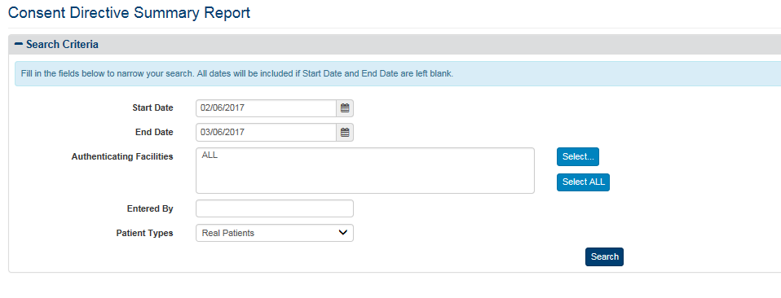

Figure 155: Example of a Consent Directive Summary Report Search Criteria Screen

1. Generate the CD report by hitting the Search Button.

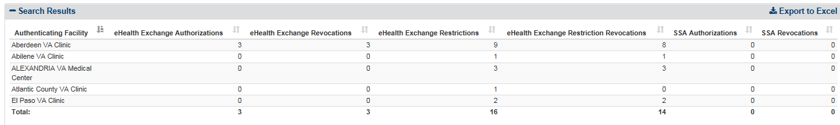

Figure 156: Example of a Consent Directive Summary Report Screen

1. The generated report shows the patients opted-in during this duration.
2. Pick the next row from the Business specified table, i.e., date range and repeat the steps until all the rows in the business specified table are accounted for.
3. Once the announcements are tabulated, they can be submitted per schedule and the results are tabulated as shown.
4. Based on the approved schedule of announcements, complete the Batch Announces and verify results generated show the number of patient announced and correlated.
5. Provide business a report of the findings.
   1. Acceptance Criteria / Compliance

Acceptance criteria will be a table of batches that will be performed to announce the patients in the specified date range for the site in question.

The batches will be performed according to the approved schedule and will demonstrate the number of patients correlated in the date range and a report of the findings will be delivered to the business.

## Appendix C

* 1. Tool Tips (Hover Overs)

VAP 2.7.0 provides tooltips throughout the system entry fields and reports. The user hovers the pointer over an item and a tooltip may appear. A tooltip is a small hover pop-up box that appears on screen containing information regarding the field hovered over. Figures 155 through 158 display a number of screenshots taken off the Disclosures Summary Report tooltips.

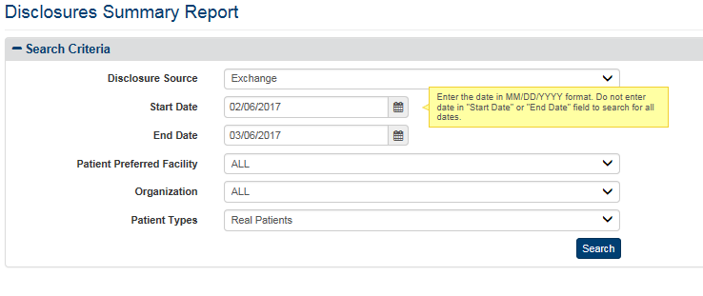

Figure 157: Tooltip (hover over) - Start/End Date

When the user hovers over Start Date or End Date (Figure 155), a tooltip appears with the following message, “Enter the date in MM/DD/YYY format. Do not enter date in “Start Date” or “End Date” field to search for all dates.”

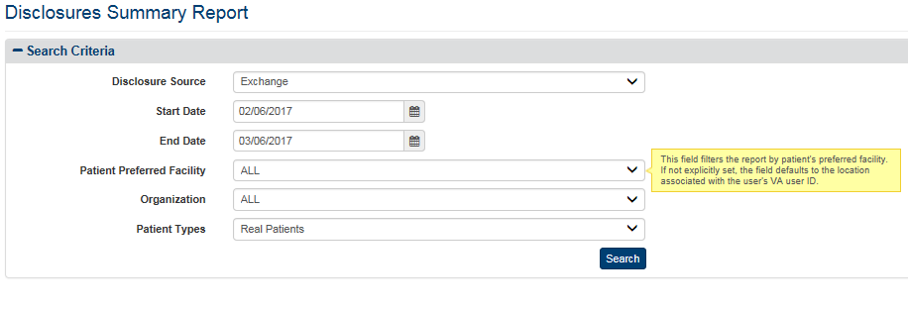

Figure 158: Tooltip (hover over) – Patient Preferred Facility

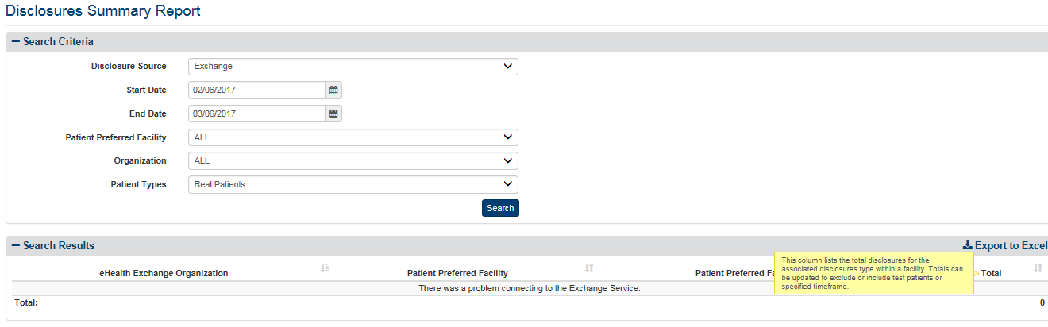

Figure 159: Tooltip (hover over) – Total

Tooltips are also provided with report headers. In Figure 157, the column header “Total” is hovered over as a box appears with the following message, “This column lists the total disclosures for the associated disclosures type within a facility. Totals can be updated to exclude or include test patients or specified timeframe.”

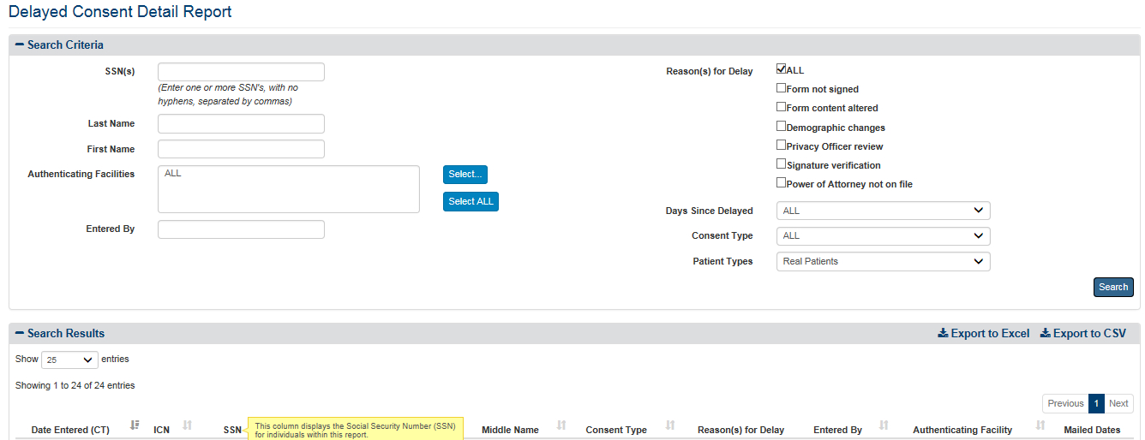

Figure 160: Tooltip (hover over) – SSN

The system provides tooltips for reports. This includes filter/search entry pages and report headers.

* 1. User Friendly Error Messages

The VAP application provides error-message handling; for display of user friendly errors. Instead of seeing code errors a standard error message is displayed to the user. For example, an error could be displayed when system connection is unavailable or when system timeout occurs. Error messages may appear when a connection with eHealth Exchange, Master Veterans Index (MVI), or Direct is unavailable. If this error is repeatedly seen, please call the VA Help Desk for assistance. These errors can also be seen for when a page does not exist.

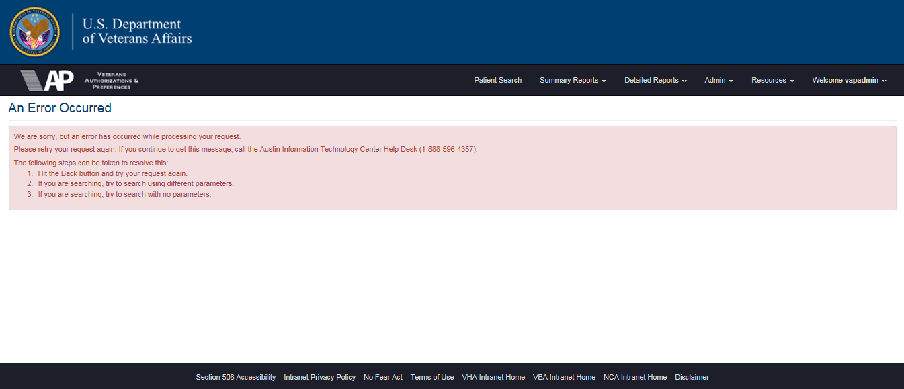

Figure 161: Error Message